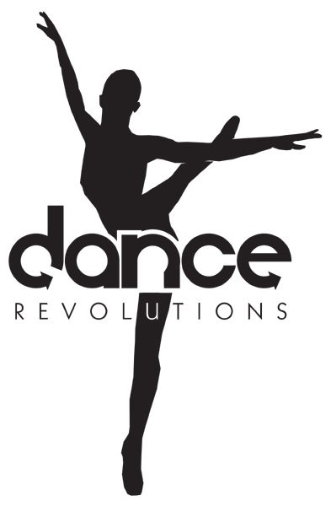
FOR OFFICE USE ONLY

Date Received:___________

Registration Paid:_________

Rate:___________________

REGISTRATION FORM
(Please Print)

Please complete and return the registration form to the studio, mail, or email to:

DANCE REVOLUTIONS
701 E. SAVIDGE STE 2
SPRING LAKE, MI 49456
jen@dancerevolutions.net

If you have any questions, please email jen@dancerevolutions.net
(* Required to be filled to complete registration)

*Students Name: _______________________________________________________________ Age ______________

*Name of Parents or Guardian:_______________________________________________________________________

*Address ______________________________________________________ *City _____________ *Zip _________

Home Phone _________________ Work Phone _____________________ *Cell phone _________________________

School Name (if applicable) ___________________________________ Grade ______ *Birthdate ______________

*Email Address __________________________________________________________________________________

Enrolling in Class(es). Please enter the day/time/type of dance class:

1. Day____________ Time____________ Dance Class_______________________________________________

2. Day____________ Time____________ Dance Class_______________________________________________

3. Day____________ Time____________ Dance Class______________________________________________

4. Day____________ Time____________ Dance Class_______________________________________________

****Please include a $30.00 non-refundable registration fee per student with your first month payment****
For a family, $50.00 registration fee total.

****Please note that registration fee is non-refundable. If your dancer chooses not to start after paying registration fee, drops the class in the middle of the season, the registration fee is non-refundable.



CONSENT AND RELEASE

This consent and release must be signed by the participants who are 18 years old or older or by a parent/legal guardian of each student before the first day of class. No student will be admitted to the classroom without this form signed.
The undersigned hereby consents to the enrollment of:
______________________________ of __________________________________________________________
(Name) (Address)
as a student of dance REVOLUTIONS from time to time. Such enrollment shall be subject to the rules and regulations established by the studio from time to time. The proprietor of the studio reserves the right at any time to termination of enrollment of any student who fails to comply with such rules and regulations. In the event of termination of enrollment, any deposit shall be forfeited.
The undersigned hereby releases dance REVOLUTIONS, Jennifer McNeice, her or agents or employees, heirs, successors, and assigns, from any liability or claim of student or student’s parents or legal guardians, arising out of any injury or accident cause by or occurring during the study of dance with the studio, without regard to the negligence of the parties.
We understand that there are inherent risks in any physical or athletic activity and that the students and parents or legal guardians acknowledge this. We also understand by participating in classes, we assume all personal injury/sickness (such as COVID-19), that may occur from dancing in group, private, or any other class forms, that we will not hold dance REVOLUTIONS liable for any occurrences of sickness/injury.
The undersigned hereby agrees to indemnify and hold harmless Jennifer McNeice and dance REVOLUTIONS, her agents or employees, heirs, successors, and assigns, against any liability, claim or expense including attorney’s fees and costs, arising out of any claim or suit with respect to the actions of students while a student at the studio or any injuries or claims occurring during the study of dance at the studio.
The Consent and Release is given by the undersigned in partial consideration for the enrollment and acceptance of student at the studio and is entered into freely, voluntarily and after a full opportunity for review by the undersigned.
In the event of a life-threatening emergency, we will render necessary care. We are not medical professionals and will not be responsible in an event of an emergency.
I have read the above consent and release and hereby agree to its contents.

_____________________________________________________ _____________________
(Parent/Guardian or Participant if over 18) Date

MEDICAL INFORMATION

Are there any medical or other health factors (i.e. prior injuries) that might affect the participant’s performance in this activity?
No __________ Yes __________
If yes, please explain ____________________________________________________________________________________

Is the participant taking any medications that might affect his/her safety or performance in this activity?
No __________ Yes __________
If yes, please explain ____________________________________________________________________________________

**Please note, if an answer is yes to either question, a medical release may be required**

I hereby have answered these questions to the best of my knowledge and believe my answers to be true.

_____________________________________________________ _____________________
(Parent/Guardian or Participant if over 18) Date

