Margaritaville Level $1,000
Company Logo on the back of event t-shirt
4 Free event t-shirts
20 Free raffle tickets
10 Free $5 raffle tickets
Your company banner displayed day of event
Social media/advertisement
4 MRV event tickets
Parrot Head Level $500
Company Logo on the back of event t-shirt
2 Free event t-shirts
10 Free raffle tickets
5 Free $5 raffle tickets
Social media/advertisement
2 MRV event tickets
Finz Level $300
Logo on the back of event t-shirt
1 Free event t-shirt
10 Free raffle tickets
1 Free $5 raffle
1 MRV event ticket
Social media/advertisement
Cheeseburger Level $100
1 line on the back of event t-shirt
1 Free event t-shirt
5 Free raffle tickets
Social media/advertisement

***All sponsors on banner made for MargaRaleighVille 2019***
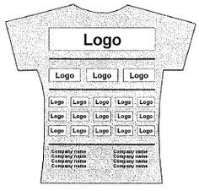

*** This is just an example of the back of a sponsor shirt***

