Gas mixer: iMixpro
Compact gas mixer with integrated constant pressure regulators
and diffusion mixing system
Gas mixer range iMixpro for the production of gas mixtures of two or three gas types.
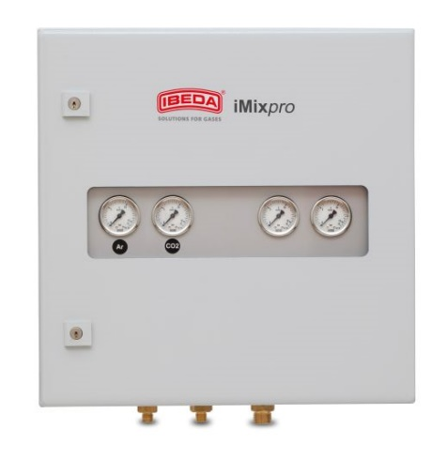
Highlights
• Optimal factory calibration according to customer‘s requirement
(within the permissible range)
• Infinitely variable up to 130 m³/h (related to Nitrogen)
• High accuracy, according to ISO 14175
• No accidental mixture changes
• Mixture production stops automatically when gas supply is interrupted
• Does not depend on gas withdrawal variations
• No additional buffer vessel needed for discontinuous withdrawal of gas
• Does not depend on input pressure differences due to integrated constant pressure regulation
• Sturdy and compact design, low maintenance
• No power supply required for production of the gas mixture
Optional:
• Inlet and outlet pressure regulator (pre-adjusted)
• Integrated gas analysis for process control
• Inlet gas filter GF
Maintenance:
Gas mixers are to be tested for leaks at least once a month.
Gas mixers are only to be opened and repaired by the manufacturer.
Technical Data:

Carrier gas: | Argon (Ar) | Nitrogen (N₂) | Carbon dioxide (CO₂)
Additive gas: | Carbon dioxide (CO₂)  Helium (He)  Nitrogen (N₂)  Oxygen (O) | Carbon dioxide (CO₂)  Helium (He)  Oxygen (O) | Oxygen (O)

Mixing range:  depending on composition of the gas mixture | 2 mixed gases: 5 – 95 Vol. %
3 mixed gases: Carrier gas: 50 – 95 Vol. %
1. Additive gas: 5 – 25 Vol. %, 2. Additive gas: 5 - 25 Vol. %

Inlet pressure: | min. 0,4 MPa (4 bar)  max. 1 MPa (10 bar)

Outlet pressure: | 0,05 – 0,8 MPa (0,5 - 8 bar) depending on the inlet pressure

Mixed gas capacity: | 50 / 100 / 130 m³/h, infinitely variable (related to Nitrogen)

Mixing precision: | ± 0,5 % abs: 1-5 Vol. % additive gas  ± 10 % of nominal value: >5-20 Vol. % additive gas  ± 2 % abs: > 20 Vol. % additive gas

Temperature: | -10 bis +50°C

Connection EN560  Gas inlet/Gas outlet: | < 100 m³/h: G1/2RH-M  > 100m³/h: G1RH-M | (optional solder connection for pipe Ø 18mm)  (optional solder connection for pipe Ø 28 mm)

Material: | Housing: sheet steel, powder coated  In-built parts: brass, stainless steel, Elastomer Copper, aluminum, anodised

Measure and weight: | heigth: | width: | depth: | weight:

without connection | 500 mm | 500 mm | 210 mm | approx. 15-25 kg
Further gas mixer versions for the production of gas mixtures of two or three gases are available on request.
Type: iMixpro
Flow capacity in Nm³/h related to Nitrogen:  Mixed gas capacity: 50m³/h  Outlet pressure [barÜ] → 0,5 1 2 3 4 5 6 7 8  Inlet pressure  [barÜ] ↓  4 18,0 16,5 12,0 - - - - - -  5 27,5 25,5 21,5 15,0 - - - - -  6 33,5 32,5 30,0 25,0 18,5 - - - -  7 42,0 40,0 38,0 34,0 28,5 21,0 - - -  8 50,0 48,0 46,5 43,5 38,5 32,5 24,0 - -  9 57,0 55,5 54,0 52,0 47,5 42,5 34,5 26,5 -  10 63,0 62,0 60,0 59,0 57,0 50,0 47,0 38,0 28,5  Mixed gas capacity:100m³/h  Outlet pressure [barÜ] → 0,5 1 2 3 4 5 6 7 8  Inlet pressure  [barÜ] ↓  4 36,0 33,0 24,0 - - - - - -  5 55,0 51,0 43,0 30,0 - - - - -  6 67,0 65,0 60,0 50,0 37,0 - - - -  7 84,0 80,0 76,0 68,0 57,0 42,0 - - -  8 100,0 96,0 93,0 87,0 77,0 65,0 48,0 - -  9 114,0 111,0 108,0 104,0 95,0 85,0 69,0 53,0 -  10 126,0 124,0 120,0 118,0 114,0 100,0 94,0 76,0 57,0  Mixed gas capacity:130m³/h  Outlet pressure [barÜ] → 0,5 1 2 3 4 5 6 7 8  Inlet pressure  [barÜ] ↓  4 46,8 42,9 31,2 - - - - - -  5 71,5 66,3 55,9 39,0 - - - - -  6 87,1 84,5 78,0 65,0 48,1 - - - -  7 109,2 104,0 98,8 88,4 74,1 54,6 - - -  8 130,0 124,8 120,9 113,1 100,1 84,5 62,4 - -  9 148,2 144,3 140,4 135,2 123,5 110,5 89,7 68,9 -  10 163,8 161,2 156,0 153,4 148,2 130,0 122,2 98,8 74,1 | The following table shows the correction factors as an example for different gas mixtures.  Application table Application table  Gas mixture Gas mixture  Vol.% CO₂ Vol.% Ar Conversion factor Vol.% CO₂ Vol.% N₂ Conversion factor  18 82 0,8812 30 70 1,048  4 96 0,8336 5 95 1,008  25 75 0,9050 80 20 1,128  Vol.% He Vol.% Ar Conversion factor Vol.% He Vol.% N₂ Conversion factor  20 80 0,8660 10 90 1,005  60 40 0,9580  Vol.% O₂ Vol.% Ar Conversion factor Vol.% O₂ Vol.% N₂ Conversion factor  4 96 0,8224 4 96 0,9952  10 90 0,8260 25 75 0,9700  Vol.% O₂ Vol.% CO₂ Conversion factor  50 50 1,020  85 15 0,922  Application example:  Gas mixture setting:  Gas mixture (Ar in CO2) [%]: 82/18  Gas mixture conversion factor (F): 0,8812  Flow rate according to table [m³/h]: 38  Gas mixture flow rate [m³/h]: 38 x 0,8812 = 33,5
Certification/ Technical Standards/ Rules
TRBS German Technical rules for operation safety, DVS German Association for Welding, Cutting and Allied Processes,
DGUV German Employer´s liability insurance association rules and regulations.
Standards/ Approvals
Company certified according to
ISO 9001:2015 and ISO 14001:2015,
CE-marking according to: Pressure Equipment Directive 2014/68/EU

(Subject to change without notice)

