Royal Marines Association Golf Society (RMA GS)
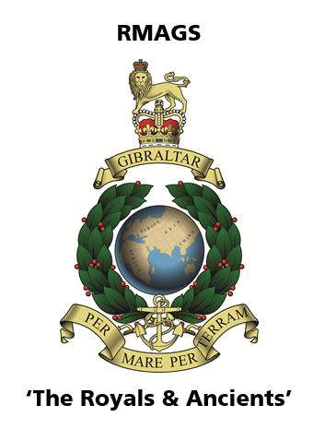
“The Royals & Ancients”
Charter
Objectives of the Society
The aim of the RMA GS is to play golf with mates, to have fun and to support the RMA. A particular aim is to encourage younger members of the retired Corps to join and play.
The Society will be run as informally as possible but at the same time should minimise any financial risk to individuals or the society or reputational risk to the RM Brand.
The main ‘season’ for RMA GS golf will be Mar – Oct inclusive annually, though matches can be played outside this period.
Organisation
The ‘Committee’, who for ease of meetings are all southwest based, will be:
Representative | Name | Role
Chairman | Paul Denning | to coordinate Committee activity and guide the development of the GS
Membership Rep | Don Hayes | to manage the membership database and annual subscriptions
Fixtures Rep | David Atkinson | to arrange the calendar and coordinate the events, using additional volunteer support
Treasurer | Rick Hall | to manage the money
Handicap Rep | George Martin | To maintain the handicap system

The Chairman will be nominated by the other Committee members.
At least one of the Committee members should ideally be a member of a Golf Club.
Committee members may serve continually.
Committee members will be reviewed annually at the AGM. Any RMA GS member may volunteer him/herself for a Committee role.
Committee meetings will be held on an ‘as required’ basis. Any member may attend and observe Committee meetings.

Membership
Membership is open to all RMA members, male and female, who are golfers. There is no minimum handicap required. International members of the RMA are welcome to join.
There will be a record of all members held by the Membership Rep. By accepting membership, members acknowledge that personal details will be held centrally and protected. These will not be shared or used for purposes other than to manage the GS. (No financial details will be retained.)
Associate Membership will be open to non-RMA members. This will have the same benefits as Full Membership with the exception of benefits of RMA direct subsidies and voting rights.
The Committee will be the arbiters of good taste in all matters concerning membership.
Guests
Members may bring guests to any fixtures. They will pay day rates for the golf as members do. Guests may win prizes covered by the day rates but not those paid for by the GS. Details will be made clear on the day.
Fixtures
The Fixtures Rep will coordinate the annual calendar of matches.
There will be an event planned each month of the season. The calendar of events is published by email.
The main annual event will be an RMA GS Annual Day run concurrent with the RM match prior to the RM Corps Family Weekend, currently held in September.
Fixtures will be advertised by email and players will be allocated places on a first come first served basis. Should matches be over-subscribed the Committee will arbitrate to ensure that there is a fair share of available places.
Rules of Golf
All RMA GS matches will abide by the Royal and Ancient (R&A) Rules of Golf.
Additionally, the local rules of the clubs where matches are played should be applied.
Format of play and rules of the competition on the day will be advertised locally by the organisers.
Local Club
The RMA GS will use Tiverton Golf Club as its ‘home’ venue. This will be reviewed annually at the AGM.

Behaviour and Reputation
Golf Societies can be viewed with an amount of disdain by members of Golf Clubs. It is paramount that our behaviour is cognisant of our position as guests of the Club and also as ambassadors of the Corps and the RMA.
Finances
The core financial model is to ‘pay and play’.
Subscriptions will be charged annually at a rate of £20 (2019/20 season) for both Full and Associate members, payable on joining and thereafter as requested by the Membership Rep by 1 Mar each year. The subscriptions will under-write any financial risk and also provide prizes etc. for the competitions. Subscriptions will be reviewed annually at the AGM.
Payments from members will be made direct to the Treasurer on joining. The Treasurer will be responsible for managing the account on behalf of the Society. Payment can be made by bank transfer or cheque.
The financial record will be audited annually by the Committee.
Insurance
The RMA GS as an entity is covered on the RMA insurance. This will cover Employers’ Liability and Public Liability only. It will not cover personal liability, kit and golf equipment. Individuals should take out personal insurance for such cover.
The RMA insurance will only cover RMA GS matches that appear on the Calendar of Events.
Website
The Website is embedded in the RMA website. Look for it under Branches.
Handicaps
The RMA GS will issue a Society handicap. The Handicap Rep will maintain the handicaps based on cards submitted.
Logo and Golf Shirts
The RMA GS logo may be used on clothing and paperwork by all members in pursuit of RMA GS business.
RMA GS golf shirts are available through the committee, at additional cost.
Annual General Meeting
An AGM will be held annually. The date of this will be notified in advance.

Signed: The Chairman Date: 22 October 2018

