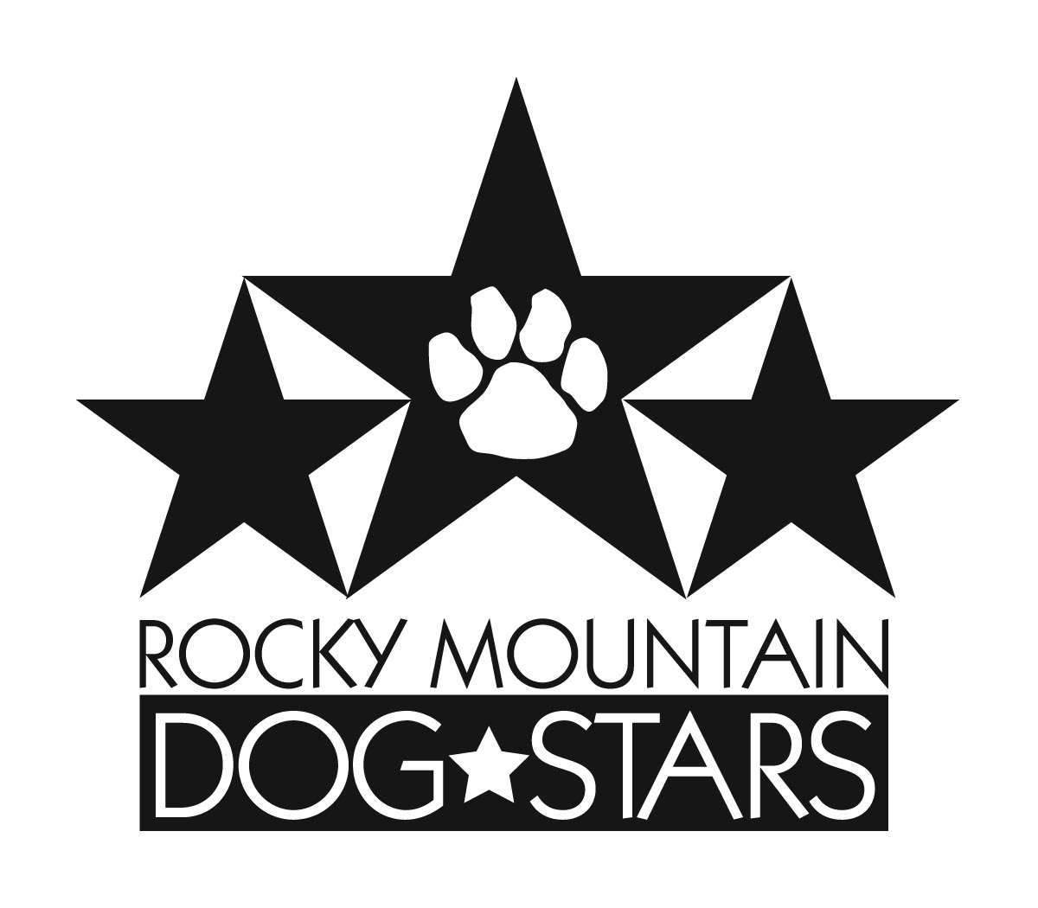

PLEASE VISIT:
https://rockymountaindogstars.com/nadac-agility FOR ADDITIONAL COVID FORM(S) REQUIRED TO BE FILLED OUT AND SUBMITTED.
Rocky Mountain Dog Stars  June 25 – 27, 2021  Roberts MT  Judge:  Stefan Elvstad  Double Run Format  Building and Ring Surface info:  Artificial Turf with rubber infill  Contact Surface:  Rubber contacts  Crating Set up times:  Anytime on  June 24, 2021  Briefing at:  Friday: 9:30 am  Saturday: 8:00 am  Sunday: 8:00 am  First dog on the line at:  Friday: 10:00 am  Saturday: 8:30 am  Sunday: 8:30 am | Preliminary Class Order:  May change depending on weather, judge’s preference, time or number of entries  Friday  Class: Double Run Single Run  Chances 2  Regular 2  Touch n Go 2  Saturday  Class: Double Run Single Run  Chances 2  Regular 2  Weavers 2  Barrelers 2  Sunday  Class: Double Run Single Run  Regular 2  Jumpers 2  Tunnelers 2

Entries Open on:  Open now  Entries Close on:  Thursday night before the trial or when trial fills  Crating available:  Indoors  Entry Limits:  Entries are limited to 500 runs per day  Move ups:  Accepted day to day but not during the day  Day of show Entries:  Day of show entries are $12/each  Refunds:  If the Dept. of Transportation closes any interstate or secondary roads, all but $4 entry for each run will be refunded. If someone withdraws from this trial before closing date, full refund will be given. In case of an injured dog or a bitch in heat, all but $4 for each run will be refunded after the closing date.  Equipment info:  Rubber contacts, dogwalk, A frame, tunnels, 24” weave poles, hoops, jumps, barrels | Show Committee  Trial Co-Chairs: Carla Van Siclen 406-697-4538 cvansiclen2@gmail.com & Jody Fay 307-752-0741  dogsetc@vcn.com  Secretary: Kristi Hayes 406-670-7570 kristi.hayes@msn.com  Ring Steward: Bonnie Fauskee  Chief Course Builder: Cathy Shryock  Confirmations:  All confirmations will be sent out via e-mail no later than the Friday night before the trial. If you would like a hard copy, please enclose a self-addressed stamped envelope with your entry. Please remember to check your e-mail. If you do not receive a confirmation or other notice from us, we have NOT received your entry.  Food info:  Some concessions may be available onsite.  Volunteer info:  If you want to learn a new job we will try to accommodate you. Your help is greatly appreciated. Thank you!  Awards and Ribbons:  Flat ribbons 1st – 4th in each class  Except Chances which is pass/fail, and Q ribbons only.  Purple qualifying ribbons, NATCH, V-NATCH, ALL AROUND NATCH & Title ribbons.  Rocky Mountain Dog Stars High In Trial Rosettes  Intro, Novice, Open, Elite, Veteran, Junior Handler, Non-Herding and Mixed Breed  DOGS THAT HAVE EARNED Q’S IN HIGHER  LEVEL “REGULAR” CLASSES ARE NOT ELIGIBLE  FOR LOWER LEVEL HIT.
Jump Height Info:
MEASURING
Measurement forms may be obtained at
https://www.nadac.com/WPsite/wp-content/uploads/2021/01/HeightCardFormToday.pdf
Dogs which require measuring:
Dogs in the Proficient Category, Novice, Open or Elite jumping 4”, 8”, 12” or 16”

Dogs which do not need to be measured:
Dogs jumping 16” in the Veteran or Junior Handler Division
Dogs jumping 20”
Dogs in the Skilled Category
Dogs with a permanent height card
Dogs listed on the Height Exemption List
JUMP HEIGHTS
There are four Standard Division-Proficient jump heights: 8”, 12”, 16”, and 20”.
There are four Standard Division-Skilled jump heights: 4”, 8”, 12”, and 16”.
There are four jump heights for the Veterans and Junior Handler divisions: 4”, 8”, 12”, and 16”.
Please see the NADAC Rulebook for the full jump height table

Brief Summary of Rules:
Please refer to www.nadac.comfor a full explanation of all NADAC rules and up to date information.

- Please note that NADAC trials should provide a safe and fun environment for both exhibitors and their dogs.
- Aggressive dogs will not be tolerated and will be excused from the trial.
- The show committee has the right to refuse any entry. Anyone not currently in good standing with NADAC will not be allowed to enter this trial.
- Exhibitors, through submission of entry, acknowledge that they are knowledgeable of NADAC rules and regulations, and agree to abide by all rules in effect at the time of this trial.
- No entry fee will be refunded if the trial cannot open or be completed by reasons of riots, civil disturbances, fire, acts of God, public emergency, an act of a public enemy, or any other cause beyond the control of the organizing committee.
- Checks not honored by the bank do not constitute a valid entry fee. There will be a $25.00 service charge for bank returned checks.
- Dog must be registered and have a valid registration number before entries will be accepted. http://nadac.com/register-your-dog/
- A copy of the current Exhibitors Handbook may be downloaded free from the NADAC web site: www.nadac.com
- Bitches in heat, lame, or blind dogs are ineligible for entry, as is any dog with a deformity which may cause a judge to not be able to reasonably assess the dog’s ability to function and perform agility obstacles safely, and in a manner that is in the best interest, health and welfare of the dog.
- No food, clickers, or other aids or devices shall be permitted on the course or within 10 feet of the ring. Food or a small non-audible toy can be in a secure container (ziplock bag is acceptable) in your pocket during your run but it cannot be used during your run, nor can you indicate to the dog it is there. All handlers may bring a non-audible toy into the ring for training purposes. They cannot earn a Qualifying score and must declare to the judge they are training before they commence their run. Please read the Exhibitor’s Handbook for more information about toys and training in the ring.
- The sponsoring clubs will not be responsible for the loss or damage to any dog exhibited, or for the possessions of any exhibitor whether the result be accident or other cause. It is distinctly understood that every dog at this event is in the care and control of his owner or handler during the entire time the dog is on the show premises.

Rocky Mountain Dog Stars, June 25 – 27, 2021, Roberts MT
Make Checks Payable to RMDS or pay by PayPal on RMDS website
Send entries to: Kristi Hayes, 1116 Lendel Ln, Billings MT 59102
Owner |  |  |  |  | Dog
Name |  |  |  |  | Call Name
Address |  |  |  |  | NADAC Reg #
City/State/Zip |  |  |  |  | Date of Birth
Phone |  |  |  |  | Height at Withers
Email |  |  |  |  | Breed Sex
Handler, If not owner |  |  |  |  | Emergency Contact Name/Phone
PLEASE INCLUDE A COPY OF YOUR DOG’S HEIGHT CARD IF YOU DO NOT HAVE ONE ON FILE.
CATEGORY: PROFICIENT ☐ SKILLED ☐
DIVISION: STANDARD ☐ VET DOG ☐ VET HANDLER ☐ JUNIOR HANDLER ☐
I WANT MY DOG TO JUMP: ☐4 ☐8 ☐12 ☐16 ☐20
Intro Jump Height: ________ (if you are entering multiple levels and want intro at a different height than above)

Class | Level |  |  |  | Day
 | Intro | Novice | Open | Elite | Friday | Saturday | Sunday
Regular | ☐ | ☐ | ☐ | ☐ | Rd 1 ☐ Rd 2 ☐ | Rd 1 ☐ Rd 2 ☐ | Rd 1 ☐ Rd 2 ☐
Chances | ☐ | ☐ | ☐ | ☐ | Rd 1 ☐ Rd 2 ☐ | Rd 1 ☐ Rd 2 ☐
Jumpers | ☐ | ☐ | ☐ | ☐ |  |  | Rd 1 ☐ Rd 2 ☐
Touch n Go | ☐ | ☐ | ☐ | ☐ | Rd 1 ☐ Rd 2 ☐
Tunnelers | ☐ | ☐ | ☐ | ☐ |  |  | Rd 1 ☐ Rd 2 ☐
Weavers | ☐ | ☐ | ☐ | ☐ |  | Rd 1 ☐ Rd 2 ☐
Barrelers | ☐ | ☐ | ☐ | ☐ |  | Rd 1 ☐ Rd 2 ☐
In consideration of the acceptance of this entry, I/we certify that I/we have knowledge of, and are familiar with, and agree to abide by, the Rules and Regulations of NADAC in effect at the time of this trial, and by any additional rules and regulations as approved by NADAC for this trial. I/we certify that the dog entered is not a hazard to persons or other dogs. I/we further agree to be bound by the “Agreement” printed on page 5 of this premium

Number of Total Runs Entered (all dogs): # ___________

□ 1-19 Runs = $11 each = ___________
□ 20+ Runs = $10 each = ___________

Junior Handler/FT college student (min 15 credits/semester)
□ 1-19 Runs = $5 each = ___________
□ 20+ Runs = $4 each = ___________
□ Day of Show (after closing) $12 each = ___________

TOTAL ENCLOSED = ___________

Owner/Exhibitor: ____________________________________Date_____________________
Parent or Legal Guardian of Junior Handler__________________________________________
AGREEMENT

The person who signs this agreement represents that he/she is authorized to enter into this agreement on
behalf of both exhibitor and the owner of entered dog. In consideration of acceptance of this entry:
1.1. As used here "NADAC" means the North American Dog Agility Council, LLC., its members, officers, directors, employees, show chairs, show committees and agents.
1.2. Exhibitor/owner agree to abide by the rules and regulations of NADAC and any other rules and
regulations appearing in the premium for this event.
1.3. Exhibitor/owner certify that the entered dog is not a hazard to persons, dogs or property and that
the entered dog's rabies vaccination is current in accordance with the requirement of the state in which the dog resides.
1.4. Exhibitor/owner acknowledge all hazards presented by the event and the event premises,
including, but not limited to, the condition of the surface, restrooms, security measures or lack of,
electrical appliances, fittings, show rings, parking areas and the presence of unfamiliar animals and
people; exhibitor and owner assume the risk of any harm arising from these.
1.5. Exhibitor/owner releases NADAC (including its respective officers, directors, employees, and
members), Rocky Mountain Dog Stars (including its officers, agents, and members), and Yellowstone Dog Sports (including its officers, agents, and employees) and will
defend them and hold them harmless from all present and future loss, injury, damage, claims, demands
and liabilities involving the entered dog, the event or event premises. Without limiting the generality of the
foregoing hold harmless provisions, exhibitor/owner hereby specifically assumes sole responsibility for
and agrees to indemnify and save the aforementioned parties harmless from any and all loss and
expenses (including legal fees) by reason of the liability imposed by law upon any of the aforementioned
parties for damages because of bodily injuries, including death, at any time in consequence of my (our)
participation in this event, howsoever such injury or death may be caused and whether or not the same
may have been caused or may have been alleged to have been caused by negligence of the
aforementioned parties or any of their employees or agents or any other persons

Run Pricing Info
If you enter this trial before the closing date, additional classes entered during the trial will be at the same price as your original entry.

Lodging Info and Directions:
Lodging in Red Lodge (approx. 8 miles): Yodeler Motel 406-446-1435, Quality Inn 406-446-4469, Beartooth Hideaway Inn and Cabins 406-446-2288, Rock Creek Resort 406-446-1111. Ask for special rates and/or no pet fees!
Lodging at Yellowstone Dog Sports: On-site rooms (bring your own towels and bedding) and camping available. Contact Lisa Fields at lfields@nemont.net for reservations.

