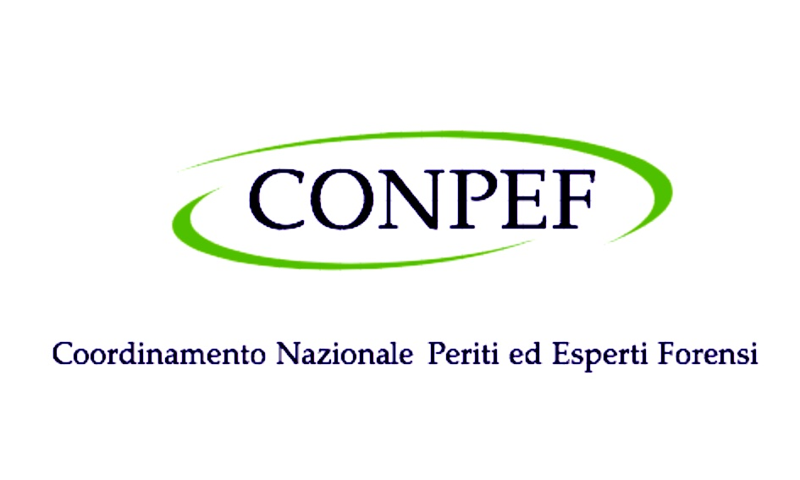 | INTERNATIONAL AFFILIATION AGREEMENT  CONPEF – International Network of Forensic Sciences

Between
CONPEF  Coordinamento Nazionale Periti ed Esperti Forensi  Italy  Represented by:  Dr. Francesco Matranga – President |  | [Name of Institution]  [Full Legal Name]  [Country]  Represented by:  [Name – Position]

Hereinafter individually referred to as "Party" and collectively as "the Parties."

Article 1 – Purpose of the Agreement
The purpose of this agreement is to establish a framework of international scientific and professional cooperation between the Parties in the field of forensic sciences, expert analysis, and the prevention of judicial errors.
Through this agreement, the Parties intend to promote collaboration, knowledge exchange, and the development of methodological standards among forensic experts, researchers, and institutions operating in different legal systems.
Article 2 – International Affiliation
Through this agreement, [Institution Name] will be recognized as an:
International Affiliated Institution
of the CONPEF International Network of Forensic Sciences
This affiliation aims to strengthen professional dialogue and cooperation among forensic institutions worldwide. It does not replace or supersede the institutional identity or professional standards of either Party.
Article 3 – Areas of Cooperation
The Parties may collaborate in the following areas:
- Exchange of professional experience and best practices in forensic sciences
- Comparative research projects related to forensic methodologies
- Scientific publications and editorial collaborations
- Development of methodological guidelines and protocols
- Participation in scientific and technical working groups
- Academic and professional training initiatives
- Cooperation in the activities of the National Observatory on Judicial Errors
Article 4 – International Scientific Events
The Parties may collaborate in the organization and promotion of international conferences, scientific meetings, workshops, seminars, and academic initiatives focused on scientific evidence and judicial error prevention.
Affiliated institutions may be invited to participate in the International Forensic Science Summit organized by CONPEF, which serves as the key annual meeting point of the Network.
Article 5 – Scientific and Professional Exchange
The Parties may encourage the exchange of researchers and experts, participation in scientific panels and working groups, collaborative research initiatives, and joint academic and educational activities.
Article 6 – Institutional Visibility
Affiliated institutions may be listed in the CONPEF International Network of Forensic Sciences and included in institutional communications and scientific initiatives promoted by CONPEF.
Article 7 – Institutional Independence
This agreement does not create legal, financial, or hierarchical obligations between the Parties. Each organization remains fully autonomous and independent in its governance, professional standards, and institutional activities.
Article 8 – Duration of the Agreement
This agreement shall remain valid for a period of three (3) years from the date of signature. It may be renewed by mutual written consent of the Parties.
Article 9 – Termination
Either Party may terminate this agreement at any time by providing written notice to the other Party. Termination shall not affect ongoing collaborative initiatives already formally agreed upon.
Article 10 – Entry into Force
This agreement enters into force upon signature by the authorized representatives of both Parties.

For CONPEF  Dr. Francesco Matranga  President  Signature / Firma  Date / Data | For …..  Dr. .  President  Signature / Firma  Date / Data

