 | March 2018
Sun | Mon | Tue | Wed | Thu | Fri | Sat
 |  |  |  | 1  Commander’s Happy Hour | 2  Pasta Dinner  6:00pm-7:30pm  $9 Donation | 3 Meeting American Legion 1:00pm-2:pm    “Star Spangled Banner” Made National Anthem 1931
4 | 5  Burger Night  5:00pm-6:30pm  $6 Donation   | 6 Meeting’s  Entertainment  5:00pm  House 6:00pm   | 7 | 8 Meeting Auxiliary 6:00pm 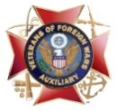  Commander’s Happy Hour | 9  Fried Chicken, Scallop Potatoes & Veggi National Home Fundraiser  6:00pm-7:30pm  $11 Donation | 10  Karaoke 6:00 pm
11  Daylight Savings  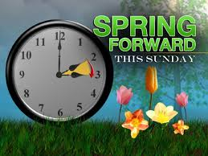 | 12  Burger Night  5:00pm-6:30pm  $6 Donation | 13 Meeting’s  BOD’s 6:00pm  Post’s 7:00pm   | 14 | 15 American Legion B-day  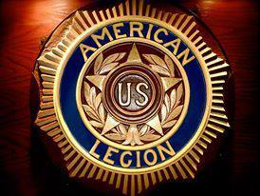  Commander’s Happy Hour | 16 Corned Beaf By Mick  6:00pm-7:30pm  $11 Donation | 17  St Patrick’s Day  
18  Breakfast  8:30am-11:00am  $10 Donation | 19 Burger Night  5:00pm-6:30pm  $6 Donation  Start of OIF 2003 | 20    First Day of Spring | 21 | 22  Commander’s Happy Hour | 23  Steak Night  6:00pm-7:30pm  $14 Donation | 24  Karaoke 6:00 pm
25  Palm Sunday | 26  Burger Night  5:00pm-6:30pm  $6 Donation | 27 | 28 | 29  Commander’s Happy Hour | 30  Chicken or Fish  6:00pm-7:30pm  $8 Donation  Good Friday | 31

