 | April 2017
Sun | Mon | Tue | Wed | Thu | Fri | Sat
1  | 2  Burger Night  5:00pm-6:30pm  $6 Donation | 3 Meeting’s  Entertainment  5:00pm  House 6:00pm   | 4 | 5  Commander’s Happy Hour | 6 Pasta Dinner  6:00pm-7:30pm  $9 Donation | 7 Meeting American Legion 1:00pm-2:pm 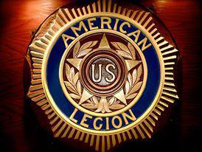  Karaoke 6:00pm
8 | 9  Burger Night  5:00pm-6:30pm  $6 Donation | 10 Meeting’s  BOD’s 6:00pm  Post’s 7:00pm   | 11  Gulf War Official Cease Fire | 12 Meeting Auxiliary 6:00pm 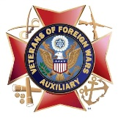  Commander’s Happy Hour | 13  Rib Nite w/ Cornbread  by  Jerry  6:00pm-7:30pm  $? Donation | 14
15 Breakfast  8:30am-11:00am  $10 Donation  Tax Day   | 16  Burger Night  5:00pm-6:30pm  $6 Donation | 17 | 18 | 19  Commander’s Happy Hour | 20  Steak Night  6:00pm-7:30pm  $14 Donation | 21  Karaoke 6:00pm
22 | 23  Burger Night  5:00pm-6:30pm  $6 Donation | 24 | 25 | 26  Commander’s Happy Hour | 27  Prime Rib Dinner  By Mick, Chester, Betsey & Paul  $12 Donation | 28
29  Champagne Brunch  8:30am-11:00am  $12 Donation | 30  Burger Night  5:00pm-6:30pm  $6 Donation

