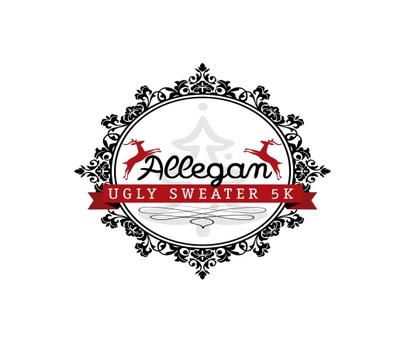

Allegan Ugly Sweater 5K Sponsorship Letter
December 4th 2021 at Allegan Riverfront

We cordially invite you to participate as a Sponsor for the 7th annual Allegan Ugly Sweater 5K. This event will be used to benefit the Allegan Wings Home. The event will be held on Saturday, December 4th 2021, at Allegan City Riverfront. The event will kick off at 1 PM with pre-race activities/registration. The 5k Run will start at 3 PM. Awards will be given for top qualifiers of the 5K, as well as awards given to the ugliest sweaters present. Post-race celebration, with music and drinks, will conclude the race.
Your sponsorship will help to defray the cost of organizing this event. Funds received from sponsorships are used to purchase T-shirts for registered race participants and volunteer workers, awards and complimentary drinks/snacks for each race participant and all tasks associated with the creation of this family friendly event. Any additional money from sponsorships will go toward our fundraising goals.

There are various levels of sponsorship for the Allegan Ugly Sweater 5K. Size and placement of logos on T-shirts and website are based on sponsorship level.

Christmas Tree Level Sponsor‐‐$500 and above
• Logo on back of the T-shirt
• Listed as sponsor on website with logo & link
• May set up one (1) table of information at the event
• Special PA announcements mentioning sponsor name during and after the race

Wreath Level Sponsor‐‐‐$250
• Listed as sponsor on website with link
• Small logo on back of race T-shirt
• Special PA announcements mentioning sponsor name during and after the race

(Continued on back)

Snowflake Level Sponsor‐‐$150 or below
• Listed as sponsor on website
• Listed as sponsor on T-shirt

Mistletoe Level Sponsor‐‐$50 each
• Listed as sponsor on T-shirt

Thank you in advance for your consideration of becoming a race sponsor. With the support of our great sponsors, this event will be an exciting family friendly event the entire city will be proud of. Attached you will find the sponsorship form that can be completed and submitted by mail or please visit our website at www.AlleganUglySweater.com for more information.

Sincerely,

Allegan Ugly Sweater 5K – Committee Members

Allegan Ugly Sweater 5K is a Non-profit organization and operates under the Federal tax code 501c3 (Public Charity). All donations are tax deductible. Tax id number: 47-1419321

