
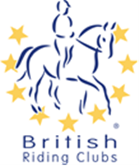
British Riding Clubs NAF National Championships – Show Jumping Area Entry Form 2026
Entry Details:
Riding Club: Area:
Class | Rider | Horse | Membership Number
Mixed 60cm

Team/Individual
Senior 70cm

Team / Individual
Senior 80cm

Team/Individual
Junior 70cm

Team/Individual
Junior 80cm

Team / Individual
Mixed 90cm

Team / Individual
Mixed 100cm

Team / Individual
Mixed 105cm

Team / Individual
Contact Details:
Please contact the organiser for entry fees and deadlines.

I agree (on behalf of the competing member/s) to be bound by the rules of British Riding Clubs. I also understand that in the unfortunate event of cancellation, refunds will be dealt with in accordance with the current Handbook. I have checked that all horses’ flu vaccinations are correct.

It is the Team Manger’s responsibility to gain parental consent for juniors to participate at BRC events.
Name
Address
Daytime Contact
Email

