BRC/BS membersip collaboration
BRC/BS collaboration have come up with a discount scheme for BRC members to join British Showjumping. See below for details and eligibility.
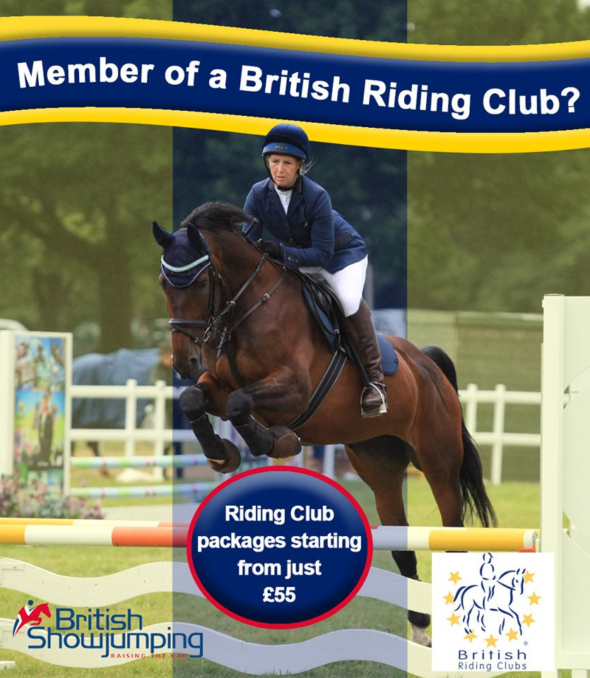
To find out if you are eligible for our Riding Club member discount please visit http://www.britishshowjumping.co.uk/membership/New-Member-Discounts or call 02476 698824

