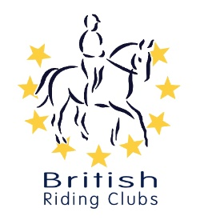

CHAMPIONSHIP DATES 2020

COMPETITION | DATE | VENUE
Arena Eventing Championships | 14 – 15 March | Washbrook Farm, Aston le Walls, Daventry, Northamptonshire, NN11 6RT
Novice Winter Championships | 28 – 29 March | Arena UK, Allington, Grantham,  NG32 2EF
Intermediate Winter Championships | 24 – 26 April | Bury Farm Equestrian Village, New Bury Farm, Mill Rd, Slapton, Bucks, LU7 9BT
Festival of the Horse | 30 – 31st May | Washbrook Farm, Aston le Walls, Daventry, Northamptonshire, NN11 6RT
Horse Trials | 07 – 09th August | Swalcliffe Park Equestrian, Grange Farm, Swalcliffe, Banbury, Oxon, OX15 5EX
National Championships | 05 – 06th September | Lincolnshire Showground, Grange de Lings, Lincoln, Lincolnshire, LN2 2NA
Dressage to Music & Quadrille Selection Trial | TBC | Bury Farm Equestrian Village, New Bury Farm, Mill Rd, Slapton, Bucks, LU7 9BT
Quadrille Final | TBC | TBC

Closing dates for all qualifiers are 21 days before the event.

Please note qualifiers should be held at least 28 days before the Championship date.

