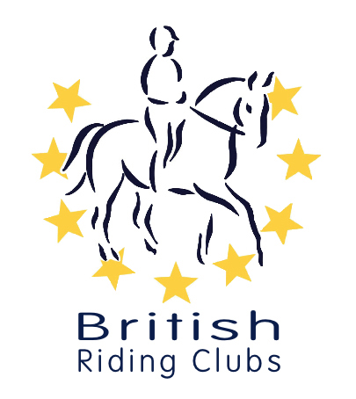
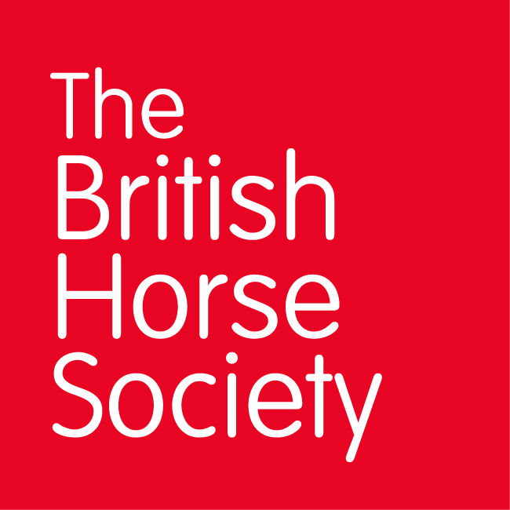
CHAMPIONSHIP DATES 2021

COMPETITION | DATE | VENUE | Notes
Winter Championships
Combined Training | 22/23rd May | Aston le Walls | Cancelled
Arena Eventing | 13/14 March | Aston le Walls | Postponed till 22/23rd May
Novice Winter | Virtual competition | Arena UK, Grantham | Contact your Club
Intermediate Winter | Virtual competition | Bury Farm Equestrian | Contact your Club
Summer Championships
Horse Trials | 6 - 8th August | Swalcliffe, nr Banbury | Going ahead as Short format competition, all classes to run as One Day Events
National | 4/5th September | Lincoln | Situation being monitored.
DTM |  |  | Situation being monitored.

