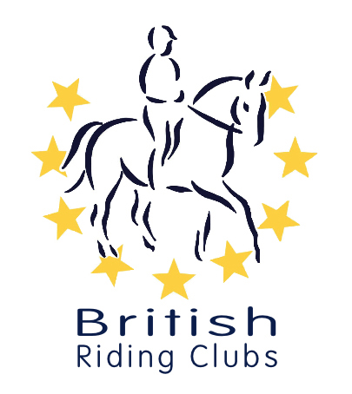
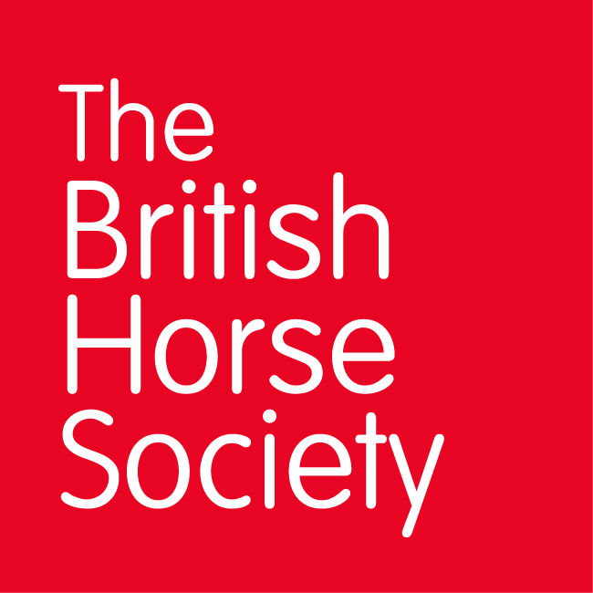
CHAMPIONSHIP DATES 2021

COMPETITION | DATE | VENUE | Notes
Winter Championships
Combined Training | 22/23rd May | Aston le Walls
Arena Eventing | 13/14 March | Aston le Walls
Novice Winter | 26 – 29th March | Arena UK, Grantham | Including 2020 Intermediate
Intermediate Winter | 23/25 April | Bury Farm Equestrian
Summer Championships
Horse Trials | 6 - 8th August | Swalcliffe, nr Banbury
National | 4/5th September | Lincoln
DTM |  |  | TBA

