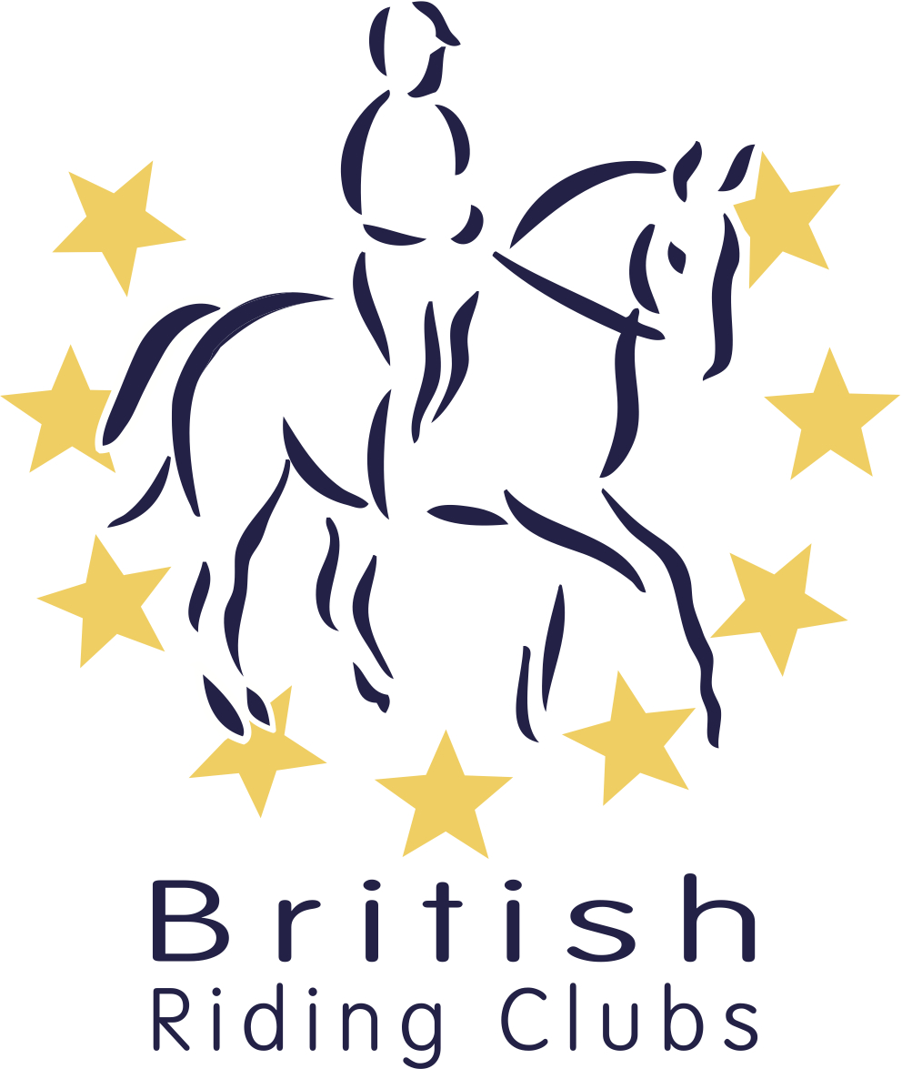
Junior Representative Form

Thank you for your interest in volunteering. By completing this form I understand that I will be representing my area and I may be contacted by its members.
Personal Information
Title:
First Names: | Surname:
Home Address:
Post Code: | BRC Membership Number:
Email: | Phone Number:
Date of Birth:

About You
What skills or experience do you have that would be relevant?

Disabilities/Health/Dietary Requirements: Any restricting factors or special requirements that you want BRC to be aware of?

How did you hear about the opportunity?

BRC Staff team | BRC Meeting/Event | BHS Website | Rider Magazine | Other
Comments and detail:

I confirm that I have read or been made aware of the BRC policies concerning:
• Role description
• Code of Conduct (as found in BRC Handbook C: Codes of Conduct)
• Photography and Social Media (as found in BRC Handbook G15.3)
• Anti-Bullying

Signature of Junior Representative

Page 1 of 2



Parental/Legal Guardian Consent
Name of Junior Representative: | Title:
First Names: | Surname:
Home Address:
Post Code: | Email:
Phone Number | Relationship to Young Person:

I give my consent that if in an emergency medical situation, BRC may act as loco parentis if the need arises for administration of first aid and/or other medical treatment which in the opinion of a qualified medical practitioner may be necessary.

Please note that to help promote and evaluate the Junior Representative there may be video filming which may be used in publicity materials e.g. leaflets, newsletters, website.

I do / do not give permission for the young person named above to be filmed or photographed during BRC activities (please delete as appropriate)
I confirm that I have read or been made aware of the BRC policies concerning:
- Role description
- Code of Conduct (as found in BRC Handbook C:Codes of Conduct)
- Photography and Social Media (as found in BRC Handbook G15.3)
- BEF Anti-Bullying Policy (http://www.bef.co.uk/Detail.aspx?page=tool-kit)

Signature of Parent/Legal Guardian

We will use your contact details to communicate with you and your parent/ legal guardian about your volunteering role and will never share any of your details with third parties. We would like to send you emails about our work, but if you would not like us to, opt out by ticking here.
Please return to brcmembership@bhs.org.uk
The British Horse Society a Registered Charity Nos. 210504 and SC038516.
Registered Address: The British Horse Society, Abbey Park, Stareton, Kenilworth, CV8 2XZ.
www.bhs.org.uk

Page 2 of 2

