New BS/BRC Show Jumping Leagues.....

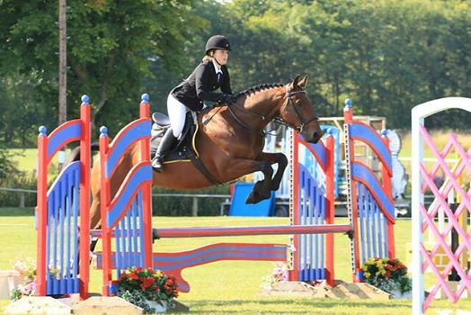

British Riding Clubs
As of the 1 April 2019 two annual BRC Leagues will be hosted on the British Showjumping website. The leagues will highlight all British Show Jumping members that are also a member of a British Riding Club and sit within either the British Showjumping Bronze or Silver leagues.
Follow the link below to find out more information about the league and to check results.
http://www.britishshowjumping.co.uk/ran…/leagues/brc-leagues

