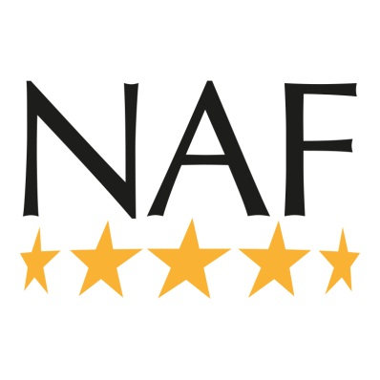
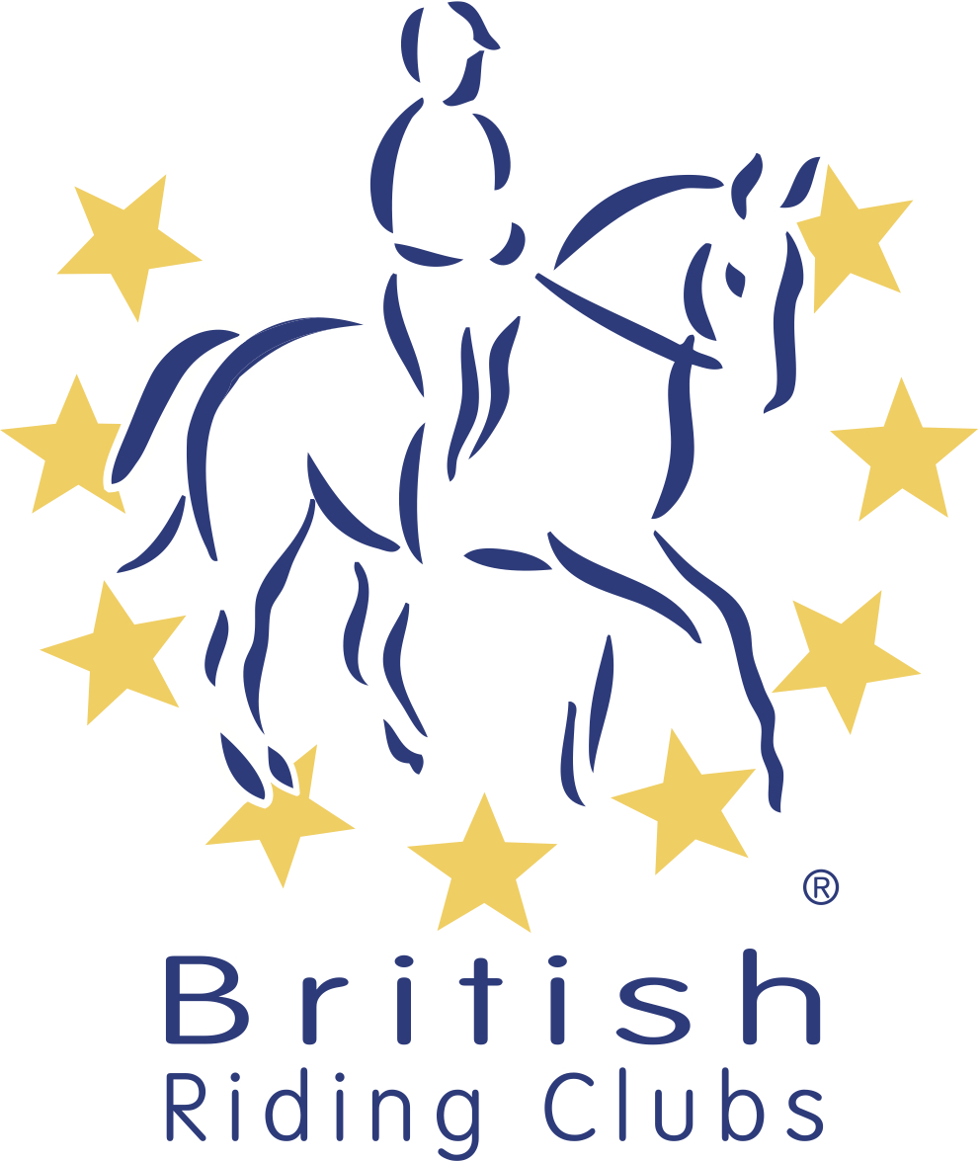
British Riding Clubs
NAF Five Star National Championships
Area Entry Form 2020
Please use as many forms as required

CLASS | TEST  (Dressage)  HEIGHT (Style J) | TEAMS & PAIRS  RIDERS | HORSE | MEMBERSHIP NO
CLASS |  | INDIVIDUALS
RIDING CLUB
AREA
ENTRY DETAILS

CONTACT DETAILS
Name
Once completed this form must be returned to the area qualifier organiser.

Please contact the organiser for entry fees and deadlines.

I agree (on behalf of the competing member/s) to be bound by the rules of British Riding Clubs. I also understand that in the unfortunate event of cancellation, refunds will be dealt with in accordance with the current Handbook. I have checked that all horses’ flu vaccinations are correct.

It is the Team Manager’s responsibility to gain parental consent for juniors to participate at BRC events.

Signed Date
Address
Daytime Contact Number
Email
Personal information that you supply to us may be used in a number of ways to facilitate your riding club membership. Your personal information will be shared with associates for the purpose of fulfilling your full membership benefits i.e. insurance providers.
BRC will automatically contact you about your membership: for example, to ensure you receive your membership benefits, to tell you about news, activities and events. This includes sending you a regular magazine, email updates, information on other membership benefits, and publishing competition times and results in the public domain.

To see our full Privacy Policy, or if you need any further information, please write to us at; British Riding Clubs, British Horse Society, Abbey Park, Stareton, Kenilworth, CV8 2XZ or go to: http://www.bhs.org.uk/privacy

