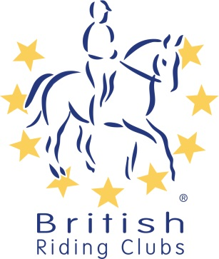
British Riding Clubs
Topspec Dressage to Music Championships
Pre-Entry Form 2020

AREA

RIDING CLUB

ENTRY DETAILS

BRC Competitions, Abbey Park, Stareton, Kenilworth,
Warwickshire, CV8 2XZ
The details given will be used for future correspondence. Please ensure all fields are completed or your entry may be returned.
Name on cheque & cheque number (This MUST be completed)

Email
Daytime Contact Number

Please return this form with correct payment to:

Payment methods:
Via the BRC Entries website

Cheque payable to British Riding Clubs

Over the phone on 02476 840518

BACs payments will no longer be accepted.

This form must be received 21 days before the date of the qualifier.

I agree (on behalf of the competing member/s) to be bound by the rules of British Riding Clubs. I also understand that in the unfortunate event of cancellation, refunds will be dealt with in accordance with the current Handbook. I have checked that all horses’ flu vaccinations are correct.

It is the Team Manager’s responsibility to gain parental consent for juniors to participate at BRC events.

By making this booking, I confirm that I have permission to act on behalf of the individuals concerned.

Signed Date
Address

Name

Personal information that you supply to us may be used in a number of ways to facilitate your riding club membership. Your personal information will be shared with associates for the purpose of fulfilling your full membership benefits i.e. insurance providers. BRC will automatically contact you about your membership: for example, to ensure you receive your membership benefits, to tell you about news, activities and events. This includes sending you a regular magazine, email updates, information on other membership benefits, and publishing competition times and results in the public domain. To see our full Privacy Policy go to: http://www.bhs.org.uk/privacy

CLASS |  | PRICE | Test | QUANTITY | SUB TOTAL
Pick a Test | Medium | £20.00 | BD Medium Freestyle to Music (2019)
 | Advanced Medium | £20.00 | BD Advanced Medium Freestyle to Music (2016)
Elementary Individual |  | £20.00 | BD Elementary Freestyle to Music (2019)
Senior Novice Individual | 0 Points | £20.00 | BD Novice Freestyle to Music (2019)
 | With Points | £20.00 | BD Novice Freestyle to Music (2019)
Junior Novice Individual |  | £20.00 | BD Novice Freestyle to Music (2019)
Senior Prelim Individual |  | £20.00 | BD Prelim Freestyle to Music (2016)
Junior Prelim Individual |  | £20.00 | BD Prelim Freestyle to Music (2016)
Novice Pairs (Mixed) |  | £26.00 | BRC Novice Pairs Dressage to Music (2018)
Pairs (Mixed) |  | £26.00 | BRC Pairs Dressage to Music (2018)
TOTAL

