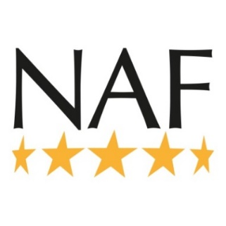
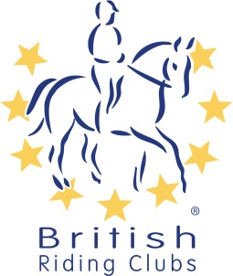
British Riding Clubs
NAF Five Star National Championships
Pre-Entry Form 2020
Show & Style Jumping

The details given will be used for future correspondence. Please ensure all fields are completed or your entry may be returned.
Email

RIDING CLUB

AREA

CLASS | TEAM/INDIVIDUAL | PRICE | QUANTITY | SUB TOTAL
110cm Show Jumping | Team | £32.00
 | Individual | £10.00
100cm Show Jumping | Team | £32.00
 | Individual | £10.00
Senior 90cm Show Jumping | Team | £32.00
 | Individual | £10.00
Senior 80cm Show Jumping | Team | £32.00
 | Individual | £10.00
Senior 70cm Show Jumping | Team | £32.00
 | Individual | £10.00
Senior Style Jumping | Team | £32.00
 | Individual 75cm | £10.00
 | Individual 85cm | £10.00
Junior 90cm Show Jumping | Team | £32.00
 | Individual | £10.00
Junior 80cm Show Jumping | Team | £32.00
 | Individual | £10.00
Junior 70cm Show Jumping | Team | £32.00
 | Individual | £10.00
Junior Style Jumping | Team | £32.00
 | Individual 75cm | £10.00
 | Individual 85cm | £10.00
Open 80cm Show Jumping | Individual | £10.00
TOTAL
CONTACT DETAILS
Personal information that you supply to us may be used in a number of ways to facilitate your riding club membership. Your personal information will be shared with associates for the purpose of fulfilling your full membership benefits i.e. insurance providers. BRC will automatically contact you about your membership: for example, to ensure you receive your membership benefits, to tell you about news, activities and events. This includes sending you a regular magazine, email updates, information on other membership benefits, and publishing competition times and results in the public domain. To see our full Privacy Policy go to: http://www.bhs.org.uk/privacy

Please return this form with correct payment to:

Payment methods:
Via the BRC Entries website

Cheque payable to British Riding Clubs

Over the phone on 02476 840518

BACs payments will no longer be accepted.

This form must be received 21 days before the date of the qualifier.

I agree (on behalf of the competing member/s) to be bound by the rules of British Riding Clubs. I also understand that in the unfortunate event of cancellation, refunds will be dealt with in accordance with the current Handbook. I have checked that all horses’ flu vaccinations are correct.

It is the Team Manager’s responsibility to gain parental consent for juniors to participate at BRC events.

By making this booking, I confirm that I have permission to act on behalf of the individuals concerned.

Signed Date
Name:
Address

Daytime Contact Number:
Email
The details given will be used for future correspondence. Please ensure all fields are completed or your entry may be returned.
Name on cheque, cheque number (This MUST be completed)

BRC Competitions, Abbey Park, Stareton, Kenilworth,
Warwickshire, CV8 2XZ

