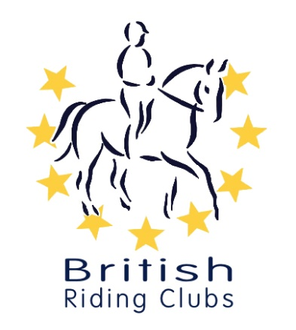

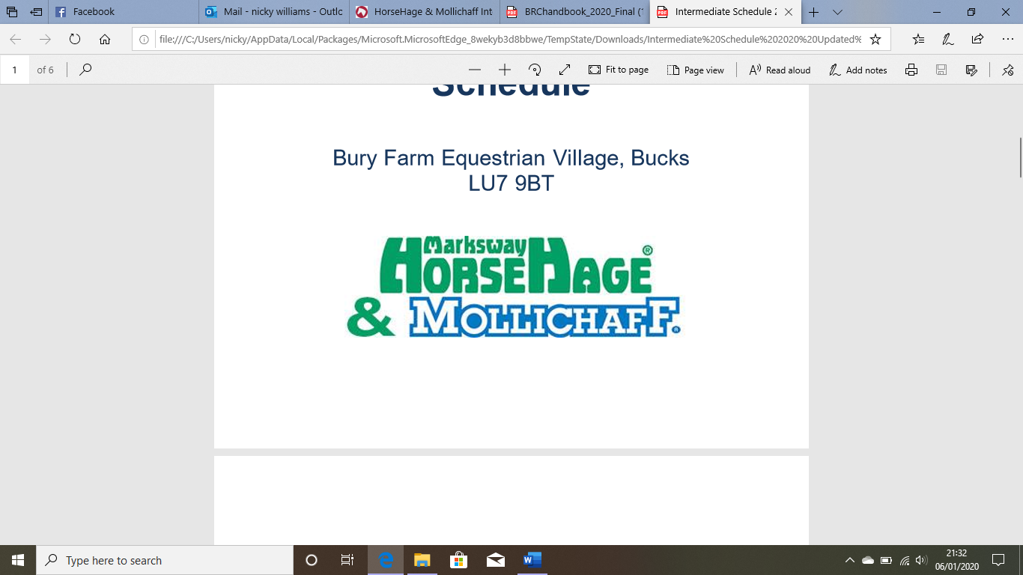

|  |  |  |
| --- | --- | --- |
| Junior Winter  Show Jumping  (Qualifier)  Max height  1st round: 90cm | Open to Junior members of an affiliated Riding Club that have paid their membership for the current year.  See current BRC 2020 rule book for Eligibility of Horses (Juniors) and also any updated changed as published by BRC website.  The same horse cannot be used for the Senior and Junior section. | £60 per team  £15 individual |
| Senior Winter  Show Jumping  (Qualifier)  Max height  1st round: 90cm | Open to Senior members of an affiliated Riding Club that have paid their membership for the current year.  See current BRC 2020 rule book for Eligibility of Horses (Seniors) and also any updated changed as published by BRC website.  The same horse cannot be used for the Junior and Senior section. | £60 per team  £15 individual |
| Winter Show Jumping  (Qualifier)  Max Height  1st round: 100cm | Open to Junior & Senior members of an affiliated Riding Club that have paid their membership for the current year.  See current BRC 2020 rule book for Eligibility of Horses.  This is a mixed class open to senior and junior teams and individuals, teams may be any combination of senior and/or junior | £60 per team  £15 individual |
| Winter Show Jumping  (Qualifier)  Max Height  1st round: 110cm | Open to Junior & Senior members of an affiliated Riding Club that have paid their membership for the current year.  See current BRC 2020 rule book for Eligibility of Horses.  This is a mixed class open to senior and junior teams and individuals, teams may be any combination of senior and/or junior | £60 per team  £15 individual |

British Riding Clubs

Winter Intermediate / Open Show Jumping Qualifier

For the BRC Winter Championships 2020

Area 20 Schedule

Sunday 7th November 2021

at

Kelsall Hill Equestrian Centre, Organsdale Farm, Middlewich Road, Nr Tarporley Cheshire CW6 0SR.

CH7 6AA

This Winter Championship will be held at Bury Farm Equestrian Centre, Mill Road, Slapton, Leighton Buzzard, LU7 9BT

On 24 – 26 April 2020

This winter championship will be held at Bury Farm Equestrian Centre, Mill Road, Slapton, Leighton Buzzard, LU7 9BT

On 22nd – 24th April 2022.

Riders jump one round. All rounds are timed; the second-round time is used to determine minor placings when faults cannot do this. All will jump against the clock immediately after the first round, even with faults unless eliminated.

All entrants must pay a prelim entry of £*32* per team or £10 for an individual to British Riding Clubs at least 21 days before the date of the qualifier (above). Prelim entry forms can be found on the BRC website for postal entries [www.britishridingclubs.org.uk](http://www.britishridingclubs.org.uk) or online entries can be made via the BHS bookshop [www.britishhorse.com](http://www.britishhorse.com) Late prelim entries may be accepted with a late surcharge of £20 per team at the discretion of the organiser if there are sufficient spaces. Late entries cannot be guaranteed and must not be paid for unless approval from the organiser has been sought.

All entries to be sent to the organiser on the official entry forms (Available online at: http://www.bhs.org.uk/enjoy-riding/british-riding-clubs/brc-downloads/brc-downloads/brc-entry-forms

If the date of the qualifier is cancelled for any reason, the close of prelim entry will remain. However, if the qualifier is moved more than 21 days later, entries will be re-opened but late entry fees cannot be refunded. Eligibility will be considered from the original close of prelim entry.

Protective Headgear

‘Protective Headwear’ must be worn at all times by anyone, whether or not a Competitor, riding anywhere at a BRC event. Harnesses must be correctly adjusted and fastened. At all BRC Championships and qualifiers ‘Protective Headwear’ must show a visible Aqua BRC ‘hat tag’. ‘Protective Headwear’ constitutes a hat which meets one of the current standards as detailed in the BRC 2020 rule book.

Your horse must have up to date influenza vaccinations in line with rule G7 in the current BRC Rulebook. BRC Flu vaccination policy as of 1st October = last jab within 12 months, no vaccinations within 7 days of the competition, and all horse must be microchipped.

British Riding Clubs and the Organiser of this event have taken reasonable precautions to ensure the health and safety of everyone present. For these measures to be effective everyone must take all reasonable precautions to avoid and prevent accidents occurring and must obey the instructions of the organiser and all the officials and stewards.

Save for death or serious injury caused by the negligence of the organiser, Area 20 Liaison Committee or any one for whom they are in law responsible, neither the organiser or Area 20 Liaison Committee, nor any agent , employee or representative accept any liability for accidents, loss, damage, injury or illness to horses, owners, riders, spectators, land, cars, their contents and accessories or any other person or property whatsoever, whether caused by their negligence, breach of contract or in any other way whatsoever.

Organiser Details

Nantwich Riding Club

Entries to Lisa Cadman, 32 Wynter Lane, Tilston, Malpas, Cheshire, SY14 7HD.

[lisa_cadman@btinternet.com](mailto:Nicky785@hotmail.com) or 07792 943096

Contact on the day as above

Bank transfer by arrangement

Closing date for entries for Prelims to BRC Headquarters and to NRC is Monday 11th October 2021.

Times will be published on Area 20 website on 1st November 2021

Last date for alterations is Thursday 4th November, NO alterations after this date must be made.

Each Riding Club to appoint a Chef d'Equipe who is responsible for making declarations, collecting team numbers and being the point of contact throughout the day.

One helper per team, the details of whom MUST be sent with the team entry.

If there is a changeover of helpers during the day it must be made clear to those people concerned that they do not under any circumstances abandon their post until the person who is taking over arrives and a proper hand over can be achieved.

By the same token the organiser must be notified of the details of ALL helpers

Jobs will include arena stewarding, warm up arena stewarding, lorry park, pole pickers