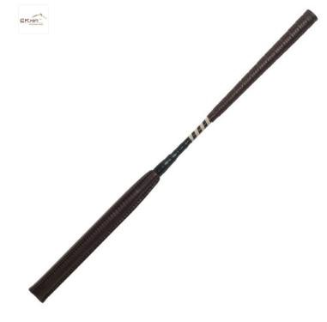
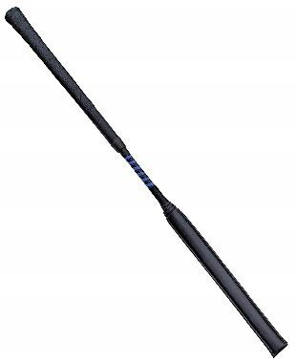

Allowable Whips

WHIP

No rider may carry, use or permit to be used a whip other than as detailed below, in the arena, the collecting ring or anywhere, on, or in the immediate vicinity of the showground. Only one whip may be carried and no substitute for a whip may be carried. A whip, if carried, must be held in the hand by the handle with the handle at the top. Also see rule 103.1.4.2 Excessive use of the whip.
- The maximum length of the “Whip” is 70cm and must be no less than 45cm.
- There must be no “binding” within 17 centimetres of the end of the “Pad”.
- The minimum diameter for a “Shaft” is 1 centimetre and the “Shaft” should run through the entirety of the whip.
- The overall weight of the “Whip” must not exceed 160 grams and the weight should be evenly distributed throughout the full length of the “Whip”.
- The “Contact area”, is considered to be 2/5’s (two fifths) of the overall length of the “Whip” and must be covered with a “Pad”.
- The “Pad” must be smooth, with no protrusion or raised surface, and be made of shock absorbing material throughout its circumference such that it gives a compression factor of at least 6mm. There is to be no wording, advertising or personalisation of any kind on the “Pad”.

Definitions
The “Whip” The singular term for the equipment in its entirety. The “Shaft” The term for the central core of the equipment.
The “Handle” The term for the riders contact area.
The “Contact Area” The term for the area that will contact or may potentially contact the horse. The “Pad” The term for the padded area that covers the shaft.
The “Binding” The term given to the threaded area between the “shaft” and the “pad” that joins the two together.

