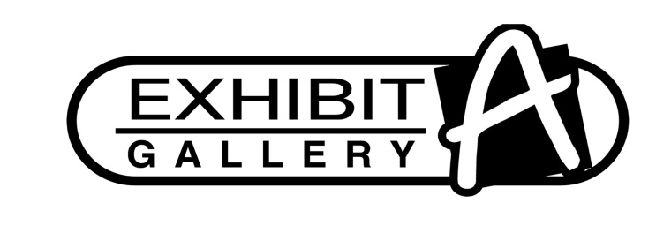

4707 N. Prospect Rd., Peoria Heights, IL 61616 (309) 693-6180

**INVENTORY FORM**

**Name _____________________________________________________ Phone _____________­­____**

**Address ____________________________________City________________Zip Code_____________**

**Email _____________________________________________________________________________**

|  |  |  |  |  |
| --- | --- | --- | --- | --- |
| **QTY** | **Description** | **Item #** | **Retail** | **40% Commission** |
|  |  |  |  |  |
|  |  |  |  |  |
|  |  |  |  |  |
|  |  |  |  |  |
|  |  |  |  |  |
|  |  |  |  |  |
|  |  |  |  |  |
|  |  |  |  |  |
|  |  |  |  |  |
|  |  |  |  |  |
|  |  |  |  |  |
|  |  |  |  |  |
|  |  |  |  |  |
|  |  |  |  |  |
|  |  |  |  |  |
|  |  |  |  |  |
|  |  |  |  |  |
|  |  |  |  |  |
|  |  |  |  |  |

* Any commission checks over $600 must supply a completed 1099 before a check is issued.
* The gallery will pay all Illinois sales tax applicable to the sale of each work sold.
* Exhibit A Gallery resumes no responsibility for the loss, damage, fire or destruction of consigned artwork. Exhibit A Gallery is under no obligation to reimburse the artist for property loss of any kind. Utmost care will be taken to protect Artist property within the gallery.

_____________________________________ _____________________________________

Signature of Artist Signature of Gallery Representative