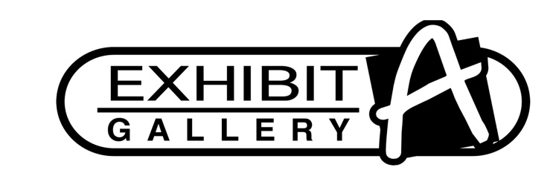
4707 N. Prospect Rd., Peoria Heights, IL 61616 (309) 693-6180

INVENTORY FORM

Name _____________________________________________________ Phone _________________

Address ____________________________________City________________Zip Code_____________

Email _____________________________________________________________________________

QTY | Description | Medium | Retail | 40% Commission

- Any commission checks over $600 must supply a completed 1099 before a check is issued.
- The gallery will pay all Illinois sales tax applicable to the sale of each work sold.
- Exhibit A Gallery resumes no responsibility for the loss, damage, fire or destruction of consigned artwork. Exhibit A Gallery is under no obligation to reimburse the artist for property loss of any kind. Utmost care will be taken to protect Artist property within the gallery.

_____________________________________ _____________________________________
Signature of Artist Signature of Gallery Representative

