UPCYCLING TOM PROJECT 2024
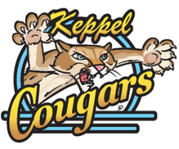
Thanks to the Cougars at Keppel for participating in the Upcycling TOM Project! The TOM & OSWW – Owen Sound Waste Watchers teams are very excited to see your class upcycling creations! Below outline the rules and guidelines to keep in mind when creating your masterpieces.
CLASS PROJECT
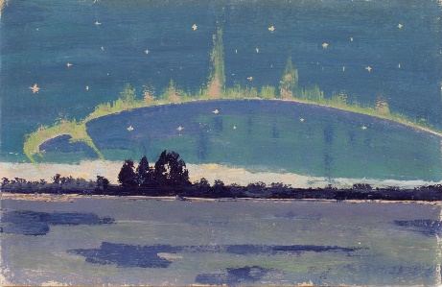
As a class, use recycled or repurposed materials to recreate the famous painting “Northern Lights” by local legend and painter Tom Thomson. This process is called upcycling – recycling, reducing waste and repurposing of material through creative expression and innovation. Don’t be afraid to think outside of the box! The sky is the limit!

ART SUBMISSION RULES & GUIDELINES
- Each class will be provided with a canvas for creating their masterpiece. Please use this canvas as the base of your creations.
- Your class must only use fully recycled/reused materials or single-use plastics in your artwork. Examples of these materials includes bottle caps, egg cartons, cardboard, glass, paper, metal and tin cans, wood, clothing, denim, plastic utensils, plastic containers, lids, scrap fabric and textiles; artworks can include elements such as: painting, collage, sculpture, and drawing.
- You may not buy any materials for your artwork. It must be made from items found and recycled items around your home, school or outdoors.
- Please abide by common safety precautions when collecting materials for your artwork (wash items and wash hands thoroughly after collection and making your artwork).
- Each class will fill out a Submission Form to go along with their artwork submission.
- Each class will complete their artworks by Thursday March 7, 2024 as all artworks will be picked up on March 8, 2024 for installation at the Tom Thomson Art Gallery in April. The artworks will be on display at the TOM for the month of April in connection with Earth Day on Monday April 22, 2024, then in storefront along the River District for the month of May.

UPCYCLING TOM PROJECT 2024
Submission Form
Please complete the following submission form/photo release permission and attach bottom part of the form to the back of the class artwork with painter’s tape. Please take a photograph of your class artwork and email a jpg along with a copy of this submission form to Heather McLeese at hmcleese@tomthomson.org.
Artwork pick up: Friday March 8 - please ensure all artwork is completed by Thursday March 7th
Name of Teacher: ______________________________________________________________
Email Address of Teacher: ________________________________________________________
Grade Level: ___________________________________________________________________
Artwork Title: __________________________________________________________________
Explanation of Artwork (no more than 200 words): ________________________________________________________________________________________________________________________________________________________________________________________________________________________________________________________________________________________________________________________________________________________________.
Artwork Photography Permission and Copyright Release
By participating and submitting your Upcycling TOM artworks to the Gallery, you are agreeing the legal release of your photographs and future photographs of the project. I hereby authorize the Tom Thomson Art Gallery (TOM), City of Owen Sound (COS) and Owen Sound Waste Watchers (OSWW) to publish photographs taken of artwork for the unrestricted use of images on a royalty-free basis for promotional purposes including the websites and printed marketing materials. I am aware that this form releases the TOM, COS, OSWW from any liabilities or claims.
I, _______________________________________ (Teacher’s print name) understand and agree to the terms of this artwork photography permission and copyright release.

Teacher’s Signature: _____________________________________ Date: ____________________________
----------------------------------------------------------------------------------------------------------------------------------Name of Teacher: ____________________________________________________________
Email of Teacher: ____________________________________________________________
Grade Level: ________________________________________________________________
Artwork Title: _______________________________________________________________

