**Finding Scholarships**

**Naviance Student**

*Log in via CLEVER/Broward Schools Single Sign On*

1. Click on the “Colleges” tab on top



1. Click Scholarships & Money

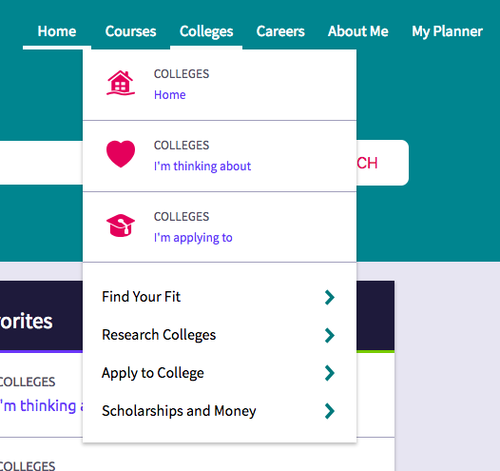

* **National Scholarship Search:** millions of dollars in scholarships from around the country
* **Scholarship List:** list of LOCAL Scholarships; input by District
* **Scholarship Match:** matches your criteria to LOCAL scholarships
* **Scholarship applications:** the applications you select to which you are going to apply

**Free Internet Scholarship Databases**

http://www.fastweb.com/

http://www.scholarshipguidance.com/

http://kaarme.com/kscholarships/search

http://www.meritaid.com/

http://www.cappex.com/

http://www.latinocollegedollars.org/

http://www.scholarshipexperts.com/

https://bigfuture.collegeboard.org/scholarshipsearch

https://www.raise.me/

**Other scholarship sources:**

* Parent(s)’ employers and YOUR employer often have scholarship programs for employees/children of employees
* The universities you are applying to- check their Financial Aid page on their website for additional scholarship opportunities!
* Follow The Scholarship Plug on Instagram, Twitter, Facebook & Snapchat