OSSTF Provincial Teacher Long Term Disability (LTD) Plan

Coverage Termination Provisions

You may qualify to cancel your LTD coverage if you meet any one of the following criteria as set out by your plan.

Scenario 1:  60% unreduced service pension | Scenario 2:  Upcoming Retirement | Scenario 3:  Age 65
You are eligible for a 60% unreduced service pension now.  OR  You are eligible for a 60% unreduced service pension within the later of the next 110 working days or expiration of sick leave and in no event more than 24 months. | Your board approved retirement date is within the next 110 working days. | You have reached the end of the month in which you turned age 65.  OR  You will reach the end of the month in which you turn age 65, within the later of the next 110 working days or expiration of sick leave and in no event more than 24 months.
Note for Scenario 1:
What is an unreduced pension?
Your retirement pension is calculated without a reduction or penalty.
To qualify for an unreduced pension under the Ontario Teachers’ Pension Plan (OTPP), you must have the “85 factor” (age + qualifying service = 85).
To qualify for a 60% unreduced pension, you must have 30 years of credited service and meet the above “unreduced pension” criteria.
Note for Scenario 2:
IMPORTANT information to consider BEFORE terminating your LTD coverage due to your upcoming retirement. If you maintain your LTD coverage:
- You are still eligible for coverage under the OSSTF Teacher Provincial LTD Plan up to the date of your retirement. You are not required to cancel your coverage simply because you have notified your board of your intention to retire.
- If you became disabled prior to your date of retirement, you are eligible to submit an LTD claim. If approved, LTD benefits would be payable until either you recover, you become eligible for a 60% unreduced service pension, or you reach the end of the month you attain age 65 (as long as you are not receiving OTPP pension benefits).
If you terminate your LTD in Scenario 2 and become disabled before retirement, you WILL NOT be eligible for LTD.

Termination of LTD Contributions:

Scenario 1 and Scenario 3:
- If your termination effective date is retroactive, your overpaid LTD contribution deductions will be refunded; limited to the current school year and one school year prior.

Scenario 2:
- If your application is received by the 15th of the month, coverage will be terminated effective on the 1st day of the following month.
- If your application is received after the 15th of the month, coverage will be terminated effective the 1st day of the second following month.
- Please note: Termination from the LTD plan will not be made retroactively.

How to complete the Application for Long Term Disability (LTD) Coverage Termination
If you meet one of the above scenarios, you can apply to terminate your LTD coverage and discontinue your LTD contribution deductions. Please complete and submit an Application for Long Term Disability Coverage Termination form including the supporting documentation required in order to process your request.

If you are exiting the plan based on a 60% unreduced service pension, the following documents are required to accompany your application form:

- The first page of your OTPP Annual Pension Statement confirming when you were or will be eligible for an unreduced pension – see example on page 3.
- The first page of your Current OTPP Service Record – see example on page 4.
- If you have already submitted your retirement to OTPP you will need to include your Retirement Statement – see example on page 5.

You can obtain these documents by logging into the Ontario Teacher’s Pension Plan (OTPP) Members Login Page.

If you need assistance, please reach out to OTPP directly.

Online via www.otpp.com/members/my/
Email at inquiry@otpp.com
Call 1-800-668-0105

Questions and where to send LTD Termination Application to:
The OSSTF Provincial Teacher LTD plan is sponsored by OSSTF. Please direct your questions to your local OSSTF district office. To ensure LTD contribution deductions are discontinued by a desired date, please submit your completed form with the necessary documentation as soon as possible to:

OSSTF District TBU contact name and contact details
<ENTER INFO>

Sample OTPP Annual Pension Statement
In the example below, you will see on the right side highlighted in blue, the earliest unreduced service pension date was January 1, 2022.

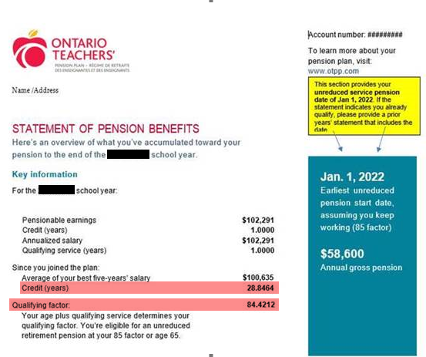

Sample OTPP Service Record
Please provide a copy of the first page of this statement.

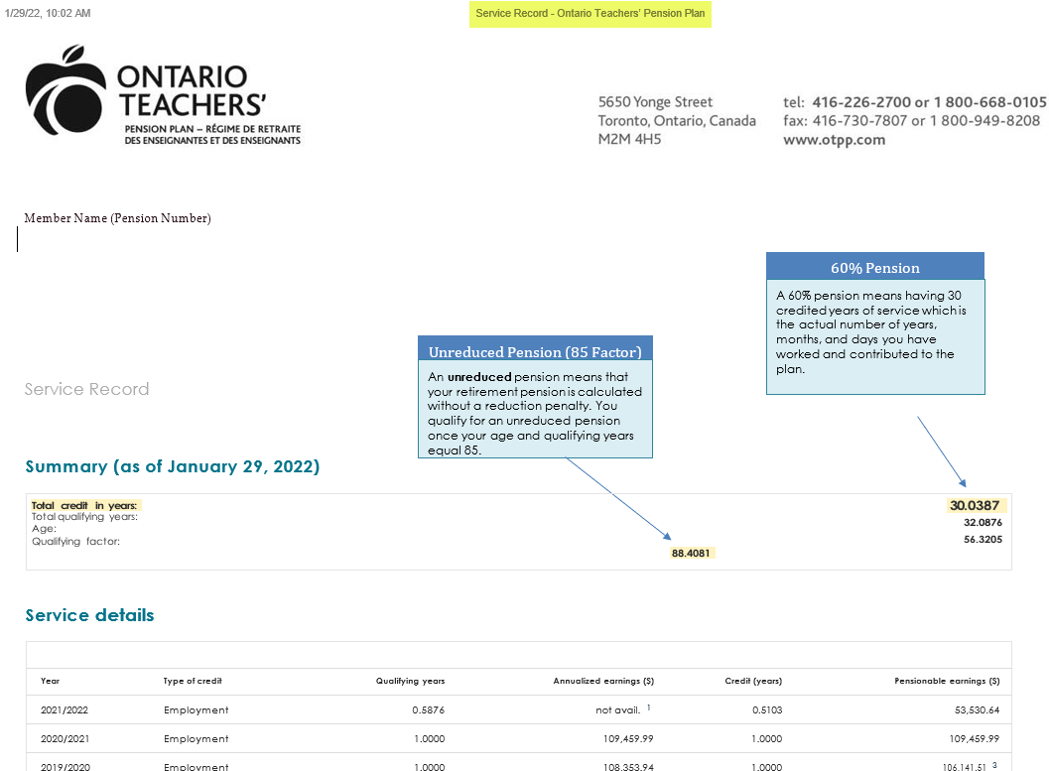

Sample Retirement Statement
This statement would only be required if you already submitted your retirement to OTPP.

