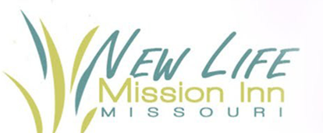

30 in 30 Challenge

Presented by New Life Mission Inn

June 1-30, 2022 | Registration May 2-13

Join in the fun as New Life Mission Inn hosts 30 in 30 Challenge. Accept the challenge and walk, run, bike, or swim 30 miles in 30 days. Participants will take on the challenge and create new healthy habits. Registration fee is $30 per person. Participants registering before May 13 will receive a challenge shirt, tracking log, certificate of completion, and a chance to win great prizes.

For more information or to register please contact Denise at [denisew@newlifemissioninn.com](mailto:denisew@newlifemissioninn.com), 573-513-2918, or stop by New Life Mission Inn Office during business hours.