Reaching Milestones through Therpay, Inc.

**16 Regency Plaza**

**Glen Mills, PA 19342**

**Phone: (302) 588-2032**

**Fax: (610)459-4726**

**Director: Kathleen A. Carney, M.S., CCC/SLP**

Email: [reachingmilestonesinc@gmail.com](mailto:reachingmilestonesinc@gmail.com)

Website:

[www.reachingmilestones.net](http://www.reachingmilestones.net)

* FAMILY
* CHILD
* PEERS
* TEACHER
* DAY CARE
* HOME
* SCHOOL
* COMMUNITY

EMPOWERING FAMILIES

SUPPORTING FAMILIES AND CLASSROOMS

PROVIING ESSENTIAL FOUNDATIONS FOR SUBSEQUENT LEARNING TO OCCUR

BEST PRACTICES THROUGH MEANINGFUL PLAY, CONCRETE SENSORY INTERACTIONS AND INTENTIONAL ACTIVITES, EXPERIENCES, AND ACTIVE EXPLORATION OF THE ENVIROMENT.

ENGAGING THE CHILD’S CURIOSITY

# Reaching Milestones through Therapy, Inc.

Early Intervention Services

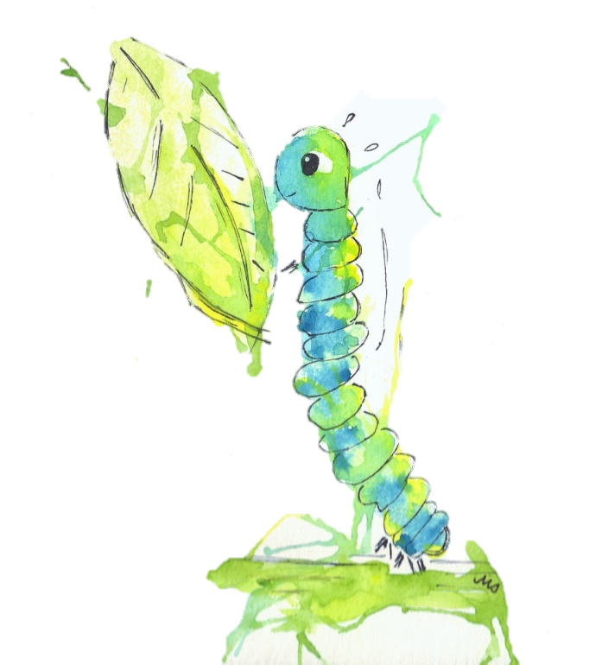

16 Regency Plaza

Glen Mills, PA 19342

(302) 588-2032

Fax: (610)459-4726

### TEN TIPS

FOR RAISING HAPPIER, HEALTHIER CHILDREN

1. Be warm, loving, and responsive.
2. Respond to the child’s cues and clues.
3. Talk, sing and read to your child.
4. Establish rituals and routines.
5. Encourage safe new experiences and play.
6. Make television watching selective.
7. Use discipline as an opportunity to teach.
8. Recognize that each child is unique.
9. Choose quality child care and stay involved.
10. Take care of yourself.

*TEN TIPS* was developed by the national I am your child campaign. Their goal is to make early childhood development a top priority for our nation.

www.iamyourchild.org

**MISSION STATEMENT:**

Reaching Milestones Through Therapy, Inc. is a reputable early intervention agency, dedicated to providing quality services to children and their families. Reaching Milestones maintains a family-centered philosophy that supports the family as the most significant component to the child’s progress. Support and encouragement, in combination with therapeutic skills and teaching, are offered by a knowledgeable and caring professional team. Through these services, families are empowered to incorporate therapeutic strategies into daily routines, maximizing the child’s ability to participate within their environment. We provide Occupational and Physical Therapy, Speech-Language Pathology, Special Instruction and Nutrition Services to the child and family within the home and community environments.

### Services

Speech- Language Pathology

Articulation Therapy

Oral-Motor-Feeding Therapy

Occupational Therapy

Physical Therapy

Special Instruction

