
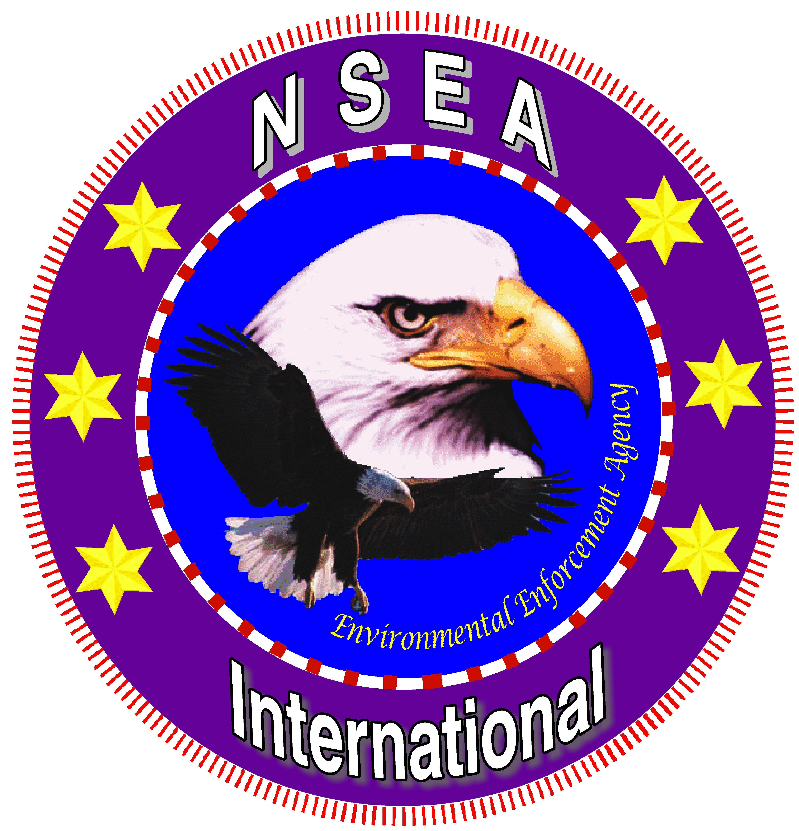

From the Ministers for the Environment

NOTICE to:
All corporate officers, aka STATE PATROL, COUNTY SHERIFF and DEPUTY SHERIFFS, and CITY POLICE.
Private Traveler and Conveyance of Personal Consumer Goods

RE: Car tag and America National Identification

We are informing you of our foreign status as non-federal America Nationals, the people having sent lawful Notices to the offices of Secretaries of all nation-States for America or equivalent qualifying agencies, the Attorney General in Washington, DC along with United Nations Secretary General Ban Ki Moon Noticing same of our America National standing along with a sample of identification cards and car tags.

All America Nationals declare that they are not DRIVERS nor do we OPERATE MOTOR VEHICLES nor do any non-Federal-citizen America Nationals NEED ANY APPLICATION FOR ANY [CORPORATE] LICENSES. It is advised that you recognize all properties that are mentioned and respect our status as foreign, private traveler, and standing having absolute diplomatic immunity as confirmed under Pub.L 92-500, Sec. 2., Sec. 505(a). America Nationals are without the municipal-chartered/franchised CORPORATE UNITED STATES, FEDERAL OR POLITICAL SUBDIVISIONS, or STATES, aka “persons” as defined under Pub.L. 92-500, Sec. 2., Sec.309(c)(3). We are non-federal, non-corporate and are not governing authorities subject to your private codes, rules, regulations, or ordinances. We are the posterity of the founding fathers, we the people, civilian America Nationals – STAND DOWN!

The forgotten legal maxim is that free people have a right to travel on the roads which are provided by their servants for that purpose, using any ordinary transportation of the day. Licensing cannot be required of free people because taking on the restrictions of a license requires the surrender of a right. Supreme Court decision states that no corporate ID is needed to transport ourselves.

Enclosed is an attachment of the Notice of Acquiescence sent to the offices of the Attorney General in Washington DC and United Nations Secretary General as well as the Secretary of State for each individual state.

DEMAND FOR SPECIFIC PERFORMANCE

WARNING – You are hereby DEMANDED; DO NOT STOP! DO NOT DETAIN!

We come in Peace! Your individual failure to comply with this DEMAND shall justify lawful action for civil damages to redress our grievances under International Laws.

Public Law 92-500 Sec. 2, section 505 (a)(1) guarantees Article XI diplomatic Immunity for the Ministers for the Environment

