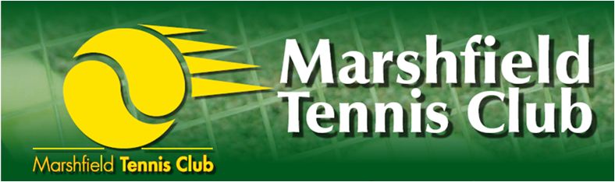

Accident and Emergency Information

In the event of an accident please see below:

- Stay calm but act swiftly and observe the situation. Is there any danger of further injuries?
- Listen to what the injured person is saying
- If the injury is minor, alert your first aider to take appropriate action
- If the injury requires specialist treatment, call the emergency services
- Deal with the rest of the group and ensure that they are adequately supervised
- Do not move someone with major injuries - wait for the emergency services
- Contact the injured person’s parent/carer
- Complete an incident/accident report form – this can be found with the First Aid kit

The first aid kit is located:

In the Clubhouse

Don’t forget to record any accident/incident in an accident/incident report form, which can be found on the notice board and next to the first aid boxes. This should be completed in full and then passed on to a member of the committee, to ensure it is officially recorded and any necessary action is taken.
Accident/emergency contact information
List of qualified first aiders:

- Trish Luckett, 142 High Street, Marshfield Tel: 01225 891081
- Rachel Cooper, 1 St Martins Park, Marshfield Tel: 01225 891194

Nearest Accident and Emergency Department:

ROYAL UNITED HOSPITAL (24 HOURS)
COMBE PARK
BATH
BA1 3NG
TEL: 01225 428331

For advice about injuries or accidents of a less severe nature, please call:

NHS Direct 0845 4647

On witnessing an accident or emergency, please ensure you complete an accident report form and hand to a member of the committee.

