All dogs must:
- Current on Rabies, Distemper/lepto/parvo, Bordetella and any other required vaccinations
- Be at least 16 weeks old
- Be spayed or neutered if 7 months of older (less than 1 year old will be assessed on individual basis)
- Be in general good health
- Be free of fleas and ticks and be on a preventative
- Be non-aggressive towards other dogs and people
- Complete Smooch my Pooch interview process to Smooch my Pooch's satisfaction in its sole discretion
- Be leashed when entering and exiting Smooch my Pooch

ORAL OR NASAL BORDETELLA MUST BE GIVEN EVERY 6 (SIX) MONTHS AND ATLEAST 48 HOURS PRIOR TO CHECK-IN (14 DAYS PRIOR TO CHECK IN IF ITS AN INJECTABLE BORDETELLA)
FOOD:
Please supply enough food for your dog's entire stay.
Please bring food in a sealed plastic container or ziplock bags.
Do not change your dog's food prior to their stay as this will result in an upset stomach. Dogs will be fed according to the instructions provided on the application or you later provide. They are fed AM and PM only so if you would like additional feeding times you must provide food and additional instructions.
PERSONAL PROPERTY:
SMOOCH MY POOCH WILL NOT BE LIABLE FOR ANY LOST, STOLEN OR DAMAGED PERSONAL PROPERTY BELONGING TO YOU OR YOUR POOCH. IF YOUR PET DAMAGES ANY PROPERTY AT SMOOCH MY POOCH YOU WILL BE LIABLE FOR THE FULL COST OF REPAIRS AND REPLACEMENTS.
***NO BEDS WITH STUFFING ARE ALLOWED***
FEES:
You must pay for all services and products via credit card, cash or check. All payment is due at the time you pick up your pooch. Credit card transactions will be charged an additional 3.99% processing fee. You further agree to pay any collections costs and the cost of any returned checks or debit charges.
AGGRESSIVE DOGS:
In order to participate in doggie daycare, your pooch may not be aggressive and must pass a temperament assessment. Your pooch may be separated from others or asked not to return if he/she exhibits aggressive or other unacceptable behavior in Smooch my Pooch's sole discretion.
ABANDONED DOGS:
You may not leave your pooch at doggie daycare or overnight past the scheduled pick-up time without prior communication with Smooch my Pooch staff. If you leave your pooch at our facility without any contact, instruction or notification regarding pickup, he/she will be deemed ABANDONED at 6pm on the seventh (7th) day after the scheduled pick up date. Smooch my Pooch will then become its legal owner and guardian. Smooch my Pooch will, in its sole discretion, determine whether to re-home or relinquish to a rescue.
DUTY TO DISCLOSE:
You must disclose on a continuing basis, any and all medical or other conditions, including but not limited to personality concerns or behavioral incidents that may affect, limit or prevent your pooch's ability to participate in doggie daycare or any other services.
VETERINARY CARE:
Smooch my Pooch will have the right to obtain medical treatment If it appears that your pooch may be ill, injured or exhibits any other behavior that would reasonably suggest he/she may need medical treatment. Reasonable efforts will be made to contact you when Smooch my Pooch determines that medical treatment is necessary, but if Smooch my Pooch is unable to contact you or your emergency contact, Smooch my Pooch will rely on this section as your consent to treat your pooch. you hereby grant the veterinarian and Smooch my Pooch the right to make medically necessary decisions for your pets treatment and release the veterinarian and Smooch my Pooch from all liability for the same. If you are unable to be reached but your emergency contact is reached, you hereby grant your emergency contact the right to make medically necessary decisions for treatment.
YOU AGREE TO BE FULLY RESPONSIBLE FOR ALL RESULTING COSTS RELATED TO ANY MEDICAL TREATMENT FOR YOUR PET(S).
You understand that an interactive play setting is not without risk of some injury to my dog. You authorize Smooch my Pooch, in its best judgment to make appropriate decisions regarding veterinary treatment and I agree to pay any medical and/or veterinary expenses incurred as a result of illness or injury to, or caused by, my dog, and alternatively, You will not hold Smooch my Pooch liable for failure to seek veterinary attention.
KENNEL COUGH:
Owner further understands that even if Owner(s) dog is vaccinated for Bordetella (Kennel Cough) there is a chance that the Owner’s dog can still contract Kennel Cough. Owner agrees that Owner will not hold Smooch my Pooch responsible if Owner’s dog(s) contracts Kennel Cough or other dog-dog transmitted ailments.

HOURS OF OPERATION
Monday-Friday 7:00am-6:00pm (boarding drop-offs by 4:00pm)
Saturday 7:00am-12:00pm (boarding drop-offs by 11:00am)
SUNDAY PICK-UP/DROP-OFFS ARE 5:30PM-6:00PM ONLY.
**A DAYSTAY FEE WILL ALWAYS APPLY TO SUNDAY PICK-UP
ACCEPTANCE AND ACKNOWLEDGMENT OF RISK
YOU FULLY UNDERSTAND THAT (a) THERE ARE INHERENT AND POTENTIAL RISKS INVOLVED WITH INTERACTIONS BETWEEN HUMANS AND DOGS, AS WELL AS BETWEEN DOGS AND OTHERS DOGS, WHICH MAY RESULT IN PROPERTY DAMAGE OR BODILY HARM AND (b) THERE MAY BE OTHER RISKS NOT KNOWN TO YOU OR SMOOCH MY POOCH, NOT READILY FORESEEABLE AT THIS TIME. YOU FULLY ACCEPT AND ASSUME ALL RISKS AND RESPONSIBILITY FOR ALL RISKS INCLUDING, WITHOUT LIMITATION, ALL LOSSES, COSTS AND DAMAGES INCURRED AS A RESULT OF YOUR POOCH'S PARTICIPATION AT DOGGIE DAYCARE, INCLUDING ANY VETERINARIAN EXPENSES. "SICKNESS" INCLUDES ANY ILLNESS BUT NOT LIMITED TO BORDETELLA (KENNEL COUGH), BLOAT, CANINE FLU OR ANY OTHER FORM OF CONTAGIOUS DISEASE.
THIS AGREEMENT INCLUDES A RELEASE OF LIABILITY AND WAIVER OF LEGAL RIGHTS AS REGARDS THE “ACCEPTANCE AND KNOWLEDGEMENT OF RISK” PROVISIONS HEREINABOVE. BY SIGNING THIS AGREEMENT, YOU ARE PRECLUDED FROM SUING SMOOCH MY POOCH LLC AND/OR RELATED ENTITIES. BY SIGNING THE AGREEMENT, YOU FURTHER AVER THAT YOU HAVE READ AND UNDERSTAND THE AGREEMENT IN ITS ENTIRETY.
By signing below, you represent and warrant that all the information provided is complete and accurate to the best of your knowledge. You agree Smooch my Pooch may send you email and/or SMS messages including but not limited to appointment reminders, upcoming reservations, and information and pictures relating to your pooch. You further acknowledge and agree that you have read, understand and agree to all the terms and conditions contained in the Agreement above.

FAQ’S

What are some possibilities I MAY see after the stay?
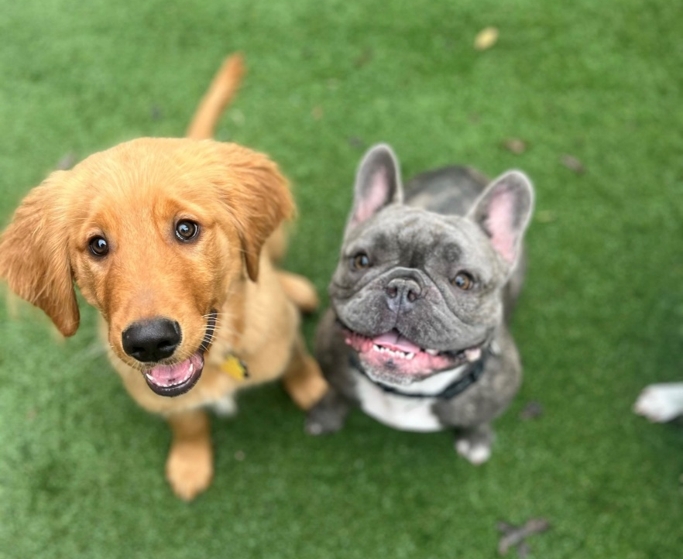
If you haven’t boarded your dog before, you probably don’t realize that they may seem a little different for a few days after you bring him/her home.
This is often completely normal and just a reaction to his/her readjusting to their surroundings. However, it helps to be prepared and to know when to worry and when to just give him/her time and space to settle home. Here is what you need to know about what to expect when you pick your dog up and take her home after their stay.

My Dog Is Acting Hungrier than Usual; Did He/She eat during their stay?
If your pooch seems extra hungry for the first few days after coming home, don’t worry. It doesn’t mean that there is anything wrong nor that they didn’t eat. Instead, this increased hunger is usually attributed to different things. Dogs tend to work up a significant appetite when they are in daycare, and this is because they spend a lot of time exercising and playing. They need extra calories to refuel their bodies. However, since dogs naturally seem to eat less when boarding, often just due to being less comfortable eating in unfamiliar surroundings, it is very common for canines to play catch-up when they arrive home. If your dog’s appetite doesn’t settle down in a few days, speak to your veterinarian for reassurance.

My Dog Seems Particularly Thirsty; Do I Need to Be Concerned?
Similar to added hunger, owners have reported that their dogs also drink more during the first few days back home. Again, this is almost certainly due to the fact he/she simply feels more comfortable drinking at home than away. Just be sure to monitor so they don’t over ingest and indirectly make themselves sick.

My Dog Is Sleeping a Lot, Is He/She Ok?
If your dog is tired and worn out, then we have most certainly done our job! You wouldn’t want to go away, and they be left largely alone or to their own devices. Instead, you want to be sure he/she is kept busy so that they remain healthy and not focused on being apart from you. We will spend a great deal of time exercising and playing with your dog so he/she is physically and cognitively stimulated and doesn’t become bored and restless. As a result, he/she may need to sleep more when he/she gets home! If she still seems unusually lethargic after a couple of days, it is worth speaking to your veterinarian just to rule out any underlying illness.

My Dog Has Had Diarrhea since coming Home, Do I Need to See our Vet?

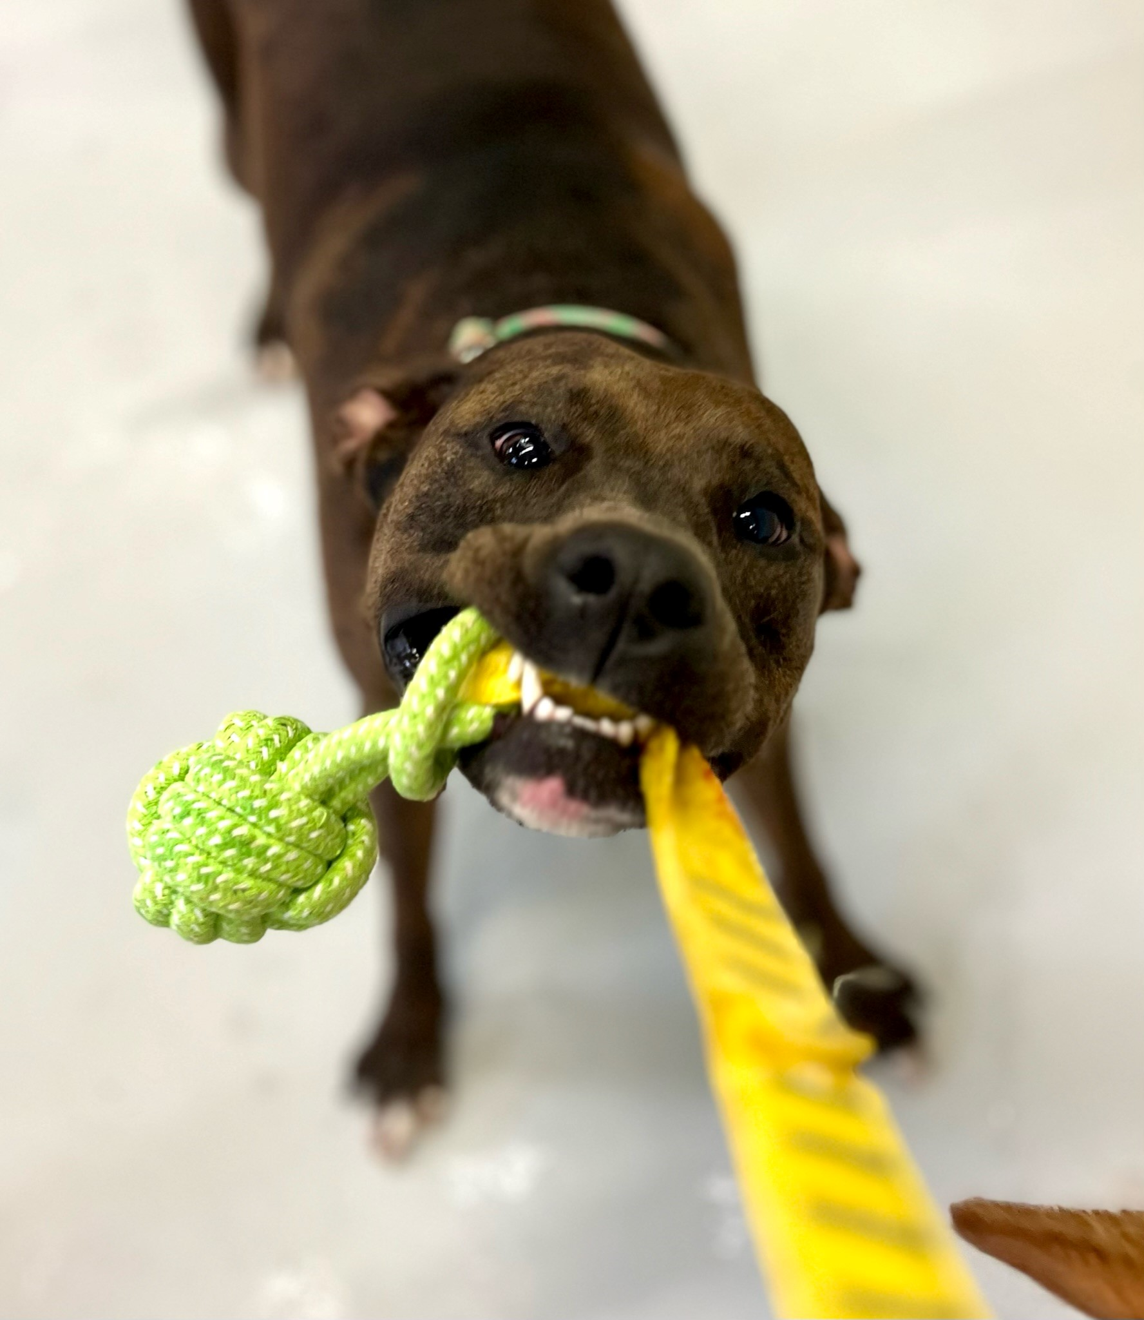
Have you ever had an upset tummy because of fear, anxiety, or excitement? A similar phenomenon can affect our pets too, and if your dog has diarrhea when he/she is away or when he/she first returns home, this could be to do with the flood of emotions she will be feeling. Diarrhea can also be caused from dietary change or sudden intake of food or water. It is less likely that she has picked up a stomach virus during their stay but not impossible. We are always on top of ensuring animals are suitably vaccinated and a high standard of sanitation. Things to try when they return home:
Stop feeding them for 12 to 24 hours: It sounds harsh, but by making them fast for a while, you can let their stomach get better and possibly let all the sickness come out in the diarrhea.
Feed bland food like rice and chicken: Once it’s time to get them to start eating again, only give them bland tasting food for a couple of days. It is easier for your dog to digest and will be easier on their stomach.
Consider pumpkin: 100% pumpkin is a known remedy for doggy diarrhea as it helps to solidify their stools and will often work its magic in just two days.

Nevertheless, if your pooch has diarrhea for more than 48 hours, it is important to schedule an appointment with your vet to rule out the underlying illness and to check that he/she is not becoming dehydrated. If he/she has diarrhea and is not drinking, see your vet immediately.

My Dog Seems Abnormally Clingy. What Can I Do to Help?
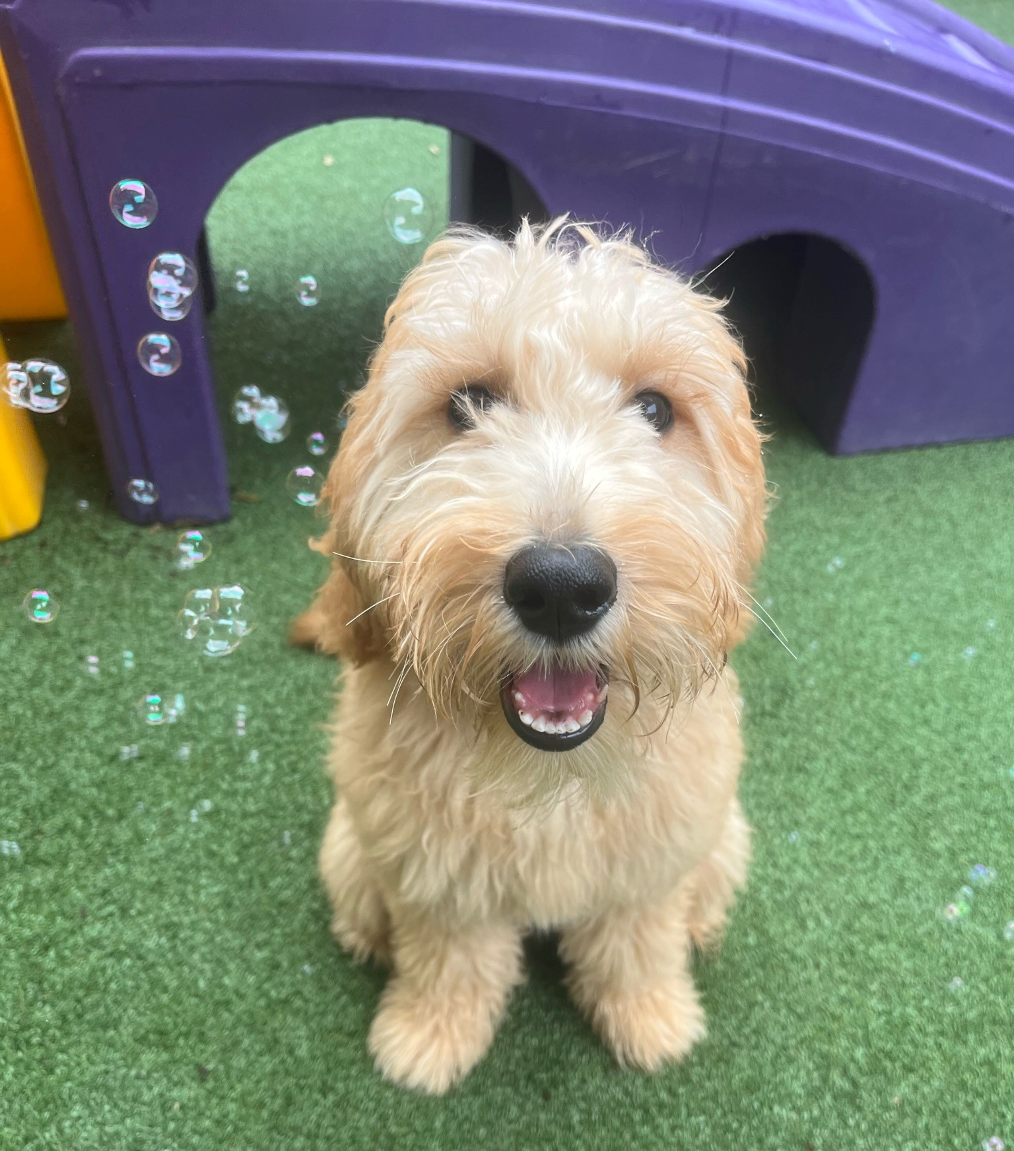
Many pets suffer from mild separation anxiety when they are temporarily out of contact with their owner. As a result, clingy behavior when you are first reunited is normal and to be expected. Nevertheless, you can help manage this and ease him/her back into their habitual, well-adjusted self by slipping back into your usual routine as quickly as possible. This will help to re-establish familiarity and help him/her feel secure.
My Dog is Coughing…What Does that Mean?
Canine cough can be caused from a variety of reasons. Just a few reasons include stress-induced, excessive barking or a respiratory infection. A respiratory infection- an infectious bronchitis of dogs characterized by a hacking cough that people describe as “something stuck in my dog’s throat” This bronchitis may not last long and be mild enough to not need any treatment. An uncomplicated kennel cough runs a course of a week or two and entails frequent fits of coughing. Uncomplicated cases do not involve fever, just coughing.
Dogs with weak or compromised immune systems are more likely to develop an upper respiratory infection. Dogs that can be stressed being away from home can have a weakened immune system and are more susceptible to any type of bacterial infection.

Does the Bordetella vaccine take care of all strains? Unfortunately, no. Other strains such as Mycoplasma and Adenovirus can cause similar symptoms. Just like with the flu in people, vaccinations do not treat these new and various strains. Although not serious, we want everyone to be aware of the signs and symptoms and what can be done in case your dog is exposed.
Upper respiratory infection strains that affect dogs can often be passed to other dogs. The strain cannot be passed to animals other than a dog, such as a cat or a human. An uncomplicated case will go away by itself. Cough suppressants can improve patient comfort while infection is resolved. If the cough does not improve in
a week this could suggest an underlying condition. Do not hesitate to bring them to your veterinarian.

What is Smooch my Pooch doing to help?
We will take all the necessary steps to help ensure germs are not spread during your dog’s stay which include:
-sanitizing each kennel, bowls and cots between dogs checking in and out
-cleaning and sanitizing all play toys
-sanitizing playroom floors, slides, and walls

Your dog’s health and safety are always our number one priority so although we cannot always prevent germs from spreading, we will do anything we can and keep you informed as well.

