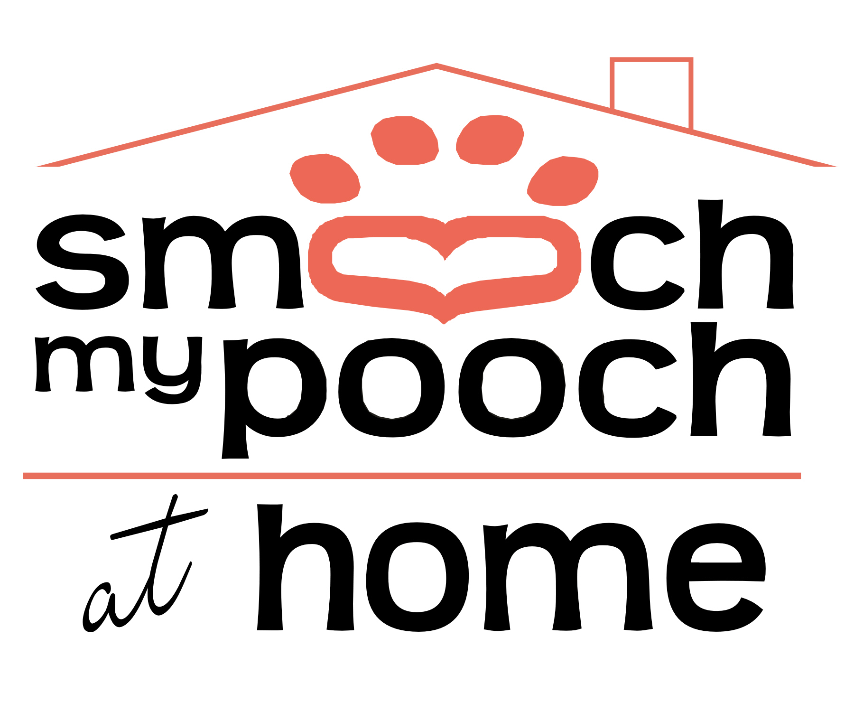
18235 Magnolia Bridge Rd.
Greenwell Springs, LA 70739
(225) 788-8598 phone
(225) 261-4484 fax
info@smoochmypooch.com

Owner_____________________________________________________________________________________________

Address_________________________________________ City______________________ State/Zip____________

Home Phone_____________________ Cell phone____________________ Add’l phone_______________________

E-Mail Address______________________________________________________________________________________

Emergency Contact___________________________________________Phone_________________________________

PET #1 PET #2
________________________________________ ____________________________________
Name Type/Breed Name Type/Breed
________________________________________________________ __________________________________________________
Color Sex Color Sex
________________________________________________________ __________________________________________________
Weight DOB/Age Weight DOB/Age
_________________________________________ _____________________________________
Neutered or Spayed Neutered or Spayed

PET #3 PET#4
________________________________________ ____________________________________
Name Type/Breed Name Type/Breed
________________________________________________________ __________________________________________________
Color Sex Color Sex
________________________________________________________ __________________________________________________
Weight DOB/Age Weight DOB/Age
_________________________________________ _____________________________________
Neutered or Spayed Neutered or Spayed

VETERINARIAN CONTACT INFORMATION

____________________________________________________________________________________________________________
Name or Clinic Name Phone/Fax

18235 Magnolia Bridge Rd.
Greenwell Springs, LA 70739
(225) 788-8598 phone
(225) 261-4484 fax
info@smoochmypooch.com

Are all shots, including Bordetella, up to date (if applicable)? YES____ NO____
(Rabies vaccination is Required)
Rabies License number: _____________________________
Microchip Number (if applicable): ________________________

DOES YOUR PET (if applicable):
COME WHEN CALLED YES___ NO____
LIKE PEOPLE YES ___ NO ____
SUFFER SEPARATION ANXIETY YES ___NO ____
DESTRUCTIVELY CHEW YES ___ NO ____
BECOME POSSESSIVE OF TOYS/FOOD YES ___ NO ____
JUMP ON PEOPLE YES ____ NO ____
FRIGHTEN EASILY YES ____ NO ____

HAS YOUR PET HAD ANY FORMAL OBEDIENCE TRAINING YES ____NO ____
IS YOUR PET AN ESCAPE ARTIST YES ____ NO ____

18235Magnolia Bridge Rd.
Greenwell Springs, LA 70739
(225) 788-8598 phone
(225) 261-4484 fax
info@smoochmypooch.com

Does your pet have any physical restrictions? How much exercise do they require in a day?
________________________________________________________________
________________________________________________________________
________________________________________________________________
How would you describe your pet? Example:
Playful, submissive, dominant, anxious, nervous, shy, outgoing

________________________________________________________________
________________________________________________________________
________________________________________________________________
Where does your pet normally sleep at night and are they crated?
________________________________________________________________
________________________________________________________________
What type of food do you feed your pet and how much per day/per meal?
________________________________________________________________
________________________________________________________________
________________________________________________________________
How often is your pet off leash? Have they ever run away? (if applicable)
________________________________________________________________
________________________________________________________________

Please list any recent illnesses and or prescribed medications:

________________________________________________________________

18235 Magnolia Bridge Rd.
Greenwell Springs, LA 70739
(225) 788-8598 phone
(225) 261-4484 fax
info@smoochmypooch.com

TO ENSURE THE SAFETY AND HEALTH OF YOUR PET, WE REQUIRE ALL PETS TO COMPLY WITH THE FOLLOWING RULES AND REGULATIONS:

In consideration for the services provided by Smooch my Pooch, I agree to the following:

- I certify my dog (pet) is in good health and has not been ill with any communicable condition in the last 30 days. I further certify that my dog (pet) has neither harmed any person or any other dog (pet), nor shown aggressive or threatening behavior. I understand that in agreeing to admit my dog (pet) for services, Smooch my Pooch and its staff have relied on my representation regarding my dog’s (pet’s) health and behavior together with all other information provided in this agreement.

- I understand that I am fully responsible for any and all harm, damage and/or injury caused by my dog (pet), including injury to persons.

- Smooch my Pooch reserves the right to refuse service to any dog (pet) and to terminate any service agreement at any time at its sole discretion.

- Payment is due for @ Home care in advance of services rendered. Any unseen charges or fees that are incurred during owner’s absence will be due upon return home.

- I have received, read and understand the payment fees and policies as outlined in this agreement and have answered all questions honestly. I understand that collection procedures may be initiated for non-payment and that I will be responsible for all associated expenses, including attorney fees and court costs.

_____________________________________________ ____________________________________________________
Owner #1 Date Owner #2 Date

