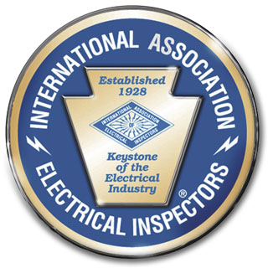

International Association of Electrical Inspectors
Genesee Chapter

2022 Sponsorship Form
Family Fun Day August 20, 2022

Seabreeze Amusement Park, 4600 Culver Rd. Rochester NY. 14622

Program #1 Platinum Sponsor Level $1,000.00
- Eight VIP passes to the event (pick up at the door)
- Advertising on the IAEI web site. Announcements throughout the event
- Your web site link from our web site
- Recognition as "Presented by your company" for our musical act via booklet articles, P.A. Announcements, and other print materials including your ad

Program #2 Gold Sponsor Level $500.00
- Four VIP passes to the event (pick up at the door)
- Advertising on the IAEI web site. Announcements throughout the event
- Your web site link from our web site
- Recognition as "Presented by your company" for our magic act via booklet articles, P.A. Announcements, and other print materials including your ad

Program #3 Silver Sponsor Level $250.00
- Two VIP passes to the event (pick up at the door)
- Advertising on the IAEI web site. Announcements throughout the event
- Your web site link from our web site

Program #4 Bronze Sponsor Level $150.00

One tabletop display
- Two VIP passes to the event (pick up at the door)
- Advertising on the IAEI web site. Announcements throughout the event
- Your web site link from our web site

