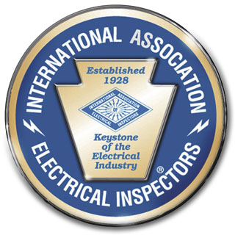International Association of Electrical Inspectors
Genesee Chapter – IAEI
Po Box 966, Webster, NY 14580-2890
Family Fun Day
Sponsorship Form
August 20, 2022
11:00 AM. - 9:00 PM.

Seabreeze Amusement Park, 4600 Culver Rd. Rochester NY. 14622

Company Name_______________________________________

Address______________________________________________

Phone #_______________________________________________

Contact Person________________________________________

Contact Email_________________________________________

Web Address__________________________________________

Level of Sponsorship

Platinum____ Gold_____ Silver_____ Bronze _____

(Please check one choice for each question)

Will you be providing new artwork for your ad? Yes___ No___

Or use last year’s ad? Yes___ No___

Table Top Space Requested? Yes___ No___

Make Check or Money Order Payable to Genesee Chapter-IAEI
Mail to: Genesee Chapter-IAEI, PO Box 966 Webster, NY 14580

Pay online at www.iaeirochester.org

