JAMAICA DELUXE ALL INCLUSIVE

Azul Beach Resort Negril Gourmet Inclusive by Karisma

Included in the pricing:
Bus transportation to Newark
Flights from Newark to Jamaica roundtrip.
Transfers airport to hotel roundtrip.
All Inclusive of meals, drinks, non-motorized water sports, tips and all taxes.
Price per person based on 2 to a room
Deluxe Suite…$1795.00

TWO DATES TO CHOSE FROM
January 20-27, 2025
January 27 to February 3, 2025

We can request alternate dates and price.

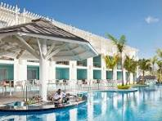
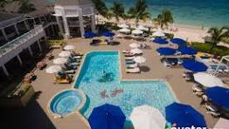
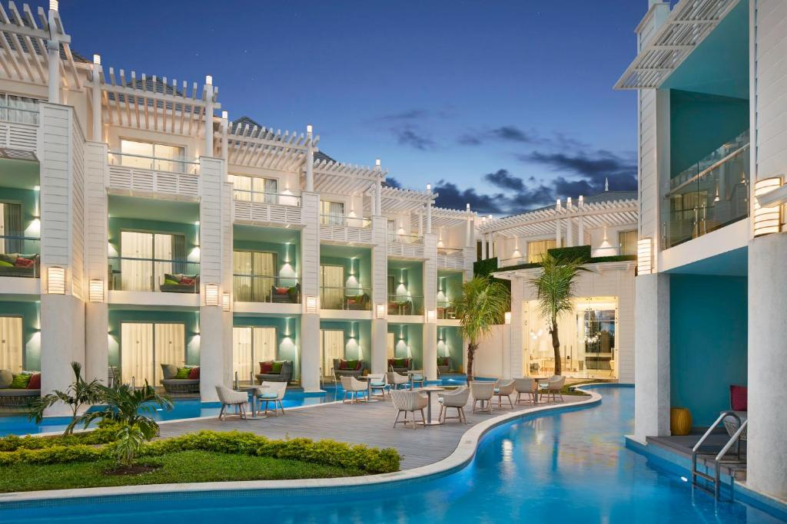
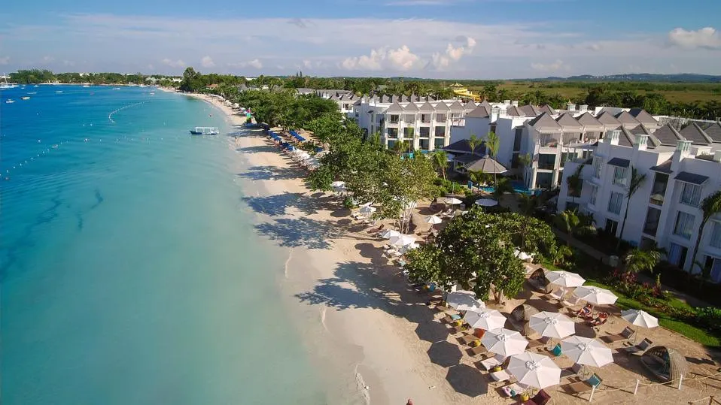
A VALID US PASSPORT IS REQUIRED FOR THIS TRIP!
ALL PRICES ARE SUBJECT TO CHANGE
UNTIL DEPOSIT IS RECEIVED.
REQUIRED DEPOSIT - $500.00 PER PERSON
VISIT US AT WWW.THOMPSONTOURS.COM
OR CALL US AT 1-866-484-6677



NOT INCLUDED IN THE ABOVE RATES:
Luggage fees to be paid directly to carrier
Seat choices on air and costs related.
Allianz Travel Insurance you will receive a quote.

