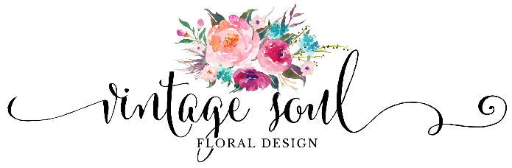

Thank you for contacting us! Your day is incredibly special and I’m honored that you’re considering us to be a part of it. I’m excited to work with you and to help bring your vision to life. My goal is to get to know you, and learn about all that is important to you and your future spouse for your big day. Below are some of the details we’ll need. If there are details you don’t have yet no worries, we can get them later. Also feel free to send me any inspiration pictures you’ve collected, and a link to your wedding Pinterest board!

I look forward to speaking with you soon!

Sincerely,



Kristen Brown

Owner/Lead Designer

Wedding Date:

Bride’s name & Phone #:

Email:

Groom’s Name:

Wedding Planner:

Email and Phone #:

Ceremony Location & Time:

Address:

Onsite Coordinator:

Reception Location & Time:

Address:

Reception Coordinator:

Will there be a cocktail hour? If so at what time?:

# of Guests:

# of Guest Tables:

Photographer:

Cake Person:

Cake Delivery Time:

**Wedding Party:**

# of Bridesmaids:

# of Groomsmen:

How would you describe the overall style and feel of your wedding? Let me know about any themes or colors you want included as well!

What is your ideal floral budget?

*(We ask for this this because we want to help keep you on budget as we discuss designs, not to max it out!)*

Besides marrying your best friend, what aspect or detail of your event are you most excited about & looking forward to on your wedding day?

We are happy to help you with vendor suggestions, what other vendors or items are you still looking for?

Is there anything else we should know?