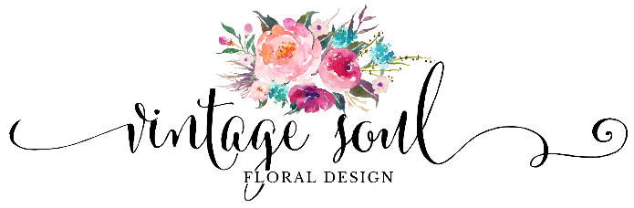

Thank you for contacting us! Your day is incredibly special, and I’m honored that you’re considering us to be a part of it. I’m excited to work with you and to help bring your vision to life.

To share a little about me, I’ve been working in the floral industry for over 12 years. I love weddings, and have experience in catering, linens, and planning but found that my passion is in floral design! I opened Vintage Soul Floral Design in March of 2017 so that I can bring my passion for weddings, eye for design details, and an obsession with flowers to every event! The goal is always to surprise, delight, and surpass your wishes by providing a floral experience that will never be forgotten.

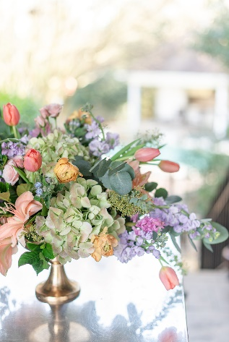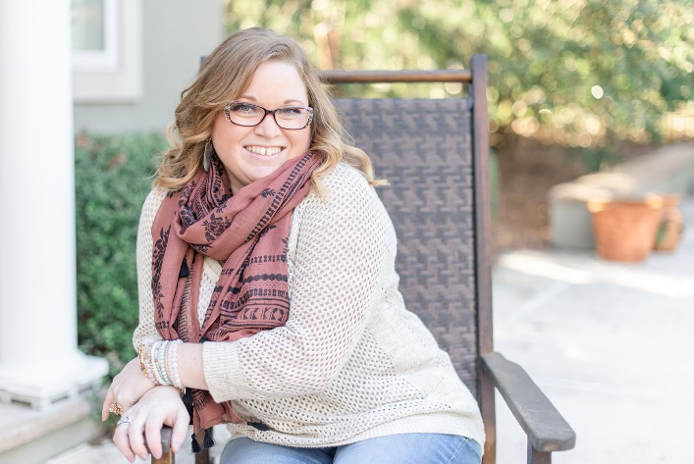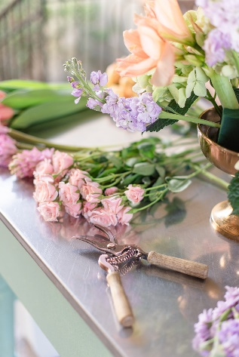

My goal is to get to know you and learn about all that is important to you and your future spouse for your big day. On the next page we ask for some more details about you and your event. If there are details you don’t have yet no worries, we can get them later. Also feel free to send me any inspiration pictures you’ve collected, and a link to your wedding Pinterest board!

I look forward to speaking with you soon!

Sincerely,
Kristen Brown
Owner/Flower Enthusiast
As Seen…
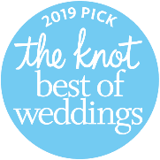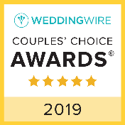
Follow Us on Instagram to see what we are up to next!
Event Inquiry:

Wedding Date:

Bride’s name:
Phone & Email:

Groom’s Name:

Wedding Planner:
Email & Phone #:

Ceremony Location:
Address:
Onsite Coordinator:

Reception Location:
Address:
Reception Coordinator:

Will there be a cocktail hour?

# of Guests:
# of Guest Tables:

Photographer:
Cake Person:

Wedding Party:
# of Bridesmaids:
# of Groomsmen:

What is your floral budget? $

Wedding Packages: We don’t have them! Every wedding is custom designed for our couples, so we offer custom proposals with unique ideas to each of our clients! We offer Full Service Weddings with delivery, installation, and break down starting at $3000, or Pick Up Weddings for budgets under that. We are also happy to travel beyond the Charlotte area, out of town minimums depend on your date/location.

How would you describe the overall style and feel of your wedding? Let me know about any themes or colors you want included as well!
Link to your Pinterest Board:
Private Board? No problem! Invite us to be a collaborator! https://www.pinterest.com/VintagesoulFD/

We are happy to help you with vendor suggestions, what other vendors or items are you still looking for?

Is there anything else we should know?

