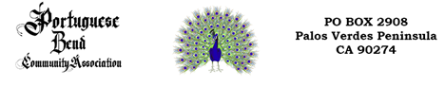

**TO ALL RESIDENTS AND NON-RESIDENTS:**

**Portuguese Bend is a private community. Posted at both entrance gates are signs “NOTICE ALL ROADS ARE FIRE LANES ILLEGALLY PARKED VEHICLES MAY BE TOWED AWAY C.V.C. 22658a Sheriff Dept 310 539-1661” If you park on any of the roads your vehicle can be towed at your expense. Parking on ANY PBCA road to access the Nature Preserve trails for hiking, cycling, visiting the beach, or visiting your property is prohibited. If you are not a property owner within the PBCA you are TRESPASSING, AS ALL PBCA ROADS ARE PRIVATE.**

**Guests or workers of residents must park on the resident’s property, off the street, when they are visiting or working.**

**If your vehicle is towed, you can recover it at:**

**REDONDO BEACH TOWING 310 530-0140**

**1417 Pennsylvania Avenue**

**Lomita, CA 90717**