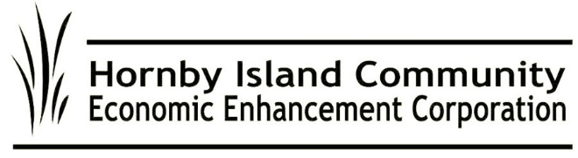
HICEEC First Edition – November 2025

🌟 Celebrating Excellence at the Fall Mixer 🌟
The Fall Mixer, held October 14th at Sea Breeze, brought together local businesses, organizations, and community members for an evening of connection and celebration. Warm thanks to First Credit Union for hosting the opening “Meet and Greet,” helping make the event a great success.
HICEEC Executive Director Karen Ross shared updates on current initiatives before announcing this year’s Enterprise of the Year. Guests then took the mic to introduce themselves and their work, followed by a lively round of door prizes — thanks to the many businesses who donated their goods and services.
Nominations for Enterprise of the Year were open to the public, recognizing local enterprises that create employment, show excellence and innovation, and contribute positively to the community.
This year’s nominees were:
✨ Central Cinema
✨ Hornby Arts
✨ Hornby Community Bus
✨ Hornby Island Fire Department
✨ Hornby Island Preschool
✨ Hornby Island Medical Clinic
✨ Thatch Waterfront Pub
Congratulations to all nominees — and to the 2025 Enterprise of the Year, The Thatch Waterfront Pub!
One nomination summed up the tone of the nominations for the Thatch perfectly: “After enduring years of frustrating setbacks, this enterprise has persevered and now offers a wonderful, renewed facility that provides more than good food, good drink, and good service. It also offers community.”
What’s Happening?
From concerts and art exhibits to tasting rooms and yoga, be sure to submit your events for sharing on the Hornby Events Calendar: hornbyisland.com/events.
MRDT Update
October 14th saw a MRDT Meeting hosted by Calum Matthew for MRDT Stakeholders. The Municipal and Regional District Tax (MRDT), or “pillow tax,” collected from visitors, continues to support Hornby’s vitality. Most funds go to an affordable workforce housing fund and to support off-season events, sports, and community initiatives. Thank you to those visitors who pay the tax and those accommodation providers who collect it. This year, successful applicants and grants awarded were:
- Shoulder Season long weekends Indoor Markets, signage: $613
- Six businesses, sharing an ad in the Spring C.V. Collective: $1,677.
- Welcome Centre at the Farmers Market (included paying for one of the central area seasonal outhouses): $5,000
- Hornby Arts Grand Opening of the New Arts Centre: $7,500
- Hornby Arts Geoffrey Road Show, off season portion: $1,500
- Natural History Centre digital programs & website: $4,000
- No Horses Jazz Festival: $1,200

At press time, $3,500. remains in this fund, applications are still open. For information on grant criteria, visit https://hiceec.org/mrdt.

Hornby Bus Leaped Through Summer
From June 27 through Labour Day, the Hornby Bus offered daily service of 11 hours. Thanks to dedicated drivers and volunteers, the program was a great success, with 4,337 people taking the bus. Winter work for the Steering Committee will include input for road enhancements to the Ministry of Transportation and Transit, driver recruitment and training, review of routes and schedule, the everlasting quest for vehicles/upgrades, discussion regarding coordination with the Denman bus service, and the potential for benches at bus stops.
Let Your Voice be Heard for Better Ferry Service
With BC Ferries ending local advisory committees, your voice is more important than ever. Share feedback with:
- BC Ferries: engagement@bcferries.com | 1-888-223-3779
- MLA Josie Osborne: Josie.Osborne.MLA@leg.bc.ca
- BC Ferry Authority: ClaireTrevena@bcferryauthority.com
- MOTI Marine Branch: Francois.Bertrand@gov.bc.ca
From your HICEEC Volunteer Board:
John Heinegg, John Grayson, Jack Hornstein, Katherine Ronan, Donna Tuele, Sheila McDonnell, Stu Amos, and Marilyn Kopansky

