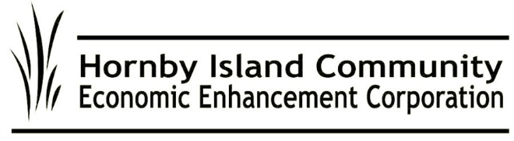

**Dec. 2024, HICEEC First Edition**

**Community grants**

In 2024, HICEEC grants went out to:

* Hornby Island Athletic Association: With additional funds from First Credit Union, to pay printing costs for Roddy’s calendar; all sales receipts will go toward operations at The Kitchen.
* Hornby Island Farmland Trust: For outreach, media, and communications.
* Community Hall Heritage Committee: Toward the major project for accessible washrooms.

In its thirteenth year, this granting plan has provided $101,021 to community groups and projects. See: <https://hiceec.org/community-grants>

**Microloan program - Islanders supporting islanders**

The “Eagles” microloan program has been fostering small business growth on the island since 2016, with 3 contracts written in 2024. To date, the group has funded 18 loans totaling $74,025. Loans are generally $5,000 maximum, with interest paid, and repayable within 10 months. Exceptions are possible. Funds for the loans come from a group of community-minded local people, who review the applications and select the ones they wish to participate in. For details, visit <https://hiceec.org/micro-loans-1>

For info on becoming an “Eagle”, please contact [karen@hiceec.org](mailto:karen@hiceec.org).

**Providing more than internet**

City West (our fibreoptic internet service provider) is sharing some Christmas love with their annual “12 Days of Giveaway”, Nov. 28 to Dec. 13th. All City West customers are automatically entered to win prizes. It’s City West’s way of expressing their gratitude to loyal customers. Hopefully someone on Hornby or Denman will have their name drawn!

In recent communications with City West, they offer reassurances that finishing servicing homes on Hornby and Denman is a priority.

**Ferry moving slowly – a year-round concern**

We thought it was coming: Public engagement and good, year-round ferry service. Were we wrong?

Q. When will promised public engagement on our Islands resume?

BCF A. *We have heard loud and clear that engagement, especially in person, should be kept to specific topics where there is an opportunity to inform change or policy or procedures. At this time, there is nothing outstanding to bring to community.*

Q. When will the Quinitsa, or a vessel with serviceable capacity, be deployed to the Hornby ferry route?

BCF A. *….. four new Island Class vessels we expect to join our fleet in 2026. At that point, our plan is to have the Quinitsa providing year round service to route 22.*

Q. Feedback to BC Ferries?

BCF A. *For further communications, please reach out to our*[*customer service contact*](https://www.bcferries.com/contact-us)*support team.* [*https://www.bcferries.com/contact-us*](https://www.bcferries.com/contact-us)

Questions regarding the serviceability of the cable ferry, and the Buckley Bay to Denman Island route, remain unanswered. Questions regarding equity in subsidies among the minor routes remain unanswered.

In summary, there is no good news—or any news, really—regarding equitable or adequate service on the routes that service our Islands.

**Celebrating excellence**

The “Enterprise of the Year Award” is HICEEC’s way to highlight our local entrepreneurial economy—to celebrate the working people of Hornby, management and staff alike, in businesses and non-profits. So, congratulations to the 2024 award winner, the businesses at the **Ringside Market**!

M**RDT, a.k.a. the pillow tax**

Consultants 4VI are helping to finalize the 2024 tactical plan and craft the 2025 plan for the Municipal Regional District Tax funds— collected from visitors to short-term, fixed-roof accommodations. The annual plans provide the pathway toward implementing the government-approved 5-year strategic plan. HICEEC thanks HIRRA, Islands Trust, the CVRD, and others who have shown their support for acquiring Crown land to proceed with this critically needed project.

**‘Tis the Season**

We wish the community Season’s Greetings, and a Happy, Prosperous New Year!

Submitted on behalf of the volunteer Board: John Heinegg, John Grayson, Jack Hornstein, Katherine Ronan, Donna Tuele, Sheila McDonnell, Stu Amos, and Marilyn Kopansky