Hornby Island Community Bus Project 2021

Fall, 2021

Report For: Comox Valley Regional District
Authored by: Karen Ross
Hornby Island Economic Enhancement Corporation (HICEEC) & the Hornby Island Community Bus Steering Committee

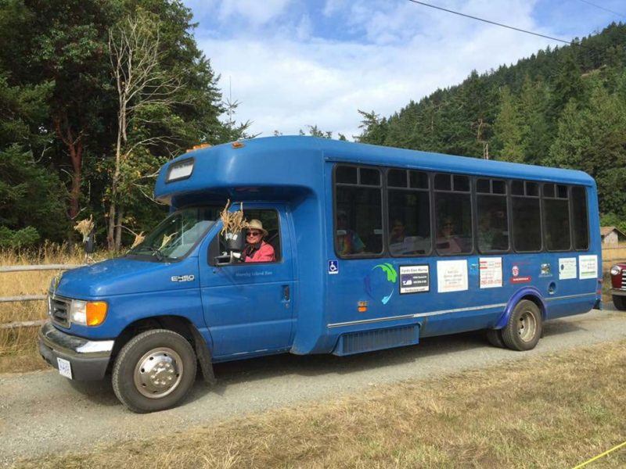
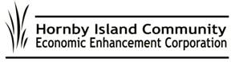
Table of Contents
Cover 1
Title page 2
Table of Contents 3
Thank You’s 4
Local Sponsorships 2021 4
A Successful Year 6
Analysis & Recommendations 9
Financials 20
Summary 22
Appendix:
- Enhanced visibility: Bus Shelter 23
- Endorsement Letter 25
- 2021 Schedule 26
- 2021 Route 27

Thank You’s
The Hornby Community Bus project could not be undertaken without the dedication, determination, and passion of the Bus Steering Committee, helpers, riders, and the dedicated drivers.
2021 Bus Steering Committee | Column1
Al Dickie
Alex Ortwein
Arne Olafson
Daisy
Daniel Arbour
Garth Millan
Hilary Wood McDonnell
John Heinegg | Adjunct volunteers:
John Nemy | Dave Englund
Karen Ross | Doug Nixon
Peter Mills | Edward Kooij
Ray Therrien | Goya Ngan
Rowan Morse | Henry Touwslager
Scott Towson | Jane Talbot
Sheila McDonnell | Matt Dickie
Stu Brown | Michelle Easterly
Sam Elder
Paul Ackerson

Contracted funding support and guidance provided by the Comox Valley Regional District, and the taxpayers of Hornby Island.

Local Sponsorships 2021

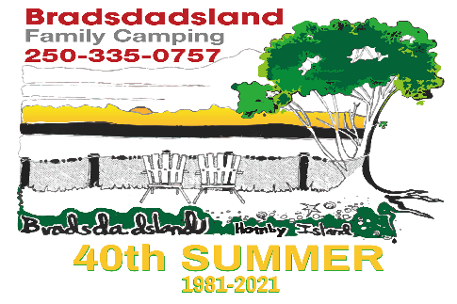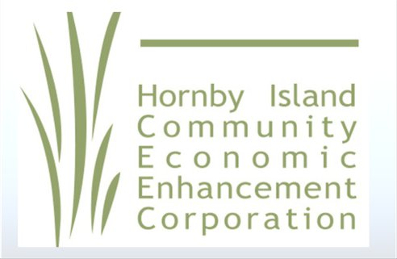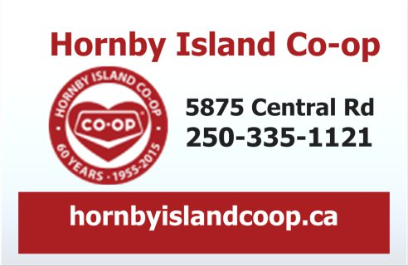

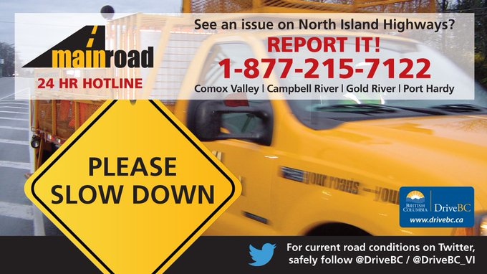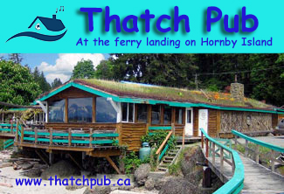

Thank you to Nelson Roofing (Courtenay) for the roofing membrane donation.

Against the Odds: A Successful Year
“a great group of people working together to have an efficient summer bus service”
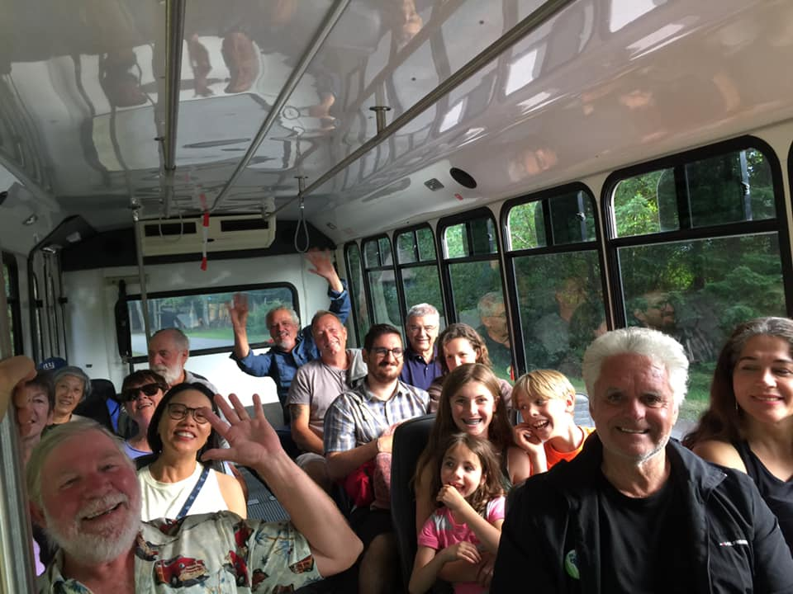
With over 3000 riders in 2021 and 72 days of operation, 8 hours/day of running time = 5.4 riders/hour. This hourly ridership average was down from the 2019 average of 7 riders/hour. This is considered acceptable due to the apprehensions regarding the 2021 COVID operating environment.

(2019 picture)

Here is a quick recap of the work done since the completion of the 2019 pilot
project.

In 2020, the Tribune Bay Outdoor Education Centre turned over ownership of the bus to HICEEC, along with the corresponding book-keeping functions. A sincere thanks to the management there (the Campbell and Ortwein families) for their leadership since 2017 when the bus was first purchased.

After grounding the bus in 2020 due to the COVID-19 pandemic, supportive feedback from the community encouraged the decision to put COVID-19 mitigation protocols in place and get the bus rolling for the 2021 summer season.

A volunteer safety officer wrote the workplace safety manual, lined up the supplies and did driver training. A volunteer engineer designed and installed a plexiglass cage for the drivers, installed a sanitation station on the bus, and procured a P.A. communications system.

As per the 2018 Feasibility Study recommendation, a Lead Driver was sought. Members of the Bus Steering Committee took on hiring all drivers, arranging on-island accommodation for the recruited Lead Driver, and orienting the new Lead Driver on the island and the bus route.

The Steering Committee’s mechanical gurus handled getting the bus into Courtenay, through the Commercial Vehicle Inspection process, and brought back to the Island.
During the season they capably handled repairs to the emergency brake and the muffler, on Island.

The National Safety Certificate was applied for by HICEEC, with support from the bus insurance agent.

And a thrilling development, a permanent parking space was secured for the bus, courtesy of Mainroad Contracting, inside the “highways compound”.

And all the while:
- Local sponsorships were solicited, and associated decals designed and placed on the sides of the bus.
- Schedules were timed, refined & designed.
- Bus stops were established, with a bench installed at the ferry and a new shelter built at the Coop Corner* (see the project outline in Addenda A).
- Advertising posters and sign boards were made for the bus stops, and print copies of the schedule were distributed to every mailbox with extras for handing out by the drivers.
- Collaborations with Denman Works and the CVRD re a cross-Denman connector
- www.hornbybus.com was updated with routes, the new hourly schedule, and a new page for the Denman service’s schedule. This link was shared in all advertising, including an ad in the annual Hornby Denman Visitor Guide.
- www.hornbyisland.com “Trip Planning” included a section on travelling to the islands and while visiting, using the bus network.
- The Hornby Bus Facebook page now has 207 followers.
- HICEEC set up administration and book-keeping for the project.
- A back-up camera was purchase, and installed, as a safety measure for the tricky back-up turns that the bus makes at both extremities of the horseshoe shaped hourly run.
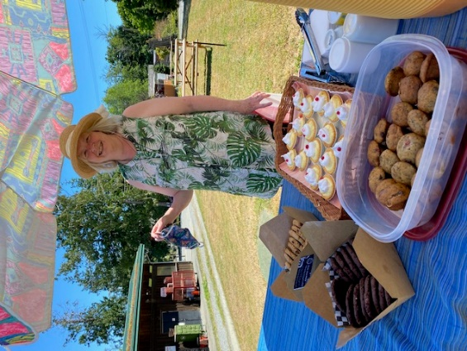
The greatest uncertainty in the service was whether there would be ridership amidst COVID-19. And although the season started rather slowly, ridership did pick up and reach 2019 levels by mid-July. However, the COVID impact did prove to be a valid concern, as Sea Breeze Lodge announced they were closing their restaurant to the public, due to the first reported COVID cases on Hornby. The restaurant closure ran from on August 19 to Aug. 27. Island ventures responded by reverting to strict COVID protocols, and bus ridership dipped noticeably.
(Sheila- opening party 2021)

Another significant change in ridership occurred with the closure of the Thatch Pub, Friday nights went from full buses to the lowest ridership of the week. It is anticipated that the anticipated 2021/2022 rebuilding of the Thatch will once again inspire Hornby Islanders to take the bus rather than drinking and driving.

In collaboration with the Festival Society, the bus serviced two night-time events at “the Farm” this year. Being accommodating for community events has been very well received, and increases visibility of the bus, and public support.

Analysis & Recommendations

We are enthusiastic to put forward the recommendation that the Hornby community bus service keep operating. Transit is needed on Hornby Island and the established Comox Valley transit does not adequately provide transit service to this service area.

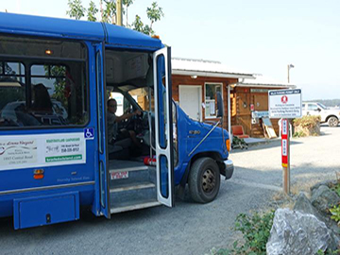
Specific recommendations

Increasing the contribution from the CVRD to further repatriate Hornby taxes
Annual operations continue to be subsidized by local business and organization donations, most of whom also pay property taxes.

Recruiting drivers is one of the biggest challenges and increasing wages would be an incentive to attract personnel. Wages paid on Hornby are currently on par with School District 71 Hornby bus drivers, but less than Handi Dart driver wages in the Comox Valley. Most businesses on Hornby faced labour shortages this year which impairs offering full-service hours.

Evaluating management of the local transit function
Currently the Hornby Bus Steering Committee makes decisions, and implements, on human resources, capital spending, mechanicals, scheduling, routing, marketing, and other various topics relating to the Hornby community bus. Although provision of public transportation is imbedded in Hornby’s Vision 2020, and falls within HICEEC’s mandate for supporting green initiatives, HICEEC’S primary purpose is not to operate a bus line. Alternatives for management should be investigated, and options could include a local society, a society with Denman Island, privatizing the service, merging into the School District busing contract, or coming under the umbrella of B.C. Transit.
Hornby and Denman Islands fall within the Comox Valley Regional District area for the provision of public transportation, with an associated levy on property taxes.

Review Route, Stops and Schedule
The hourly schedule has been developed with service to the most populated/commercially accessible locations. This hourly service ran from Ford Cove, through Sandpiper subdivision, to the Coop, through Galleon subdivision, to the ferry landing. A very tight schedule. At the busiest time of the summer, traffic snarls at Ford Cove, the Coop, and Wed./Sat. at the Farmer’s Market caused driver frustration and delays. The bus often ran late.

A fundamental position in developing the bus schedule is based on “ease of use for the consumer”. For example, the time that the bus is at Ford Cove is 8:23, 9:23, 10:23, 11:23, 5:23, 6:23, 7:23. A rider simply needs to remember that their stop is at the 23-minute mark.

It would be recommended that the schedule be reworked to drop some of the less used stops but retain core hourly service at the 3 anchor locations – Ford Cove, the Coop, and the ferry landing.

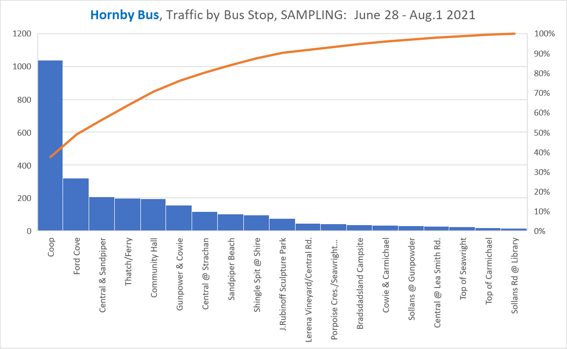
An analysis has been done of the schedule, and the peak ridership built to, and from, the midday period when the bus was not operating. (no service12:15 to 4:35 p.m.). The graph below shows ridership, by hourly increment, except the time frame 4:35 to 5:11 when the time frame is only 2/3 of an hour (when the bus started up operations after the split shift). If this variance in time frame is account for, the graph is clear and shows the 10 to 12 timeframe leads up, and the 4 to 6 downward curve.

The earlier starting time was established to give working people rides to work, and to meet the Denman Connector. Unfortunately, the Denman Connector was in a “start-up” pilot project this year, which could taint the data otherwise may have indicated the value of future collaborations. Specifically:
- The Connector only operated on Friday, Saturday, and Sunday. The limited data does not support serving the ferry landing for that earlier period of the day.
- Early reports on Facebook were challenging the reliability of the service, as a coordinated schedule is very hard to keep when the ferries are shuttling. (and we definitely want the ferries to continue to shuttle!).

Feedback from the Community has indicated:
- The hours should service the Farmer’s Market, which is held Wednesdays and Saturday, from 11 a.m. to 2 p.m. Parking is a nightmare, and the vendors would be supportive of the bus if service was provided.
- Residents at Whaling Station do not receive any service, and question this. Noted that the bus did two runs/day to Whaling Station, in the 2017 pilot project, but those runs were cancelled in the following year due to lack of ridership. Perhaps some creative scheduling could address this.
- Ford Cove has a real parking problem, and people not obeying no parking traffic signs, etc. The Bus Steering Committee met with some of the residents, and the HIRRA president, to be part of a creative solution for this situation. It may require some off season lobbying to relocate the bus stop into a new area.
- One of the favoured rider groups on the bus in 2019 was the preschool. “The littles” rode the bus every week for a rotating destination of field trips. This year, COVID was an issue. In August, the manager arranged to try one day, to see how the parents felt, etc., and it was cancelled due to the COVID outbreak on the Island.
- The community continues to express strong negative feelings towards the operation of a gas-powered vehicle but indicates strong support to make the investment in a zero carbon-emission vehicle.

No extension of the service time frame, for a full-time transit service, is recommended yet.
Statistics from operations during 2021 are consistent with those from 2019, the appetite for regular public transit is directly related to the number of people on the island. With summer service, that number starts building, reaches the peak for the two weeks on either side of the August long weekend, then starts tapering off as the tourist season comes to an end.

Continue looking for efficiencies in Island Bus Service

Hornby Island is serviced with school bus service by First Student, a private bus contractor with its’ head office in the U.K. This international company bids on the contract with the local School District, on a regular basis. In 2017, Gord Campbell, the manager of the Tribune Bay Outdoor Education Society, worked with School District 71 to get the Hornby run designated as a “white run”, which means that the non-student public could have access to the same bus as the older children. (Not the littles). Service to Hornby high school students is provided, daily during the school year, both on Hornby Island, on Denman Island, and on Vancouver Island - from Buckley Bay to high schools in Courtenay.
Representatives from the Comox Valley Regional District, School District 71, the Ministry of Education, and the Ministry of Transportation will be having discussions on how the government could be more efficient in this area. An August 2021 announcement by B.C. Transit has extended free ridership for all people under the age of 12.

Liaise with MOTI Regarding Quality of Stops
In 2019, HICEEC staff member, James Emerson, drafted a document with names and locations of stops, paired with photographs of them and handed it over (in physical form) at the MOTI office in Courtenay, BC. The contact that James communicated with was Tallina McRae, District Operations, Technician/Area Manager. Tallina and MOTI granted permission to operate on Hornby, but a “permit” was not granted until we get more funding from the local government or get included in the BC Transit Framework.

Improve Reliability—Relief Bus, Radios, Interactive Phone App

Improvements to service and operation levels, new technology, etc. should be constantly regarded.

Skills Development & Driver Training

The Bus Steering Committee continues to encourage and promote local driver training. In 2019, a professional driving school was engaged, and brought to the Island, to conduct a one-day workshop to assist local people in obtaining their Class 4 Learner’s Permit. There were 10 spots in that training, although not all were filled. No new drivers have come from the training and the follow-up on-hands training that two of the trainees took. A major reason for the difficulty in on-island recruiting is that the Hornby bus only runs for two months/year, and those are the two busiest months when people have more work that they can handle already.

In 2021, both regular drivers were from off island. One from Denman Island, and the other recruited from the Interior.

The Steering Committee understands that lack of a qualified local workforce is a big challenge. This fall, Committee members are again advertising for interested parties, offering to help them get trained and acquire the required qualifications.
The Lead Driver from this year, Stu Brown, is also offering to assist, and has expressed his intent to return to the project next summer.

Plan B, in the face of a labour shortage, would be to drop the lowest two days of ridership, Mondays and Tuesdays, from the 2022 schedule. This is not seen as ideal, due to the lack of continuity of service and lack of the fundamental principle “ease of use for the consumer”.

Another benefit of collaborating service with the School District is that the job is then year-round.

(Bus launch June 25, 2021)

Improve Promotion of the Service to Inform People Better
There were various improvements on our promotion and marketing tactics this year. Along with the route map and schedule being available on www.hornbybus.com (thanks Daisy at homegrownsite.com) and www.hiceec.org, physical copies were made and mailed out to all of our residents, on Denman and Hornby, and physical copies were left at local businesses, and on the bus. The committee also had a “opening day” party, held at the Coop on Friday, June 25th 2021. This was a day for handing our schedules and maps, visitor guides, food and beverages, and for updating people on our 2021 summer and September bus service. The Steering Committee was present to answer any questions the public had.
Social media also was implemented this year, with the Hornby Island Bus Facebook page and the Hornby island Social Media page.

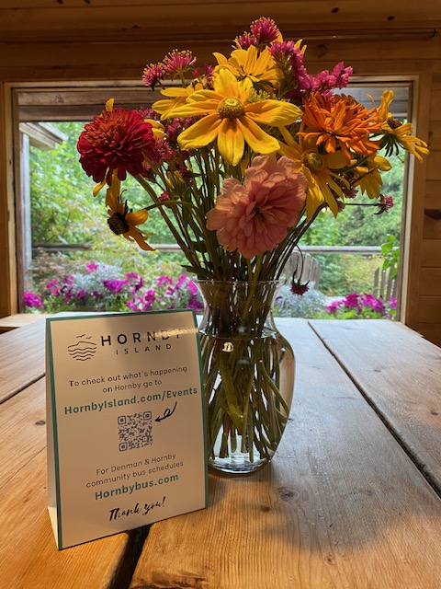
How to reach Visitors, and summer residents, with information about the bus was identified as a challenge. In early August HICEEC produced tent cards to be placed on restaurant tables, in Vacation Rental homes, and at the Farmer’s Market. These “mini bulletin boards” advertised various HICEEC’s projects, including the Bus. It is recommended that these tent cards be done again for 2022, prior to the start of the season and that local hosts be instructed on how to effectively use them to help share information.

(tent card promotion, 2021)

Liaise with Denman Works and the CVRD regarding the Cross-Denman Connector
In 2018 the CVRD commissioned a Feasibility Study on the Hornby Summer Community Bus. Excerpt from the Study:

As a result 102 people completed the Hornby Bus Review survey, between August 23rd and October 1st, 2018.

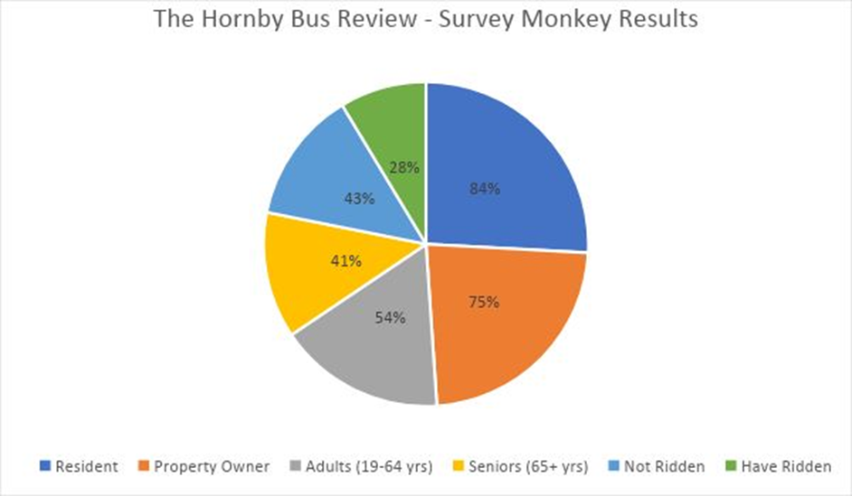
84% of the respondents are residents 75% are property owners of Hornby Island 59% are adults (19 - 64 years)
41% are seniors (65 years +)
67% spend 12 months a year on Hornby Island
43% had not ridden the Hornby Bus yet as they had intended too 28% who responded to survey had ridden the Hornby Bus

46% of residents who answered are going off island up to two times a month in their own vehicle with no other passengers. 39% of residents who answered are traveling off island with a passenger. To get to Hornby Island, the personal vehicle is the most common, 97%.
Q14. I would ride The Hornby Bus if...(Check all that apply):

a bus stop was 400 Meters or less from my accommodation. | 46.75%
there was a connecting bus across Denman Island. | 72.73%
it ran from April to October. | 57.14%
if it had a bike rack. | 45.45%
if it was wheelchair accessible. | 19.48%

In the Feasibility Study, the option for a cross Denman Connector had strong community support, as it would serve as a link to using the BC Transit service that provides service north, from the ferry terminal at Buckley Bay. Additionally, Island Link offers service to the south, with connections on the major ferries to Vancouver.

For the 2021 Pilot Project for service across Denman Island, and reliable pilot project interpretations, we need to remember that this is Year One. Any new business/endeavour takes time to develop their market.

None the less, some conclusions can be considered:
- The service would need to operate 7 days/week during July and August, in conjunction with the Hornby service.
- Social media would need to be managed. Positive engagement on social media, and regular “happy story” telling are recommended for promoting the cross Denman link.
- More promotion is required for this service to become known to Visitors and summer residents.

CVRD lead for securing tenure for a home for the bus

Mainroad Contracting has provided a home for the Hornby Bus, on a handshake. Great for a small community, but not enough as we look forward to electrification and a charging station.
(Mainroad Contracting Yard – Chris Cowley, Al Dickie, Doug Nixon – New home for the bus, 2021)
There are three identifiable sites for the CVRD to assist in finding “a home for the bus”.
- Formalize an agreement with Mainroad Contracting, for a specific area, and access to an electrical drop and infrastructure.
- Dedicate an area on the CVRD owned property at the Hornby Firehall for this use.
- Hold the Spark accountable for providing a home for the bus. In the initial negotiations for the Spark Society to secure the Old Firehall, one of the Bays was proposed as a home for the bus. Once the tenure was turned over, this opportunity was lost. The CVRD could pursue this location, via property tax relief, or other means.

Seek Funding for an Electric Bus
“At the direction of the membership at the December 12, 2018 Hornby Island Residents’ and Ratepayers’ Association (HIRRA) general meeting, the HIRRA Executive is writing in support of a local Hornby Community Bus Steering Committee, facilitated by the Hornby Island Economic Enhancement Corporation (HICEEC), applying for funding to acquire an electric bus, and associated infrastructure, to provide public transportation on Hornby Island.” (The full letter is in Appendix B).
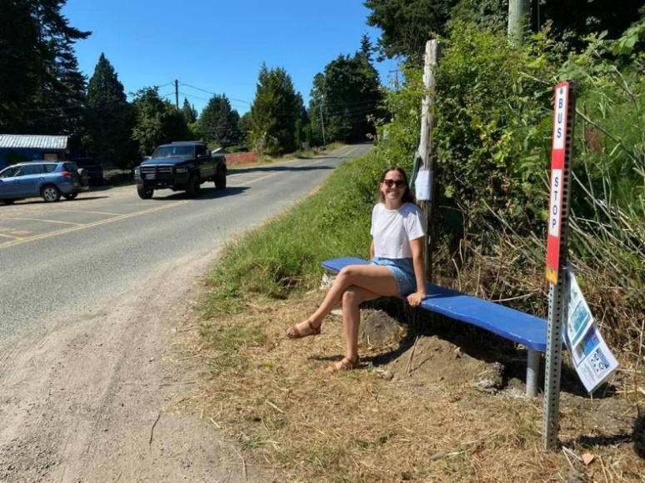
The most likely source of funding for an electric bus, and associated infrastructure is the Hornby Island’s allocation of the CVRD gas tax money. What could be a better use of this Fund than using it for transportation?

(Thatch Bus Bench, 2021)

2021 Financials

Revenue
This year was another great year for local sponsorship. Our cash sponsors were the Hornby Island Coop, Jeffrey Rubinoff Sculpture Park, the Ford Cove Store & Cabins, the First Credit Union, Lerena Vineyard, Bradsdadsland Campground, Tribune Bay Outdoor Education Centre. In total, local sponsors donated $13,000.

In-kind donations were made by the Thatch Pub and Mainroad Contracting.

In 2017, the Hornby businesses were told their support was needed to get a bus on the road, and they stepped up to the plate. The second year, two of the initial businesses dropped off, indicating they “had given”. Year 3, two more sponsors dropped off for economic reasons. Although there is some loss and gains on these sponsorships, there is a vocalized local business resistance to paying for transit both through their property taxes, and a sponsorship.

In addition to sponsorships, 2021 on-board donations and sale of bus supporter pins collected approx. $1800. and the CVRD operationally donated $50,000.

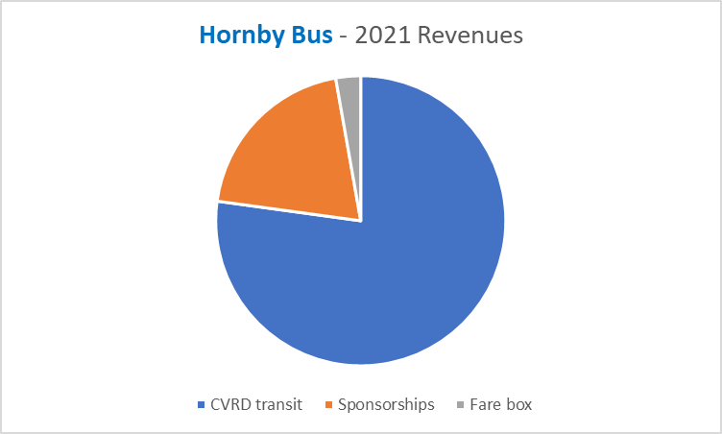

Expenses
Expenses in 2021 consisted of procuring a National Safety Code number, getting the Commercial Vehicle Inspection, fleet & volunteer insurance, fuel, extensive repairs, wages, COVID mitigations, new safety equipment, recruitment ads, establishing a driver accommodation campsite, and overhead. With expenses not yet finalized, but estimated at $65,000. The bus runs a very tight financial ship. It is fortunate that $17,000. Of CVRD funding for 2020 was rolled forward, and will allow the sponsorship money from 2021 to be used in a capital reserve fund. If must be emphasized, that only the passion of the Steering Committee, and the generous amount of volunteer labour that goes into the operations, make it possible to operate each year.

.

Summary
A repatriation of more tax dollars from the CVRD, will be necessary as we move forward with the bus project on Hornby Island.
With
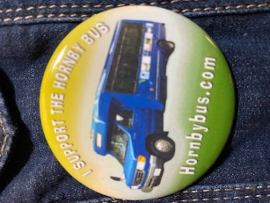
- ever increasing public awareness of the bus service
- concerns over climate change and the need for positive solutions
- the wisdom for efficient public transportation systems
  - the responsiveness of the Steering Committee to react to community
feedback
the bus continues to appeal to the globally minded population groups on Hornby.

In analysis of the current pilot project, recommendations include:
- Increasing the contribution from the CVRD to further repatriate Hornby taxes
- Evaluate operational management of the local transit function

Review Route, Stops and Schedule dependent on resources

As a stand-alone service, transit is not recommended for other than July and August

The opportunity for an extended season lies with efficiencies in Island bus service regarding collaboration with School District 71

Liaise with MOTI Regarding Quality of Stops
- Improve Reliability—Relief Bus, Radios, Interactive Phone App
- Skills Development & Driver Training. Access to staff and accommodation

Improve Promotion of the Service to enhance visibility and enhance ridership

Liaise with Denman Works and the CVRD regarding the Cross-Denman Connector

Encourage the CVRD to be the lead for securing tenure for a home for the bus

Seek Funding for an Electric Bus & Infrastructure

Lobbying for Area A “gas tax funds” to be directed specifically to transportation

The challenges are summarized around management of transit on Hornby, financing operations, liability and risk taken on by volunteers, obtaining a more environmentally friendly vehicle, and in extending the service beyond the summer months. After 4 years of pilot project, the Bus Steering Committee recommends that the CVRD commit to a reliable, sustainable public transportation system on Hornby.

Appendix A: Bus Stop Shelter

Feeling very proud of our old fashioned Hornby “barn raising”!

The CVRD offered some funding, to enhance the visibility of the bus service. The Bus Steering Committee took the challenge. In the Spring of 2021, a hand-built Hornby bus

stop shelter idea was conceived, at the site recommended by the Coop Store, with access to a good pull-out and a safe parking lot area to turn. With a great deal of volunteer effort, the concept was developed.

The project was a spearheaded by Steering Committee members Peter Mills and Al Dickie. The timbers were felled and milled on Hornby Island, and donated by the Dickie family. Community volunteer help came from Henry Touwslager, Paul Ackerson, Matt

Dickie, and Doug Nixon/Mainroad Contracting. The roofing membrane was donated by Nelson Roofing (Courtenay). Gravel and other materials were purchased from local suppliers. Goya Ngan and Edward Kooij are seeding and donating the plants to complete the sod roof design, in Fall’21 once the drought is over.

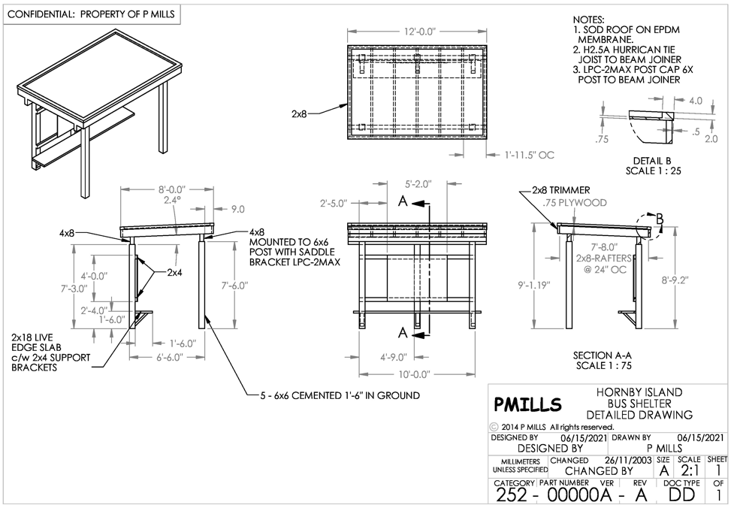

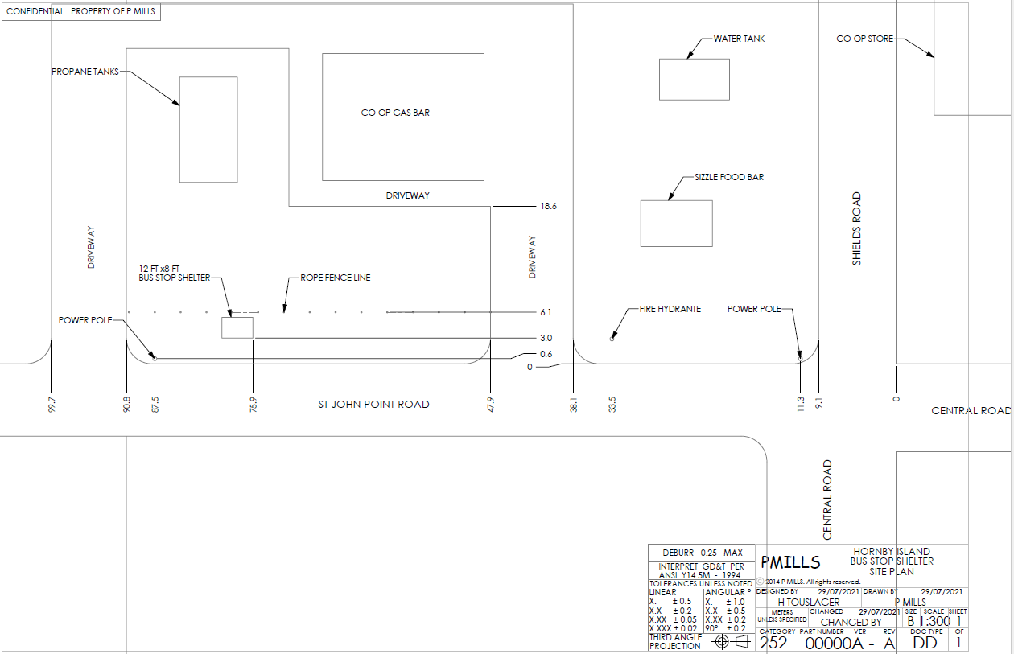

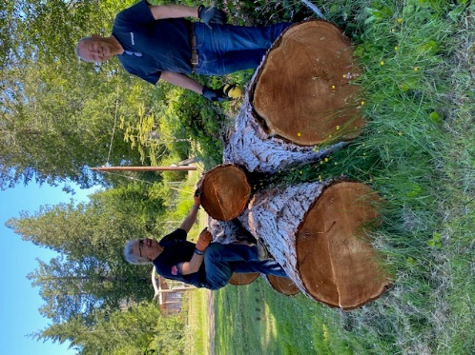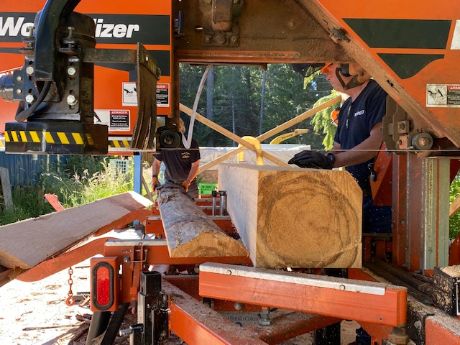

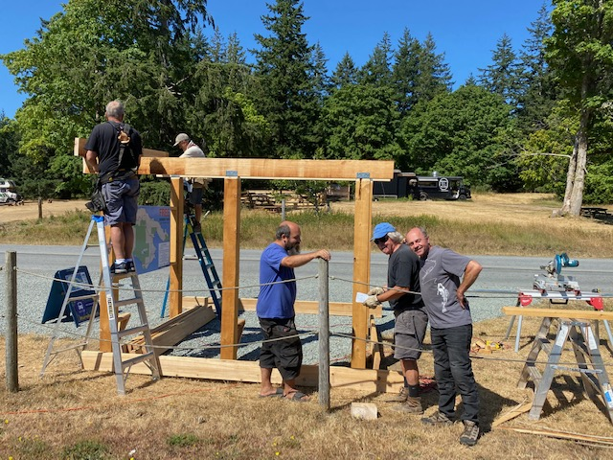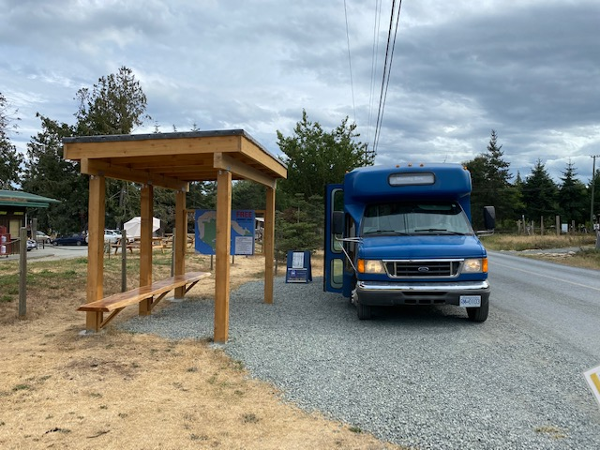

Appendix B: Endorsement Letter

February 26, 2019

Re: Hornby Community Bus Project

To Whom It May Concern:

At the direction of the membership at the December 12, 2018 Hornby Island Residents’ and Ratepayers’ Association (HIRRA) general meeting, the HIRRA Executive is writing in support of a local Hornby Community Bus Steering Committee, facilitated by the Hornby Island Economic Enhancement Corporation (HICEEC), applying for funding to acquire an electric bus, and associated infrastructure, to provide public transportation on Hornby Island.

The Hornby Community Bus Project has been researched, promoted, and sponsored by HICEEC, Hornby Island Outdoor Education Society, local businesses, and HIRRA starting in 2017 with the purchase of a second-hand 24 passenger bus. The pilot project was continued and expanded in 2018 and was the subject of a Feasibility Study funded by the Comox Valley Regional District.
Establishing a Hornby Community Bus Steering Committee and seeking funding for a quieter, fuel-efficient (or ideally electric) bus, were two of the key suggestions in the Feasibility Study report. There is strong community support for a low-emission local bus service.

HIRRA also supports HICEEC seeking access to some of the $60,000 in taxes already requisitioned each year from Hornby Island taxpayers for public transit in the Comox Valley.

As the HIRRA Executive, we stand fully in favour of continued and improved public transportation for our community.

Sincerely,

HIRRA Executive:
Rob McCreary, President
Linda Manzer, Vice-president
Lynn Nunley, Treasurer
Anita Lewis, Secretary

Appendix C: 2021 Schedule
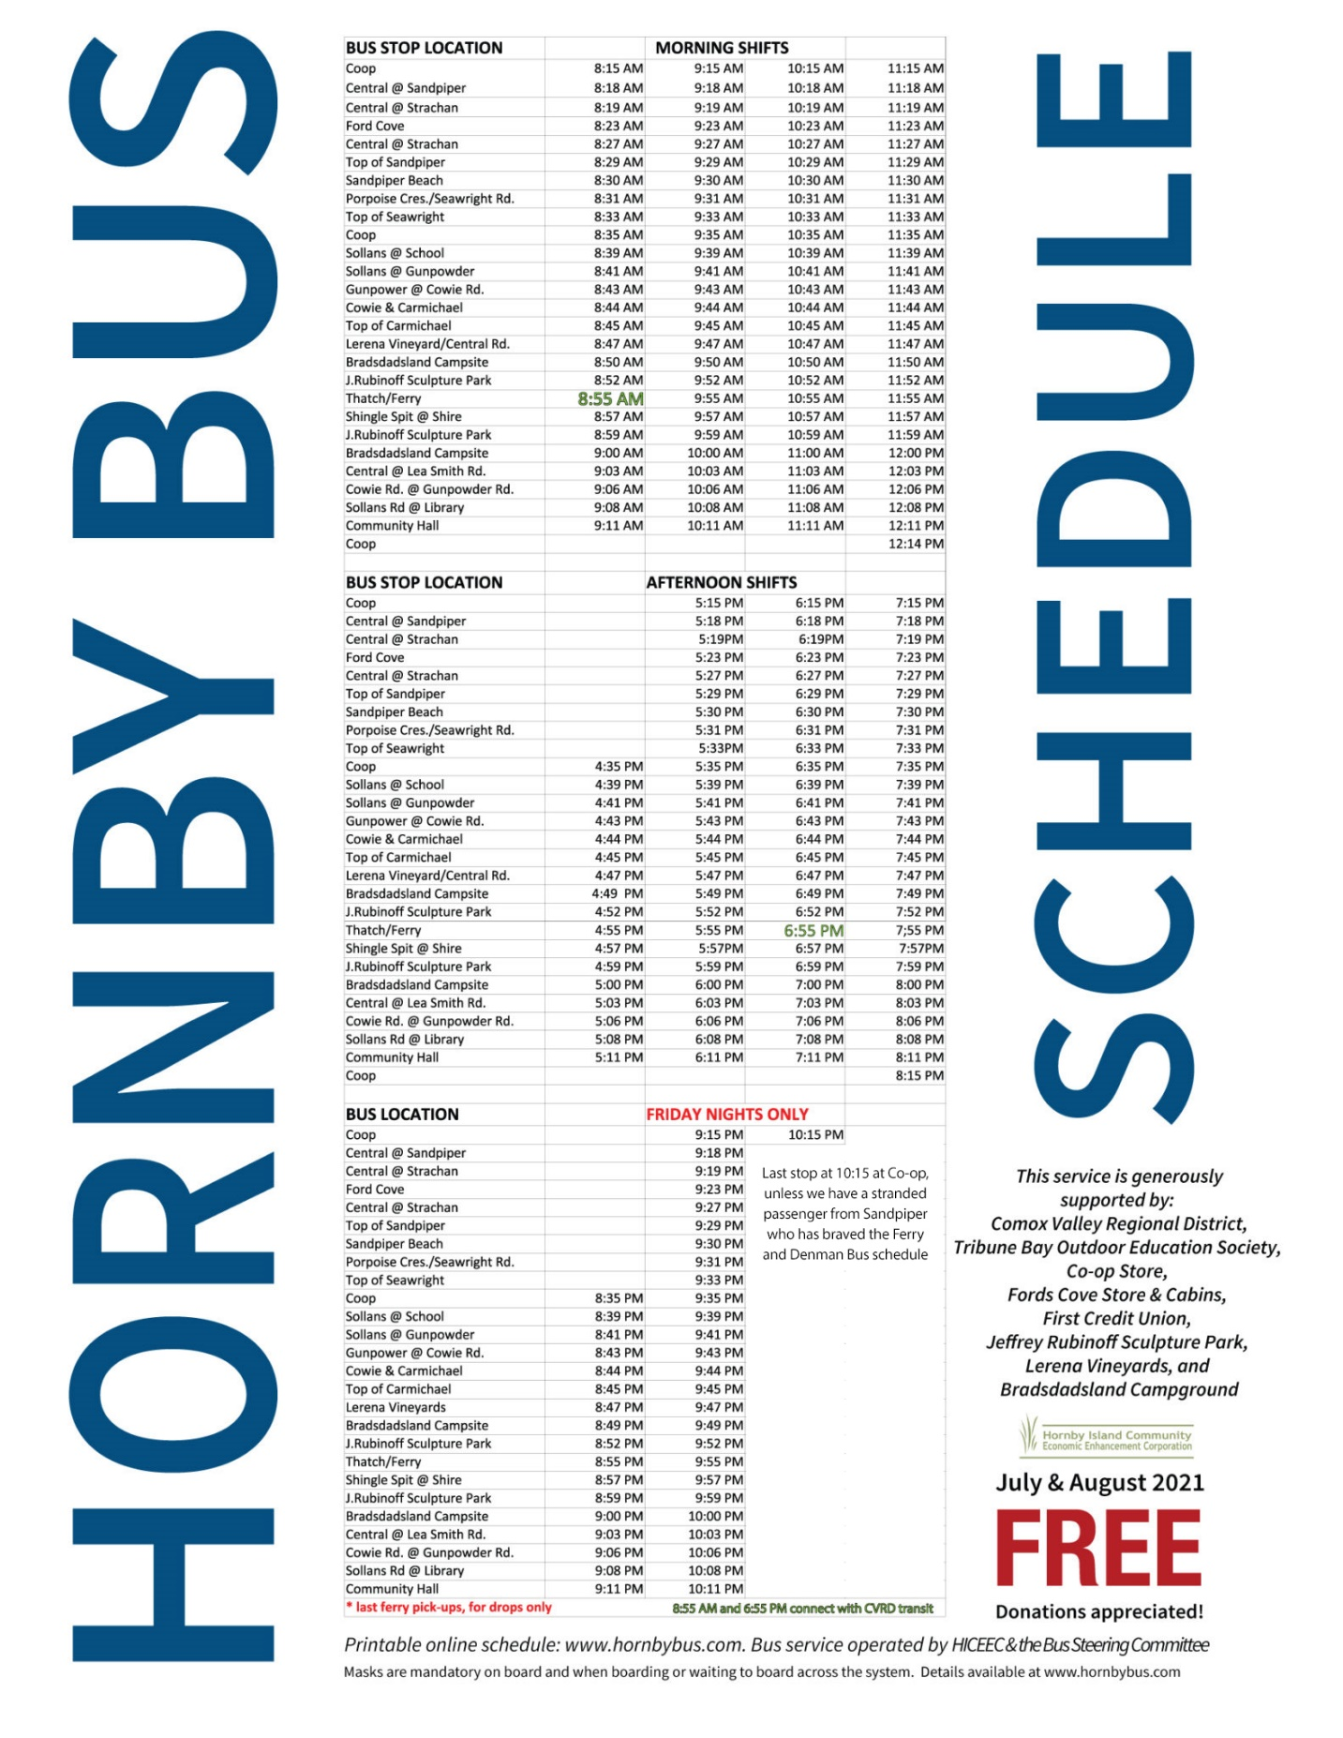

Appendix D: 2021 Route map

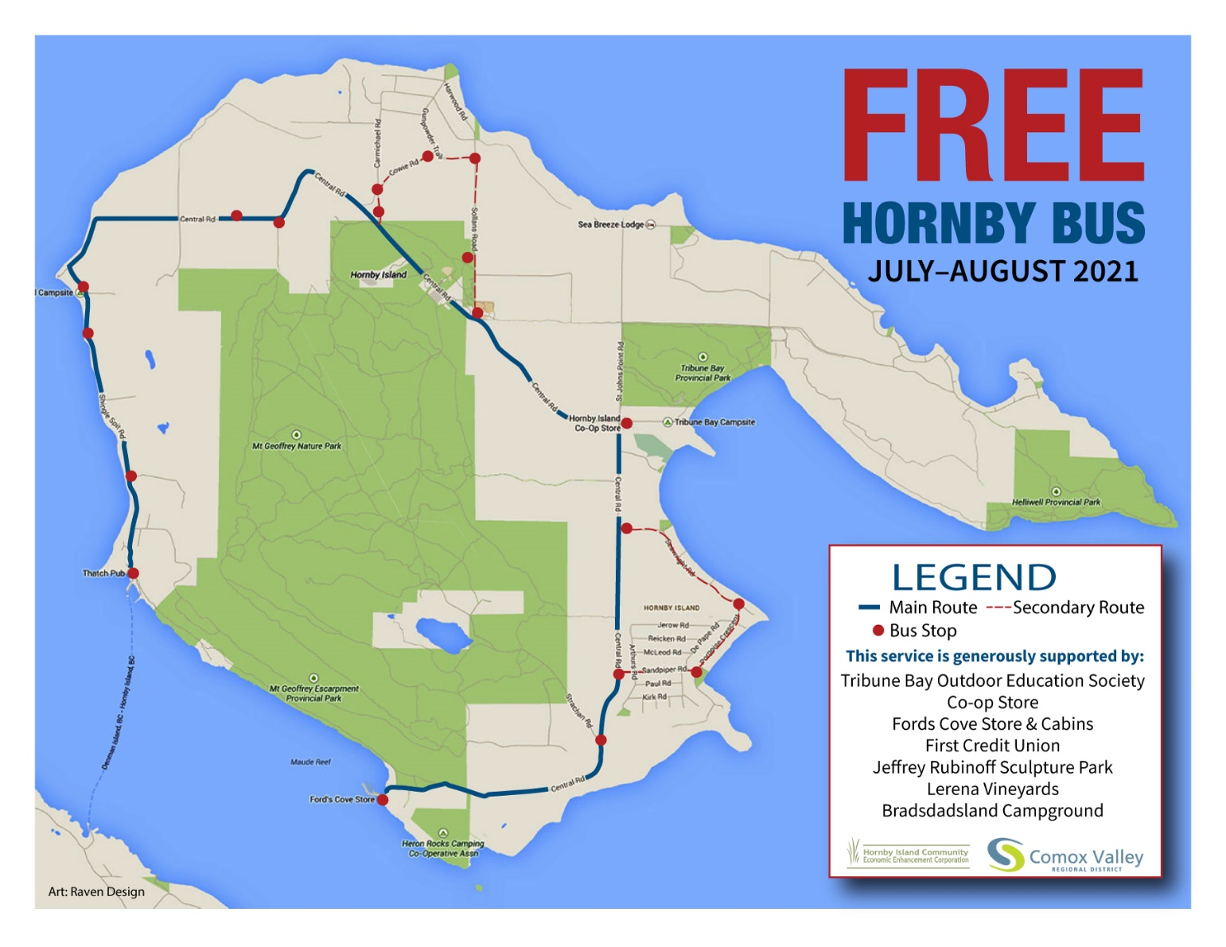
Graphic Design and Web hosting, www.hornbybus.com are all provided by Homegrownsite.com and Hornby Bus Volunteer Web Masters Arne Olafson and Daisy Nobel.

