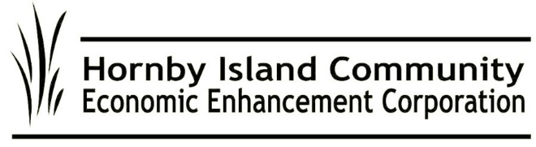

**May 2025, HICEEC First Edition**

**Land for Homes: A Vision for the Future**

At the close of 2024, HICEEC submitted an exciting proposal to acquire 10 hectares of Crown Land, at an ideal site across from the Firehall. Unfortunately, the application was rejected, but a new path may be opening through sponsorship from the Regional District.

The mission is clear: With the right infrastructure in place, families can bring their tiny homes to this beautiful location. Additionally, space is envisioned for staff accommodation, offering housing solutions for local employers and their dedicated workers. The Island cannot thrive without homes for the people who work here. This initiative is a crucial step in ensuring a sustainable and resilient future for our community.

**MRDT Funds Hitting the Streets**

Most of funds collected through Municipal Regional District Tax—the “pillow tax” collected from visitors—are being set aside for affordable workforce housing. The MRDT program mandates that a component of the funds be dedicated to messaging—for events, sports, and initiatives. To date, two grants have been made: Hornby Indoor Market for signage, and a 7-enterprise collaboration ad in the Spring edition of the regional magazine Comox Valley Collective. Continuing grants are available. Visit [**https://hiceec.org/mrdt**](https://hiceec.org/mrdt) for the information package.

**Hornby Bus Questionnaire Results**

Your input on the future of transit on Hornby is requested. Please complete the online survey:<https://www.surveymonkey.com/r/NBQP6L8>

**Same format, new cover**  
The 2025/26 edition of this year’s Visitor Guide will be available in early May. Thanks to John McLachlan for once again for doing the graphic design for the front cover—very Canadian, eh? This collaborative marketing effort amplifies the Hornby message: “What you do matters”. Thank you to those that chose to showcase their business while supporting sustainable tourism.

**The Ferries: The Verdict**

BC Ferries has responded to the Hornby Ferry Action Discussion Group regarding the community's concerns about ferry service on Route 21 (Buckley Bay to Denman) and Route 22 (Denman to Hornby). We take a moment to celebrate the win: the 44-vehicle Quinitsa will be deployed to the Hornby route in 2027, year-round! While it's disappointing that the full improvements we need haven’t yet been implemented, we’re finally seeing some movement toward solutions.

In the meantime, the Kahloke will continue as the primary vessel on Route 22 and will shift to a supplemental role on Route 21 during peak seasons. (Note that the Kahloke is scheduled for a refit in October 2025.) The Quinitsa, with a capacity of 44 automobile equivalents, will serve Hornby during the peak season in 2025 and 2026, ultimately becoming the primary vessel on the Hornby route in 2027.

We are grateful that both the Kahloke and Quinitsa have proven to be reliable workhorses—unlike the cable ferry, which continues to face mechanical issues and struggles with lift, particularly its inability to "double." The main question now facing us is: Why are the limitations of the cable ferry not being effectively addressed?

Now that the Ferry Advisory Committee has been disbanded, the responsibility falls on each individual voice to be heard. If you want these questions answered, you can reach out directly to the following representatives:

* Josie Osborne – Josie.Osborne.MLA@leg.bc.ca
* Claire Trevena, BC Ferry Authority Board Mid-Island Rep. – ClaireTrevena@bcferryauthority.com
* Francois Bertrand, Executive Director, Marine Branch, MOTI – Francois.Bertrand@gov.bc.ca

**Submitted on behalf of the volunteer Board:**  
John Heinegg, John Grayson, Jack Hornstein, Katherine Ronan, Donna Tuele, Sheila McDonnell, Stu Amos, and Marilyn Kopansky