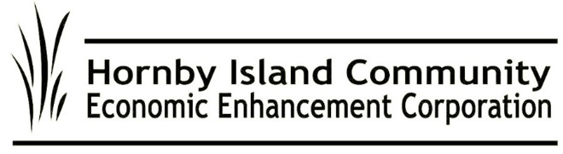

**Oct. 2024, HICEEC First Edition**

**Bus Service Update**

* Our cherished little white bus has been stored away for the winter after an outstanding 2024 season.
* A new liaison with the Water Taxi, operated by Big Island Encounters, offered rides to some new “day trippers”. The bus continued to provide an alternative to private vehicles, a reliable ride to work and play for Island youth, and a friendly ride to residents and visitors alike.
* Beyond the regular 11-hour summer schedule, the bus extended service to special events, including the Hornby Festival, the Annual Quilt Show, and the Fall Fair.
* The CVRD is studying the possibility of merging bus services on Hornby and Denman Islands. This could lead to administrative efficiencies, coordinated hiring, and enhanced scheduling links. The Tribune Bay Outdoor Education Centre (TBOEC) is also involved as a key partner, given its year-round operation and transportation needs across both islands.
* Special thanks to Heart Vineyard’s Table Restaurant for hosting a delightful “Windup the Season” meal, which honored our hard-working volunteers, loyal sponsors, and dedicated drivers.

**MRDT: Supporting Our Community**

The Municipal Regional District Tax (MRDT), originally developed as a tourism program, has expanded its focus to support initiatives benefiting local residents. This tax, collected from visitors, now funds a range of community projects.

This year’s MRDT-funded projects include:

* Contributions to the Welcome Centre, including a $2000 contribution toward Central Island outhouse service
* The Natural History Centre’s Summer/Fall Speaker Series
* Public education initiatives like the Tribune Quirky Quiz and Stakeholder Survey
* A Responsible Marketing Campaign designed to promote sustainable travel and shoulder season visits

Most of the 2024 MRDT funds have been allocated to a capital reserve for Affordable Workforce Housing, with the funds temporarily invested in GICs to earn interest.

Stakeholder engagement for 2025 will take place this Fall.

**Your Voice Matters: Speak Up for Better Ferry Service**

The Ferry Advisory Committee (FAC) continues to lobby for improved ferry service. Hornby traffic frequently faces severe, unacceptable delays: on some morning runs, no Hornby vehicles make it onto the Baynes Sound Connector (BSC), and it is also rare for all Hornby traffic to make the through-connection to Buckley Bay.

The FAC is pushing for supplemental service beyond Labour Day weekend and has requested the reinstatement of the previous shuttling policy, in place until September 2023, which made shuttling mandatory when a specified number of vehicles were left behind on a scheduled run.

Additionally, a motion made at the September HIRRA meeting requests that BC Ferries ensure that the first 15 cars leaving Hornby from the first run until noon each day be guaranteed space on the BSC.

We’ve demonstrated before that our voices can make a difference. Let’s continue to advocate for full-time, reliable ferry service on both the Hornby and Denman routes. The more feedback BC Ferries receives, the stronger our influence. Share your experiences and suggestions at engagement@bcferries.com.

**You're Invited!**

Join us for the HICEEC 2024 AGM on October 6th at 3 PM at New Horizons. We’d love to see you there! If you’re not yet a member, sign up soon so you can have your say: HICEEC Membership at https://hiceec.org/about. We look forward to connecting with you!

**Save the Date:** The Annual Fall Mixer is scheduled for Sea Breeze Lodge on Tuesday, October 22nd. The focus of the event will be the presentation of the 2024 Enterprise of the Year. This event is a premier opportunity to network with the business and nonprofit communities.

**Submitted on behalf of the volunteer Board:** John Heinegg, John Grayson, Jack Hornstein, Katherine Ronan, Donna Tuele, Sheila McDonnell, Stu Amos, and Marilyn Kopansky.