**MRDT GRANT BACKGROUND: Events, Sports, Initiatives program**

The Municipal Regional District Tax (MRDT), collected on Hornby Island by HICEEC, is part of a broader Provincial tourism program. A portion of these funds will be allocated to the Sport, Events, and Initiatives program through an open application process. In addition to the requirements under the Provincial tourism programs, our organization, as the evaluator of the grants, asks that applicants consider the 17 Sustainable Development Goals (SDGs) established by the United Nations. As part of the evaluation process, we place a strong emphasis on sustainability and environmental responsibility, encouraging applicants to adopt a "walk lightly" approach and minimize the environmental impact of their initiatives.

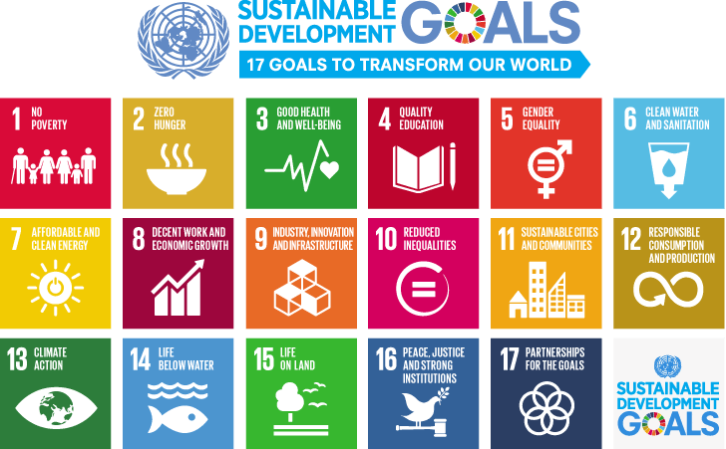

1. **No Poverty:** End poverty in all its forms everywhere.
2. **Zero Hunger:** End hunger, achieve food security and improved nutrition, and promote sustainable agriculture.
3. **Good Health and Well-being:** Ensure healthy lives and promote well-being for all at all ages.
4. **Quality Education:** Ensure inclusive and equitable quality education and promote lifelong learning opportunities for all.
5. **Gender Equality:** Achieve gender equality and empower all women and girls.
6. **Clean Water and Sanitation:** Ensure availability and sustainable management of water and sanitation for all.
7. **Aﬀordable and Clean Energy:** Ensure access to aﬀordable, reliable, sustainable, and modern energy for all.
8. **Decent Work and Economic Growth:** Promote sustained, inclusive, and sustainable economic growth, full and productive employment, and decent work for all.
9. **Industry, Innovation, and Infrastructure:** Build resilient infrastructure, promote inclusive and sustainable industrialization, and foster innovation.
10. **Reduced Inequalities:** Reduce inequality within and among countries.
11. **Sustainable Cities and Communities:** Make cities and human settlements inclusive, safe, resilient, and sustainable.
12. **Responsible Consumption and Production:** Ensure sustainable consumption and production patterns.
13. **Climate Action:** Take urgent action to combat climate change and its impacts.
14. **Life Below Water:** Conserve and sustainably use the oceans, seas, and marine resources for sustainable development.
15. **Life on Land:** Protect, restore, and promote sustainable use of terrestrial ecosystems, manage forests sustainably, combat desertiﬁcation, and halt and reverse land degradation and biodiversity loss.
16. **Peace, Justice, and Strong Institutions:** Promote peaceful and inclusive societies for sustainable development, provide access to justice for all, and build eﬀective, accountable, and inclusive institutions at all levels.
17. **Partnerships for the Goals:** Strengthen the means of implementation and revitalize the global partnership for sustainable development.

Respond to the SDG that makes sense for your event/experience.

**Examples, in terms of events, sports, and initiatives**

**Goal 8: Decent Work and Economic Growth**

**● Action Ideas:**

○ Job creation for local residents, including Indigenous community members.

○ Supporting local suppliers and businesses.

○ Highlighting local social enterprises, providing information on ethical shopping and sustainable products and/or vendors.

**Goal 12: Responsible Consumption and Production**

**● Action Ideas:**

○ Implementing waste reduction strategies and conducting a post event waste audit.

○ Sourcing sustainable materials and minimizing single-use plastics.

○ Promoting eco-friendly activities and tours.

**Goal 14 & 15: Life Below Water, Life on Land**

**● Actions Ideas:**

○ Protecting natural ecosystems by adhering to responsible tourism practices.

○ Supporting conservation initiatives or enhancing the ecosystem (e.g. reforestation, planting pollinator species, wildlife protection, etc.)

○ Donating a portion of your profits to conservation, restoration, or research.