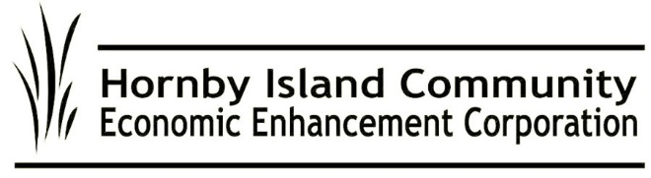

**Sept. 2024, HICEEC First Edition**

**Bus Stop Update**

* **Last Day of Service:** Sunday, September 1. A big round of applause to our stellar team: Driver Manager Jill Gathright, drivers Sorcia Amor, David Hayward, and backups Garth Millan, Steve Macdonald, and Ray Therrien.
* **Love to Sponsors:** The Coop, Jeffrey Rubinoff Sculpture Park, First Credit Union, H.I. Bakery & Pizzeria, Heart Vineyard, Thatch Pub, Mainroad Contracting, and Bradsdadsland Campsite!
* **Bus Steering Committee & Pit Crew Kudos**: Peter Mills, Gary Law, Garth Millan, Ray Therrien, Chris Allen, Steve Macdonald, Karen Ross & Cam Domay (HICEEC), John Heinegg (HICEEC), and Daniel Arbour (CVRD).
* Watch for the Hornby Fall Fair pop-up service.

M**RDT in Action**

The Municipal Regional District Tax—paid by visitors to support projects that benefit the community, including affordable housing—is in place and funds are being collected. 4VI, an industry consultant, has been contracted with, to assist with implementing the 5-year strategic plan. This group formerly assisted with community consultations on MRDT and helped guide the initial direction of the program. We are fortunate to be back working with Calum Matthews and team. This year’s public consultations will take place this Fall, prior to the submission of the Annual Tactical Plan to the Province.

**A Friendly Face**

The HICEEC Welcome Centre at the Farmers’ Market thrived thanks to Ambassador Michele Papp’s friendly smile and expertise. Michele provided valuable information on bus routes, dog access, fire restrictions, ferry schedules, events, restaurant hours, places and people to buy from, hiking trails, and more. (And it wasn’t just visitors asking!) Great job, Michele, and kudos to all the Farmers Market vendors for their quality work and hosting such an engaging market!

**Your Voice Matters: Take Action for Better Ferry Service**

BC Ferries is facing fiscal challenges, with fare increases failing to keep pace with rising costs. As a result, the planned terminal redevelopment at Gravelly Bay was canceled. Yet, improved year-round ferry service, especially on Route #21, is urgently needed. The current 30 hours per week of tandem service in July and August isn’t enough. It’s also unacceptable that maintenance on the cable ferry after scheduled hours disrupts vital transportation for our emergency services.

We’ve shown before that our voices matter. Let’s continue to push for full-time, reliable service on both the “Hornby” and “Denman” routes. The more feedback BC Ferries receives, the stronger our influence. If you’ve had a frustrating experience or suggestions for improvement, share them at [engagement@bcferries.com](mailto:engagement@bcferries.com).

**A roof over your head**

The excitement is palpable as construction finally begins on Beulah Creek Housing! This milestone is the result of countless efforts and contributions from many passionate individuals. We remember the seed funding and administrative support from HICEEC that helped get this project off the ground, many years ago. (Special thanks to Katherine and Daniel!) We also honor the previous landowners, the Island Trust, ISLA and its dedicated volunteers, Daniel Arbour, and MLA Josie Osborne for their behind-the-scenes lobbying, as well as the Hornby Housing Society and the entire supportive community. Here's to clear skies and a smooth journey toward welcoming residents to their new homes!

**You're Invited!**

Join us for the HICEEC 2024 AGM on October 6th at 3 PM, at New Horizons. We’d love to see you there! If you’re not a member yet, be sure to sign up soon so you can have your say: <https://hiceec.org/about> Looking forward to connecting with you!

Submitted on behalf of the volunteer Board: John Heinegg, John Grayson, Jack Hornstein, Katherine Ronan, Donna Tuele, Sheila McDonnell, Stu Amos and Marilyn Kopansky