Hornby Island Community Economic Enhancement Corporation
2023 Annual General Meeting
October 15, 2023
New Horizons’ Hall

Present Board: John Heinegg – Chair, John Grayson – Vice Chair, Jack Hornstein – Treasurer, Katherine Ronan – Secretary, Sheila McDonnell - HIRRA Appointee, Donna Tuele – member at large

Staff: Karen Ross – Executive Director (in attendance)
Cam Domay – Bookkeeper (not attending)

Attendees: April Lewis, Darren Bond, Garth Millan, Joanne Ovitsland, John A. Reid, Laura Chalfin, Louise McMurray, Marilyn Kopansky, Pete Kimmerly, Sheila McPherson,
New members, not eligible to vote: Lynn Nunley, Tara Channel
Non members: Chris (Kopansky ?)

CALL TO ORDER (Chair – John Heinegg)
President John Heinegg chairing. HICEEC AGM called to order at 4:09 p.m.

INTRODUCTION OF BOARD, STAFF & COMMITTEES (Chair – John Heinegg)
Each board member and staff. John Heinegg welcomed everyone, and acknowledged First Nations Territory.

ESTABLISHMENT OF QUORUM (Secretary – Katherine Ronan) 10% of membership/64 members
13 Participants. 10 members, 6 Board, 1 staff. Quorum is met.

Chair Heinegg clarified that in the 2021 AGM, NOTIICE WAS GIVEN that the next year was a transition year between the practice of attendance and membership being synonymous, and the requirement in the bylaws that a Board accepted application for membership is required.

APPROVAL OF AGENDA (Chair – John Heinegg)
Agenda was approved by general agreement M/S/C

REPORTS
I. Minutes of the 2022 AGM, for the year 2021. (Karen Ross)
Abbreviated minutes were read aloud by Karen Ross and approved as presented by general agreement (poll) – 4 abstained, remainder in approval.

Notes:
Request from the floor to send the draft minutes out, with the invitation to attend the A.G.M., to give the members time to review the draft, prior to voting for acceptance. Board agreement.

After the next year’s AGM, finalized minutes are published on www.hiceec.org

II. Chair Report (John Heinegg)
Priorities for 2022, included:
  - Housing, with a focus on acquiring Crown Land for development
  - Internet – years of work on bringing high speed internet to the Island. Delays currently re MoTi permits.
  - Ferry – Work to upgrade and replace ferries. Moving on getting newer ferries before the old ones sink. (Note: Summer 2023: Bigger ferry on Route 22, May to Dec.)
  - MRDT – after several years of work, the Provincial Cabinet passed it into law for Hornby, starting in June/22. Collections are slow, especially from Air BnB. The 5 year Strategic Plan was approved in 2022. In 2023, the Ministry had a major shift, with Cortes getting the funds solely for housing. (Note: with the exception of mandatory administration and destination events contributions)
  - Guiding documents – set with public consultation:
    - Vision 2020
    - Economic Action Plan 2015
    - Work in progress, Vision 2030 and Beyond

Note: Need more input from younger people

Chair report received, as presented by John Heinegg.

III. Treasurer Report (Jack Hornstein) (Refer to Financial Statements)

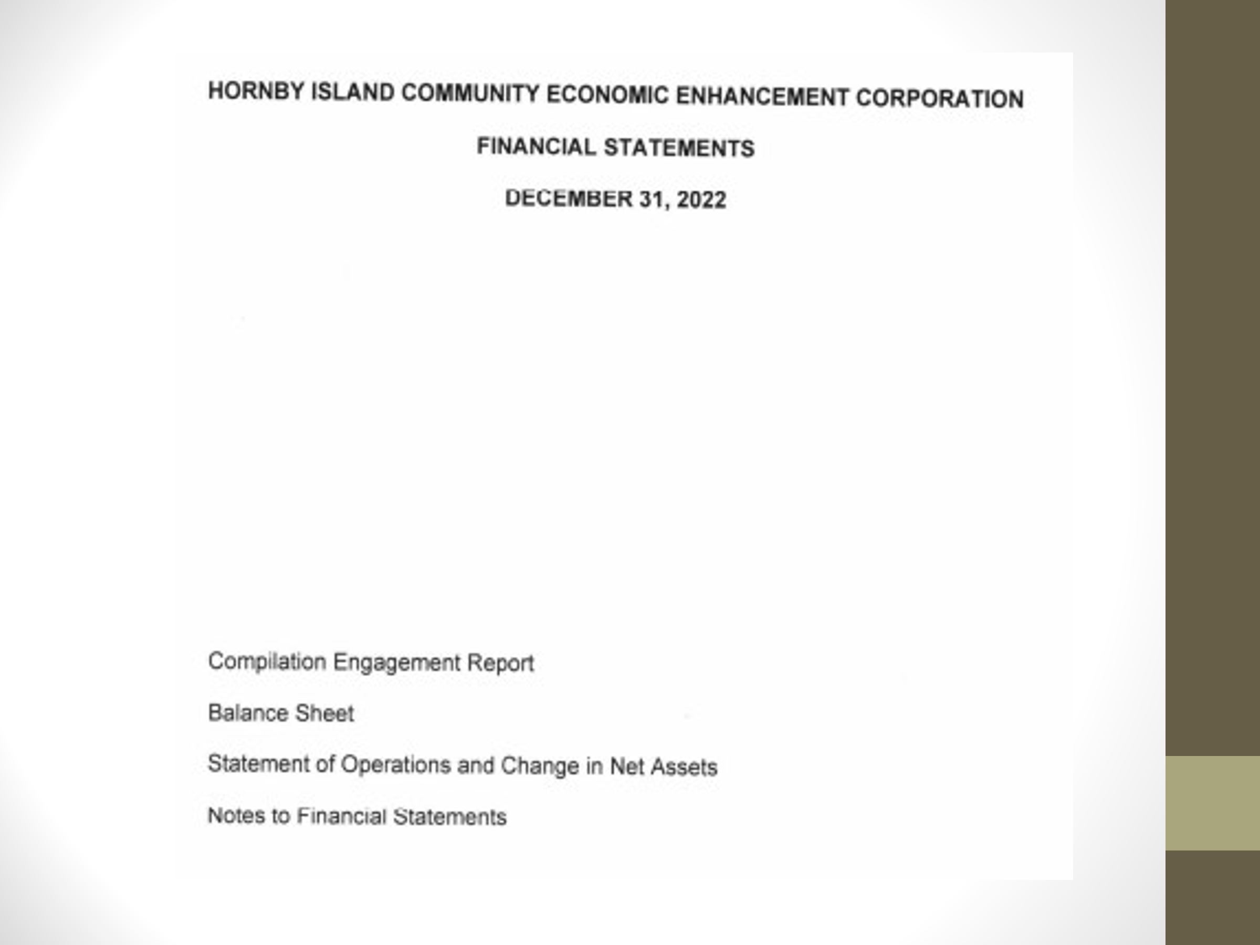

Discussion:
Deferred:
- $62K MRDT
- $63K Bus & Transit
- $20K Housing

Prepaid revenue: 2023 www.hornbyisland.com invoicing was done at the end of the 2022 fiscal year

Operations: $40K needed for staff, rent, operational costs, Jan./23 – May/23

HornbyIsland.com and the Visitor Guide are a good service, individual businesses and non-profits could not afford to get this range of advertising on their own.

Bus – money comes from the CVRD tax levy, the fare box, and sponsorships of local businesses (advertising on the outside of the bus)

MRDT revenues:
- $62K as of December, 2022
- $62K in 2023 in the first 6 months
  - Note: Online Accommodation Revenue has not been significantly received for either year

Liaison with CVRD:
HICEEC Board has asked the CVRD finance department, several times over the last two years, for a line by line breakdown of total revenues from Hornby Island Taxpayers.

The information should be readily available. The next letter is going to the Chief Financial Officer for the CVRD.

Concern that Hornby is being taxed for services not received, or not receiving good value for the money paid for services received. E.g. Transit. (Note: Hornby got out of the Recreation levy for the Valley, and got the money directly to Hornby, which funds “Hornby Rec.”

General discussion was supportive of this investigation.

M/S/Carried, Jack Hornstein/Katherine Ronan “That the 2022 Financial Statements be accepted as presented.”

M/S/C Jack Hornstein/John Grayson. Appointment of accountants: Motion to appoint Tara Smith, CPA, of Comox, to complete a Notice to Readers accounting for the 2023 fiscal year.
“That Tara Smith of Courtenay be appointed to complete a Notice to Readers for the 2023 Fiscal year to be presented at the 2024 AGM.” Vote:

M/S/C Jack Hornsten/Sheila McDonnell/Carried. Waive requirement for an audit. It is favoured to do a Notice to Readers, due to financial costs. 3 types of financial oversight: “Notice to Reader”, approx. cost $1800., “Review Engagement”, approx. cost $5000., “Audit” approx. cost $10,000.

M/S/C Sheila McDonnell/Donna Tuele “The annual dues for HICEEC membership shall be set at zero for the upcoming year”.

IV. Staff reports

- Karen Ross – 2022 overview slide –

STAFF REPORT – Karen Ross
WORKING FOR OUR FUTURE
- Fiscal prudence & leveraged funding: grants, advertising revenues, MRDT
- Advocating for improved affordable, universal, internet
- Optimizing green, affordable community transportation
- Collaborate with other organizations and government agencies
- Training & workforce development: Ambassador program, bus drivers, trainee book-keeping.
- Supporting environmental protections & food sustainability
- Hornby Island Housing Network
- Updating the Hornby Island Community Vision & Economic Action Plan
- Messaging and engagement with websites, social media, print media

- MRDT: Program outline:
As directed by an adhoc group of tourism stakeholders, in Jan. 2020, HICEEC engages outside consultants to help administer the MRDT file. The first consultant was Tourism V.I., then COVID hit and the file went dormant. When we reactivated outreach, TVI was not available, but recommended the services of Gull Lake Consulting. That firm took on the project, through in-person public engagement & online surveying, to develop the 5 year strategic plan and the one year tactical plan which were used by HICEEC to finalize approvals with the Provincial Cabinet to initiate the MRDT. The Ministry of Finance initiated this new tax in June of 2022.

Revenues in 2022 were approx.. $62K, significantly less than projected. The issue was lack of revenues from the Online Accommodation Providers (OAP'S). The OAP are not required to identify their clients, confidentiality and all. As the OAP's are big multinational companies, the Province cannot insist on having them identify their clients. However, with some local help, from Plan H and HICEEC staff, properties renting through Air BnB, VRBO, and other OAP's have been identified and the URL's submitted to the Ministry. The Ministry of Finance is now providing these URL's, in order to track down the missing funds. For absolute clarity, the OAP have been collecting this money, it has simply not made it's way into the Hornby payouts yet.

As with any start-up programs, there are hitches. We remain confident that this is being actively sorted out. However, without confirmation of the income stream, budgeting and project implementation has been impaired.
In the meantime, receipted funds are being held in G.I.C.’s at First Credit Union.

2 other significant points:
- Main projects that are in the HICEEC 2023 annual plan are:
- “Carrying Capacity” study, 4 VI indicates this is difficult, as it actually changes daily/seasonally, etc. Could be replaced by a “Sustainable Tourism Action Plan”.
- Responsible Tourism Guide (RTG)
- Shoulder season events
- Affordable workforce housing

- If more money is not received very soon, cuts will need to be made to the projects budgets to start implementing them in 2023.
  - Workforce housing moneys are approved to be carried forward,
to establish a “war chest” towards capital investments.

Notes:
- It is anticipated that the OAP money will be received, and be incorporated into the budget in the year that happens.
- Oct. ’23, we have engaged 4VI to start Stakeholder Engagement.
  - Circle back on 2023, if required, and implement reflecting possible budget cuts to reflect the diminished revenues received.
  - Develop the 2024 Tactical Plan. One year plans all fall within the confines of the 5 year strategic plan which was agreed on by stakeholders and regional government.

The first in-person engagement is Monday, Oct. 23, 3 to 5 p.m., Sea Breeze.
Following an overview of the program, there will be an opportunity to discuss ideas, ask questions, provide feedback. There will be other Stakeholder engagement sessions to follow.

- Internet. John Grayson, HICEEC Board Lead on the project, reported:
  - John and Karen have been working on this file, lobbying right up to the Associate Deputy Minister levels of both MoTi and Citizens Services, along with our M.L.A. to encourage the local MoTI office to adapt their rules to the new trenchless technology, and the logistics of inground utilities.
  - At 7 a.m., on Monday, October 23/23, the installation company, Summit, will be on Hornby to start doing home drops.
  - Half of the Hornby “backbone” has not been started. Phase 3 and 4 of the Hornby mainline are still waiting for MoTi permits to proceed. The delay is due to MoTi's unfamiliarity with the new technology of cable burial; MoTi would prefer the familiar old method of placing wires on poles. However, CVRD Area A rep. has spoken against this in discussions – preference for in-ground services due to the protection from wind and wild fires.
  - The other issue has been permitting for the subsea cable itself. Karen wrote the Mayor of Vancouver, which prompted a response from their permitting department, and access has now been granted to the Vancouver Internet Exchange for the whole Provincial project.
  - Denman construction preceded Hornby, and it is anticipated that the first 160 homes will be “lit up” on October 18th.
  - Hornby services will be “live”, optimistically in late winter or early spring/24
  - HICEEC is in regular communications with City West, Summit, the CVRD, and all government departments that have a hand in this project.
    - Note: Sept/23 HIRRA meeting, the executive and members were asked to lobby to the Ministry of Transportation to grant the permits for allow work to resume on the Hornby project. Thanks to HIRRA.

- Ferry issues.
  - HICEEC formed the Hornby Ferry Action Discussion Group.
    - AGM P.P. Slide acknowledgement: This group consisted of the Sea Dogs (retired BCF personnel – Sr. Capt. Pete Kimmerly, Capt. Ron Tuele, Capt. Harry Fearman, and Brian Pannell), research engineer Bernhard Weiss, HIRRA V.P. Kent Lukinuk, and Transportation professor Colin Boyd. Many other people worked on lobbying for improved ferries on Routes 21 and 22. Including Hornby FAC members Stephan Wehner, Rob McCreary, Sandra Rutherford, Ron Edmonds, and Grant Scott. (Note: in 2023 the Denman FAC members were invited to join this discussion group).
  - During 2022, a campaign was initiated: Analysis, surveys, 2700 name petition, reports, & regular media coverage. Picture in the AGM slide show: May/22, Daniel Arbour, Karen Ross and Grant Scott meeting in the B.C. Legislature with Minister of Transportation, Rob Fleming, and M.L.A. Josie Osborne lobbying for improved ferry service.
  - January, 2023, Karen Ross/HICEEC became the Chair of the Hornby/Denman Ferry Advisory Committee.
    - Note: Solution Quinitsa, identified by the Hornby team was initiated in 2023, and tandem service on Route 21 for 2 summer months. Quote Pete Kimmerly “this was the best summer ferry service that we’ve had in 30 years”.
    - As the Sept./23 engagement, Ret. Sr. Master Kimmerly identified the BIG WIN. Financially feasible and do-able - a win for Hornby, Denman and BCF: In the absence of immediately planned new vessels for our routes. When the planned 4 new vessels for the Minor Route fleet are here, the Quinsam will be free. “Put the 80 car Quinsam on Route 21, the 44 car Quinitsa on Route 22”
      - In the Fall/23 public engagements, our community will be asked to endorse this solution.

- Bus Steering Committee – Core managing group, slide acknowledgement:
Peter Mills, Garth Millan, John Nemy, Gary Law, Ray Therrien, and recently retired Colin Boyd.
Daniel Arbour, CVRD rep., and other committee and volunteer helpers.

- Hornby Statistics shown. (School registration, census population, Coop sales, ferries ridership)
  - Available on https://hiceec.org/statistics-1

BUSINESS

NOMINATION AND ELECTION OF DIRECTORS (Chair – John Heinegg, Secretary – Katherine Ronan)
As HICEEC seeks to recruit Directors with particular skills, nominations must be pre-approved. Nominations from the floor require the support of 5% of members present.
John Heinegg and John Grayson terms are up and they are standing for re-election.

Marilyn Kopansky expressed interest. A Hornby property owner since 2001, Marilyn has been in discussion with HIRRA to become the 2nd HIRRA appointee on the Board. No action required.

No nominations from the floor.

M/S/C Laura Chalfin, Katherine Ronan “That the nominations of John Heinegg and John Grayson to the Board of Directors be approved.”
– A round of applause followed.

GENERAL DISCUSSION AND QUESTIONS
Q. Why is the 2022 A.G.M. so late this year? It is hard to remember/look back this far.
A. There were a crunch of AGM’s, from other organizations, in June.

Q. Will HICEEC continue to push for the referendum agreement that the Internet project will provide service to every home, regardless of whether the owner has signed up for services?
A. This is a huge provincial project, with unexpected hurdles – in the number and timing of permits, the breaks in supply chains due to COVID, the labour shortages, and other financial challenges. Some pivoting has, and will continue to, occur. HICEEC is definitely working diligently to get as much as possible for all residents of Hornby.

Q. How was Wellesley Consulting Group (WCG) engaged to do the Economic Development Strategy?
A. Katherine met Ross Birchall through contacts in Victoria. He/his company wrote a proposal to work on the HICEEC housing file through being self funded from successful grant applications. HICEEC is not directly paying WCG.

Q. Did WCG apply to ICET for money to do the E.D.S.? How much was that grant?
A. WCG is not eligible to apply for grants. They do the work and then HICEEC signs the applications. The ICET grant was $15,000.

Q. Encourage HICEEC to look at all projects through the lens of the Climate Crisis.

Q. Request that www.hornbyisland.com refuses to host the advertising for activities that are non-compliant with the Hornby Land Use Bylaws, this specifically refers to Vacation Rentals.
A. Enforcement of Bylaws is the responsibility of Island Trust, and their Bylaw Investigation Office.
HICEEC does not have the capacity, or knowledge, to enforce bylaws. What is done is Education. Any new properties are referenced to the importance of complying with all laws – bylaws, tax remittance, etc.
Suggestions from the floor:
- If the Bylaw Investigation Officer identifies a property to HICEEC that has been found guilty of contravening the bylaws, that the HICEEC Board considers withdrawing advertising rights, or supporting that owner to come into compliance.
- If hi.com gets too heavy, people will just shift to the more anonymous Online Travel Agencies. It is better for properties to advertise on hornbyisland.com, with local messaging and context, than chasing them online to the Online Accommodation Providers.
- HISTRA is doing a great job in raising the standards and educating around compliance. A potential effective strategy is community pressure to comply.

Q. Cortes Island just announced that their whole MRDT program can be used for Affordable Housing. Can the Hornby MRDT program be shifted so that all the money is used for Affordable Housing?
A. Hornby has a 5 year contract, as identified in the 5 Year Strategic Plan.
There may be some opportunities to shift some monies.
Suggestions from the floor:
- It is important to keep money for messaging, and education, and maybe other programs that benefit the community.

Q. Cedar Lane B n B/Louise reported that she has called Air BnB and been assured that they are collecting, and remitting, the PST and MRDT on her behalf. What could be happening?
A. Hornby is not well defined on Air BnB, when you put in a request for accommodation on Hornby, listings on Denman, Fanny Bay, Qualicum, etc. show up. However, this is a great avenue to further inquiries, as confidentiality cannot be used if it is a client inquiring. Suggest further investigations along this line.

Q. How is the MRDT responsibility for paying different than other taxes? In any other tax situation, the actual business owner is ultimately responsible for the payment of taxes. The owner cannot sidestep their responsibility by saying a 3rd party was supposed to remit.
A. Protection of Hornby owners will be brought forward with Ministry staff.

ADJOURNMENT - Motion to adjourn AGM
John thanked everyone for attending, and becoming more informed on the work that HICEEC does.

M/S/C John Grayson/Katherine Ronan

HICEEC AGM Adjourned at 6 pm.

