🏡 Beulah Creek Village – Housing Allocation and Eligibility Overview
Beulah Creek Village is a 26-unit affordable rental housing development on Hornby Island, delivered through a partnership between the Hornby Island Housing Society, M’akola Housing Society, and BC Housing. The project represents a significant addition to the island’s housing supply and introduces a structured, income-based approach to housing allocation.
The unit mix and indicative rent structure for Beulah Creek Village, as provided by M’akola Housing Society, are summarized below.
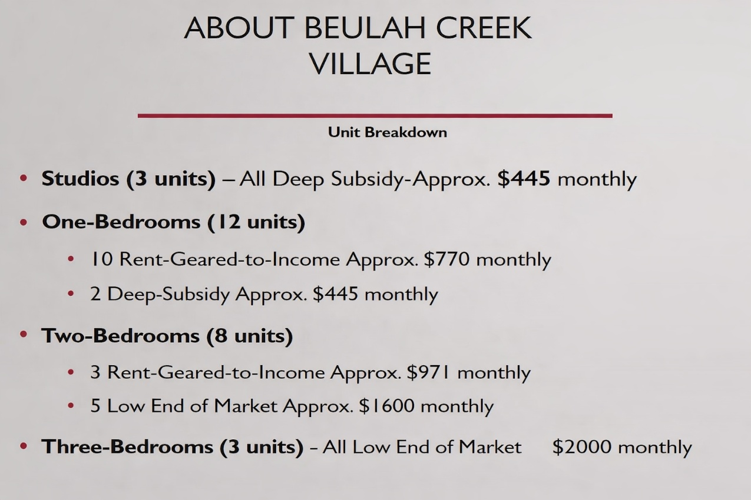

Unit breakdown provided by M’akola Housing Society, showing the distribution of units by type, program category, and approximate monthly rents at Beulah Creek Village.

Unit Mix
The development includes a range of unit types intended to serve individuals, couples, and small families:
- 3 studio units
- 12 one-bedroom units
- 8 two-bedroom units
- 3 three-bedroom units

Program Allocation
All 26 units are pre-assigned across three affordability categories:
- 5 units (20%) – Deep Subsidy
- 13 units (50%) – Rent-Geared-to-Income (RGI)
- 8 units (30%) – Low-Market Rental
Each category is tied to specific income ranges and program requirements.
The following diagram provides an overview of how income eligibility, program requirements, and unit availability interact to determine access to housing at Beulah Creek Village.
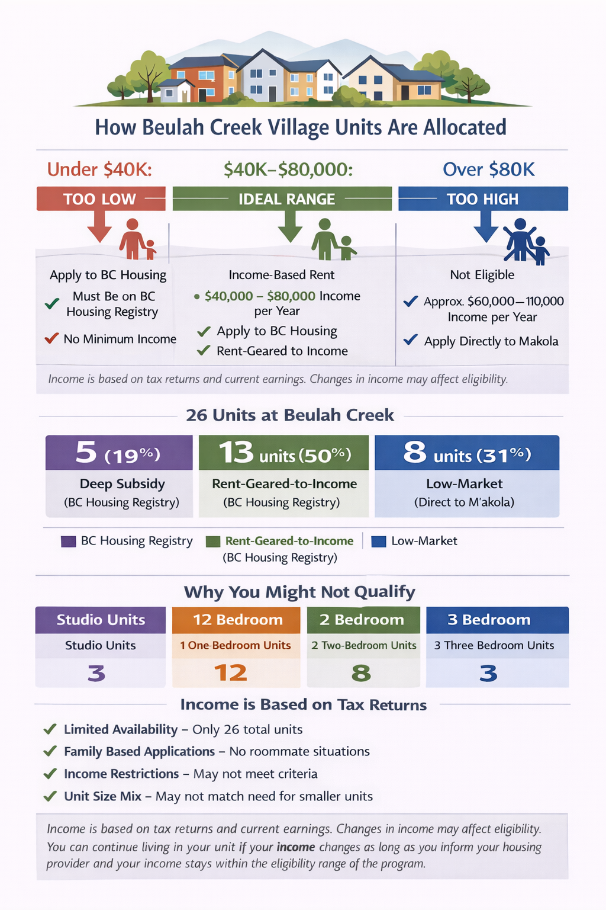 Illustrative overview of how income eligibility, program requirements, and unit availability interact to determine access to housing at Beulah Creek Village.

The allocation of units across programs also determines how applicants access housing, with different application processes depending on the program category.

Application Streams
There are two distinct application processes:
- Deep Subsidy and RGI Units (18 units / 70%)
Applicants must be registered on the BC Housing Registry.
Tenants are selected by M’akola Housing from this centralized list based on eligibility and priority need, with priority to Hornby Island residents.

- Low-Market Units (8 units / 30%, currently 2 and 3 bedroom units)
Applicants apply directly to M’akola Housing, with priority to Hornby Islanders.
Selection is based on income verification and the ability to afford rent.

Income Framework
Eligibility for housing is determined by both income level and ability to pay rent, as illustrated in the accompanying graphic.
- Under approximately $40,000/year
Applicants are generally only eligible for Deep Subsidy or RGI units and must apply through the BC Housing Registry.
- Approximately $40,000–$80,000/year
Applicants may qualify for RGI units (via BC Housing Registry) or Low-Market units (via M’akola Housing), depending on income and affordability.
- Above approximately $80,000/year
Applicants are generally not eligible for Beulah Creek housing.
Income eligibility is assessed using:
- Most recent income tax return (Notice of Assessment)
- Current income verification (pay stubs, employment confirmation, or benefits)

Program Fit and Affordability
Each program serves a distinct income group:
- Deep Subsidy
Intended for very low-income households, including those receiving income assistance or disability benefits. Rents are set at government-defined shelter rates.
- Rent-Geared-to-Income (RGI)
Rent is calculated at approximately 30% of gross household income, making these units accessible to lower-income working households.
- Low-Market Rental
Rents are fixed below market levels but require sufficient income to support monthly payments. As a result, these units are generally accessible only to moderate-income households.

Important Considerations
Applicants must:
- Meet income requirements
- Fit within a specific program category
- Match an available unit size
- Be selected through the applicable process
As a result, individuals may qualify for housing but not receive an offer due to limited availability within their category.

Limited Supply Within Each Category
The number of units in each program is fixed:
- Only 5 units are available for the lowest-income households
- The majority of units are applied for through a centralized system (BC Housing Registry)
- Low-Market Rental units are limited to applicants who can meet affordability thresholds

Affordability Thresholds
Low-Market units require applicants to demonstrate income within a defined range (with rent being no more than 30–35% of income). This effectively excludes many lower-income, and higher-income, applicants from this category.

Housing Stability
Tenants are not required to leave if their income changes over time. However:
- Rents may be adjusted (for RGI units)
- Eligibility is reviewed periodically
This provides a level of housing stability, while maintaining alignment with program guidelines.

Conclusion
Beulah Creek Village successfully delivers housing within the framework established by BC Housing programs. However, the structure of these programs results in a system that is:
- Structurally segmented by income program type
- Generally fixed in unit mix allocation
- Some limitations in flexibility in responding to the full range of local housing needs
Beulah Creek Village represents a meaningful and important addition to Hornby Island’s housing supply. It provides secure, well-managed housing for a range of residents and demonstrates the value of partnership with provincial housing programs.
However, while the project successfully serves some households, it does not fully address the range of current housing demand on Hornby Island.
In particular:
- Lower-income households compete for a very limited number of deeply subsidized units
- Many workforce households fall between eligibility thresholds or cannot be matched to available units
- A significant number of applicants may remain unhoused due to program constraints
The result is a persistent gap between available housing and actual community need.
Without additional housing approaches, these gaps are expected to persist.

Forward Direction
This analysis highlights an important conclusion:
Projects such as Beulah Creek Village are necessary—but not sufficient—on their own to meet the housing needs of the Hornby Island community.
To address the identified gaps, there is a clear need to continue advancing affordable workforce housing initiatives that:
- Reflect local income realities
- Provide flexibility across income ranges
- Expand supply for the working population that supports the island’s economy

Next Steps
The Beulah Creek Village project represents a significant and positive addition to Hornby Island’s housing supply and demonstrates the value of partnership with established housing programs.
At the same time, the analysis above indicates that additional approaches will be required to address the full range of housing needs within the community, particularly for the local workforce that supports year-round economic activity.
In this context, there is an opportunity to build on existing efforts by exploring complementary housing models that can expand supply, increase flexibility across income ranges, and better align with local conditions.
HICEEC is continuing to advance the Hornby Island Affordable Workforce Housing initiative to address the gaps identified above. Building on the lessons from Beulah Creek Village, this work is focused on exploring housing models that are flexible, responsive to local income realities, and aligned with the needs of the island’s workforce.
Ongoing feasibility analysis, supported through the Province’s Rural Economic Diversification and Infrastructure Program (REDIP), will help identify practical approaches that can complement existing housing and contribute to a more complete and resilient housing landscape for Hornby Island.

