Celebrating Excellence
HICEEC BUSINESS OF THE YEAR:
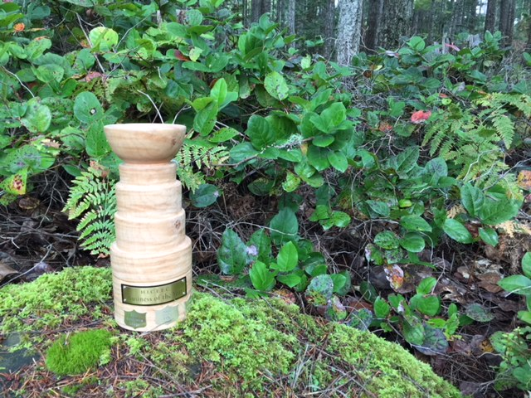

2014:
Bishop Family & Sea Breeze Lodge
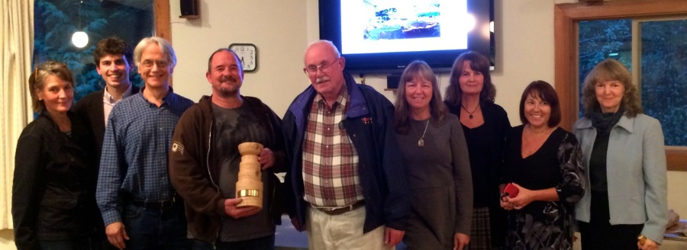
2015:
Dale Armstrong & Alex Lamonte, Hornby Island Coffee & LIX
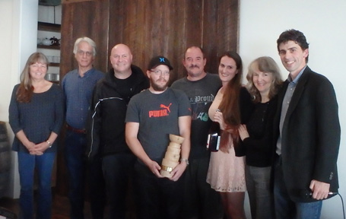
2016:
Dr. Peter Walford, dentist
2017: Michael McNamara & Tim Wyndham,
Blue Sky Design
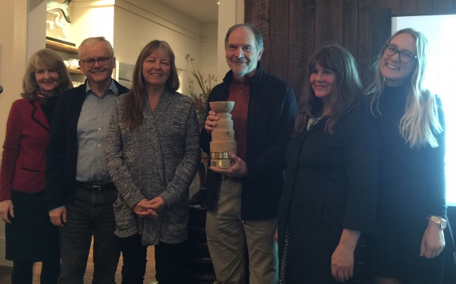
2018: Gord & Allison Campbell,
Tribune Bay Outdoor Education Society
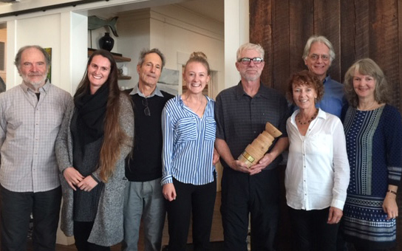
2019:
Marc Atkinson Recording Studio
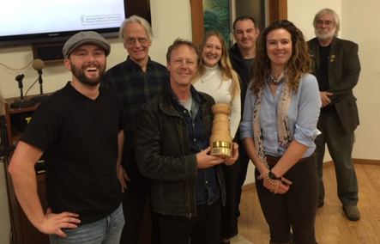
2020:
Jon & Jane Laskin, Hornby Island Bakery & Pizzeria
