- CVRD website November/23

https://www.comoxvalleyrd.ca/projects-initiatives/past-current-projects/hornby-denman-high-speed-internet

Hornby & Denman High Speed Internet

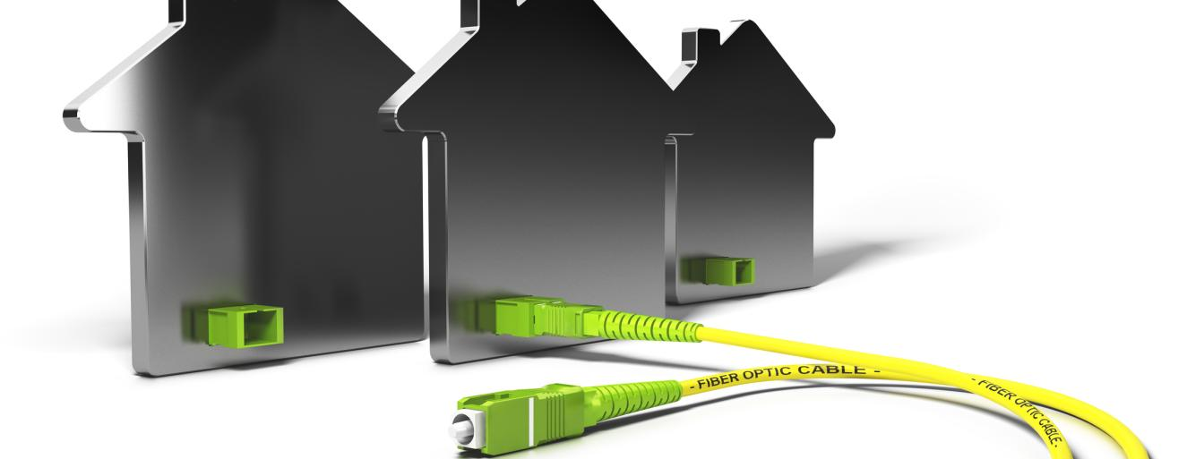
- 1
- 2
CVRD Contact
Corporate Services-
250-334-6000 (main)
|Contact Form

Where Are We Now
CityWest has begun construction of the underground fibre-optic network on the islands. After construction is complete, the fibre-optic infrastructure will be tied into the Connected Coast network, a joint partnership operated by CityWest and the Strathcona Regional District. For information concerning the construction project or on CityWest and their subscription service offerings, please contact CityWest at 1-800-442-8664 or via email.
The CVRD and CityWest have entered into a contribution agreement that awards CityWest with the capital funding and also provides 20 percent of the revenue earned to the CVRD for grants and others forms of assistance that benefit residents and community organizations within the service area.

Milestones:
As project milestones are identified we will be sure to provide further details here. For more information on CityWest and their subscription service offerings visit here: www.citywest.ca.

Background:
On November 27, 2021 a referendum for the proposed Hornby and Denman Islands high-speed internet initiative was held. The official results have been tallied and the community has voted in favor of moving forward with the project. 94% of voters were in favour of establishment of the service, authorizing the necessary borrowing and entering into an agreement with CityWest, the telecommunications service provider. Voter turnout was 55% of the estimated eligible electors.
Total project costs are estimated at approximately $7.6 million with 90 per cent being covered by grants. A community contribution of 10 per cent or $760,000 is required as part of the grant funding criteria.
CVRD News: Official Results Show That Hornby and Denman Islands High-Speed Internet Project Moving Forward

Receive updates by subscribing to Project Updates.
For more information call 250-334-6000 or contact us.
- Bylaws
- Denman and Hornby Islands High-Speed Internet Contribution Service Establishment Bylaw No. 672, 2021
- Denman and Hornby Islands High-Speed Internet Loan Authorization Bylaw No. 673, 2021
- Denman and Hornby Islands High-Speed Internet Capital Contribution Agreement Authorization Bylaw No. 678
- Background Documents
- Denman and Hornby Islands High-Speed Internet Contribution Service 2022 - 2026 Proposed Financial Plan - Staff Report February 2022
- CityWest Funding Announcement News Release - August 10, 2021
- August 2021 Electoral Areas Services Committee Meeting - Staff Report
- July 2021 Electoral Area Services Committee Meeting - Staff Report
- January 2021 Electoral Area Services Committee Meeting - Staff Report
- Connectivity Report – Volume 1
- Connectivity Report – Volume 2
- Public Involvement
Residents on Hornby and Denman Islands were invited to participate in two online open houses regarding this initiative. Recordings of the virtual open houses are available below and consolidated Q&A's are available here.
  - October 6, 2021 (12:00pm - 1pm)
Watch the recording of the Virtual Open House
  - October 7, 2021 (5:00pm – 6:00 pm)
Watch the recording of the Virtual Open House

