<https://www.comoxvalleyrecord.com/news/hornby-island-to-proceed-with-pillow-tax/?fbclid=IwAR38RHUaazmth7d_sA73PKL_aqZJ_kkGuTASbOb8aLQfQsPAK2trVDgjR8o>

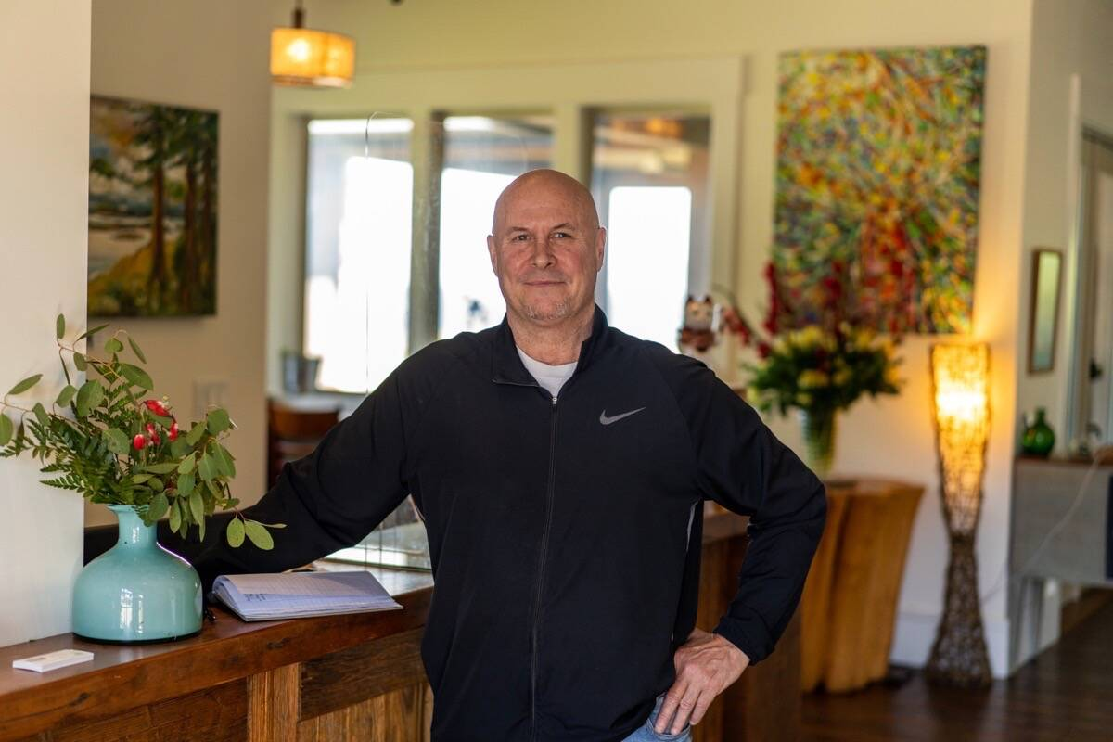

Jeff Bishop welcomes guests to Sea Breeze Lodge on Hornby Island. Photo supplied

Hornby Island to proceed with pillow tax

Mar. 2, 2022

Hornby Island will soon collect room revenues from accommodation providers to support the management of tourism, investment in local infrastructure, and housing initiatives.

In late February, the Province confirmed ratification of a three per cent tax on all fixed roof transient tourist accommodation on Hornby Island, which will come into effect on June 1. The receipts from this tax will go directly to the local community in a regulated program administered by the Hornby Island Community Economic Enhancement Corporation (HICEEC).

The Municipal and Regional District Tax (MRDT) was introduced in 1987, by the provincial government, to help participating communities better capture the benefits of tourism.

“For decades, the Hornby community has talked about initiating a ‘pillow tax’ in order to raise money from our tourism economy to support local projects and infrastructure, and more recently to address workforce housing,” said Karen Ross, community economic development officer for Hornby Island. “The island will be able to receive monies from commercial accommodation and short-term vacation rentals to the benefit of the community.”

With a convergence of motivations, HICEEC applied to be recognized as an “eligible entity” in the collection of funds, and with the support of the Comox Valley Regional District, for Hornby Island to be delineated from other areas of the Regional District as a stand-alone taxing jurisdiction. As part of the program’s requirements, a primary stakeholder group made up of island accommodation providers will provide guidance to the fund’s allocations. The eligible priorities expressed by the group include affordable workforce housing, visitor education and developing a more sustainable tourism season.

“As with many popular B.C. communities, it can be difficult to achieve a balance between the benefits and impacts of tourism,” said Daniel Arbour, Area A director of the CVRD. “I am hopeful that this fund will assist the community in addressing perennial problems, and over time support a great experience for residents and visitors alike.”

FMI: hiceec.org/mrdt